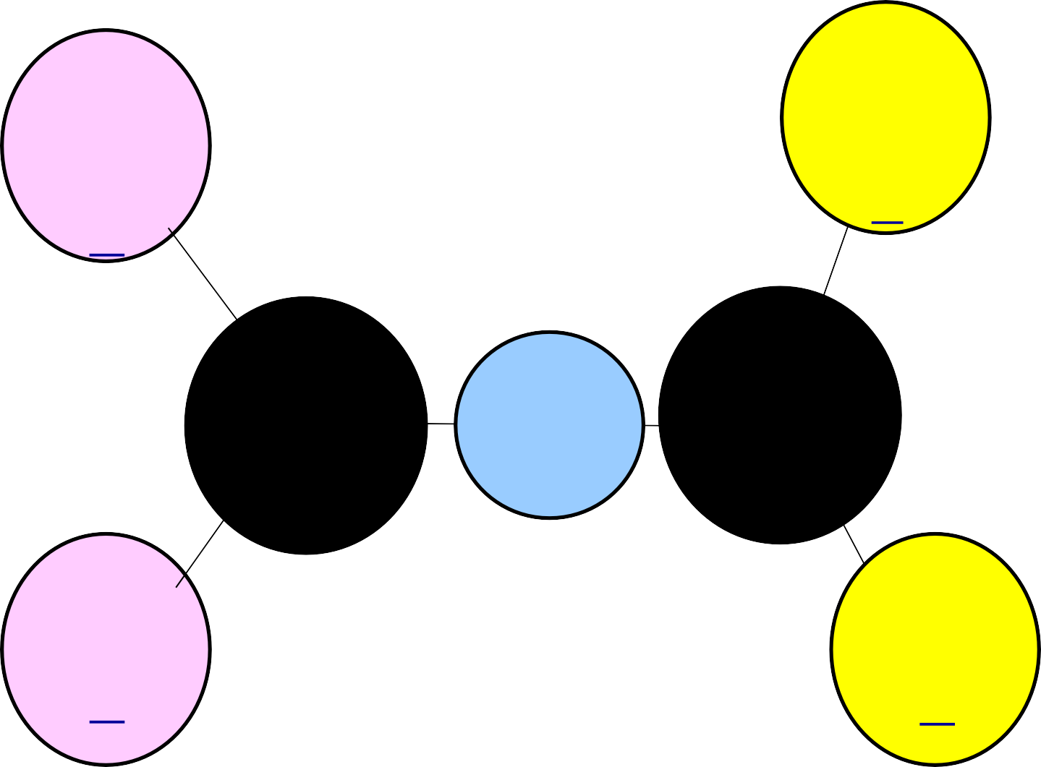
Number of Testing Days
Total Testing
Days for grades 3 – 8 with SSI retesting =
27
Total Testing
Days Grades 3 – 8 with SSI retesting =
27
4th & 7th writing now a 2-day test
Most of the EOCs are 2- day tests
All EOCs offer 2 additional testing opportunities per year
•
STAAR
EOC
•
Both will have
Tests, Make up Days, and Re- tests
TAKS
•
Total Testing Days for grades 9th – 11th with Exit Level retesting =
25
Total Testing Days for 9th – 12th grade EOCs with retesting =
45

