
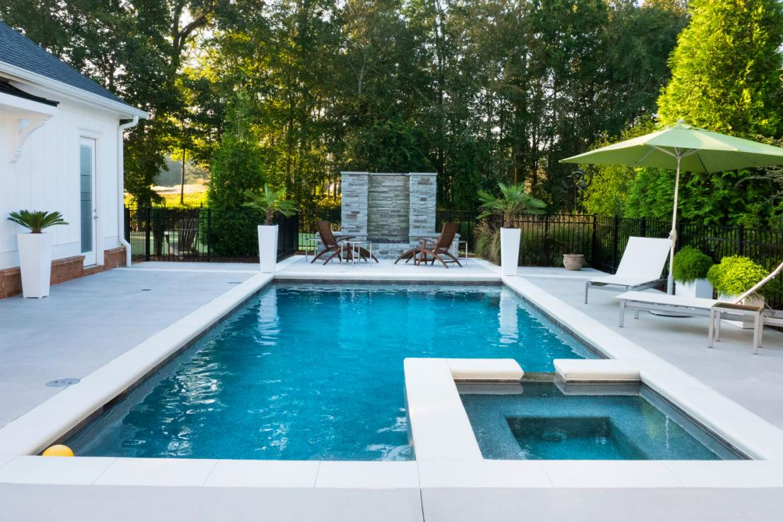


+1234-567-890
Call Now
POOL SERVICE
professional pool cleaning and repair
30%
OFF
COMPANY NAME
+1234-567-890
Call Now
www. templateLAB.com=
- Destruction of algae and fungus;
- Removal of limescale;
- Disinfection;
- Deep cleaning of all surfaces of the bowl;
- Cleaning the joints and seams of the pool;
- Polishing of details from a stainless steel and the chrome plated surfaces.
OUR SERVICE

