
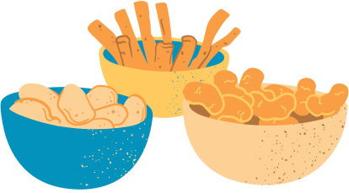
DRINK
- Diet Soda
- Regular Soda
- Ginger Ale
- Coffee
- Hot/Iced Tea
- Water
- Lemonade
- Juices
- Smoothies
Room service
SNACK
- Popcorn
- Mixed Fruit
- Chocolate Kisses
- Potato Chips
- Pretzels
- Cookies
- Granola Bar
- Doritos
- KitKat
- Ice Cream
Please choose the food and hang this outside your door before 4 pm. Deliveries will be made between 6-7 pm.

