

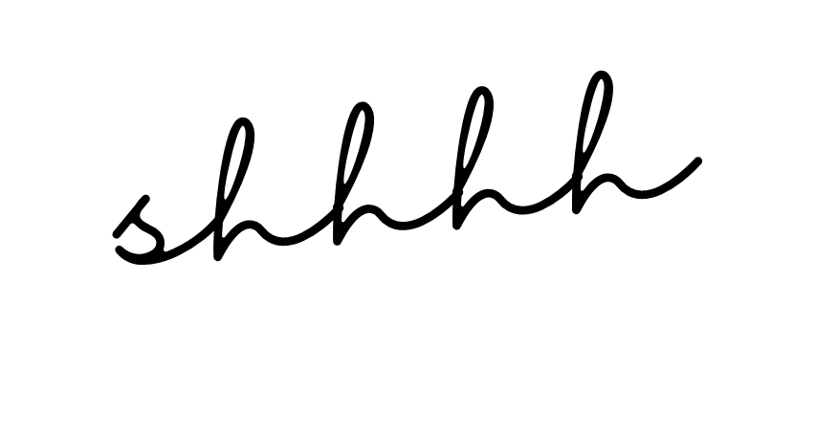
PLEASE
DO NOT
DISTURB
we were up all night partying with the
MR. & MRS.
ANDERSON

