
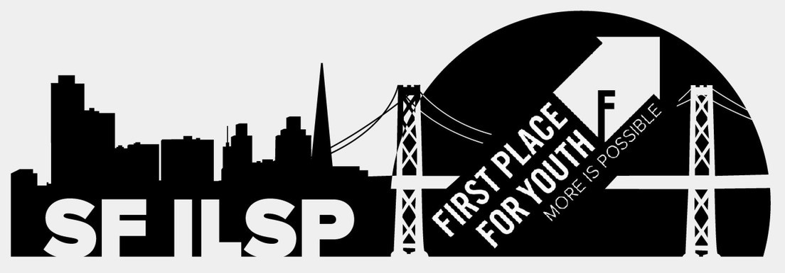


S F I L S P ' S

BACK TO SCHOOL NIGHT!

S E P T E M B E R 2 0 T H 4 - 6 P M A T I L S P

Food
Fun Activities Raffle Prizes (Computer)
$25 Gift Cards

