
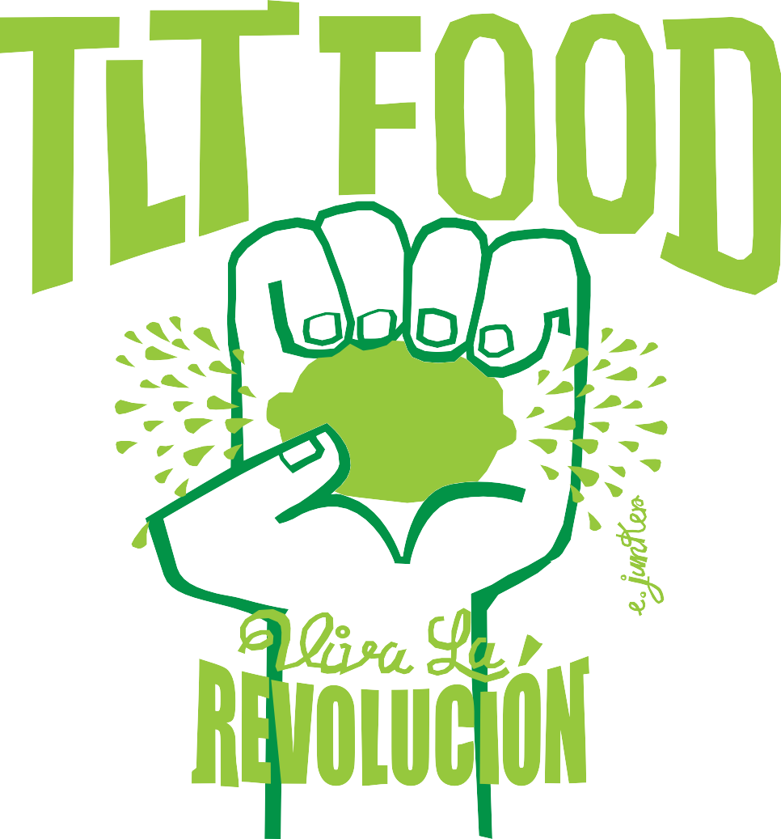
ba

IPSF FUNDRAISER

Join us at TLT Food Irvine
Mondays and Wednesdays in November
15% of your order goes to
IPSF (Irvine Public Schools Foundation)

705 SPECTRUM CENTER DR. IRVINE, CA 92618
ACROSS FROM CHIPOTLE & NEXT TO LYFE KITCHEN AT THE IRVINE SPECTRUM

*Please present this flyer or show on your phone

