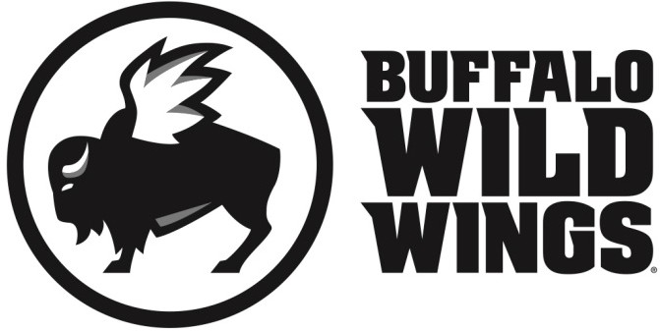
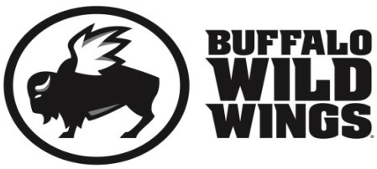
Paton PTO Fundraiser
A great cause and some great food
All friends, family and supporters of Paton PTO are invited to participate in their fundraising event on
Wednesday, February 22, 2017
Everyone is invited to gather at Buffalo Wild Wings in Shrewsbury (476 Boston Turnpike) for lunch, dinner, or a snack. On this day, 20% of purchases* accompanied by the certificate below will be donated to
Paton PTO.
Paton PTO Fundraiser Wednesday, February 22, 2017
Present this certificate to your server at the time of your order and 20% of your purchases* will go to support
Paton PTO.
*Valid towards Dine-In and Carry-Out. Not valid towards gift card purchases. Flyers are not permitted to be distributed inside or outside the restaurant.
Only valid at 476 Boston Turnpike, Shrewsbury, MA (508) 845-2999

