
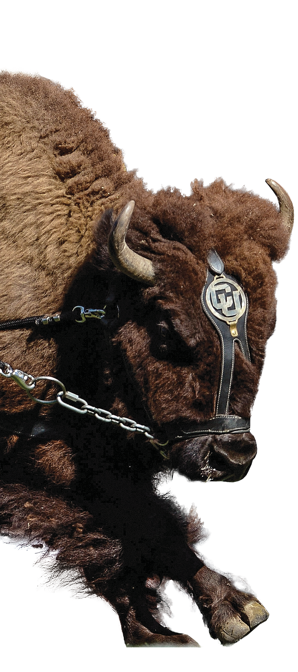

ralphie appearances
DONATION LEVELS FOR MEET-AND-GREETS

ATTEND RALPHIE PRACTICE
$500
SIDELINE PASS FOR RALPHIE’S RUN
$1,500
RALPHIE APPEARANCE ON CU-BOULDER CAMPUS
$4,000
RALPHIE RUN ON CU-BOULDER CAMPUS
$6,000
RALPHIE APPEARANCE OUTSIDE OF CAMPUS
$4,500
plus $0.50 per mile away from campus
EDUCATIONAL PRESENTATION BY RALPHIE HANDLERS
NO CHARGE FOR ON CAMPUS EVENTS

All events with Ralphie are subject to the Ralphie Live Mascot Program policies and procedures as well as the availability of the Ralphie Handlers and Ralphie, NCAA Compliance rules, access to have Ralphie in a safe location during the event, and approval by the Program Manager. Due to the nature of working with a live animal, Ralphie’s appearances maybe subject
to last minute delay or cancelation in the best interest of Ralphie. Additionally, whether or not Ralphie runs at an event is at the sole discretion of the Program Manager, who may cancel it in the best interest and well-being of Ralphie. Ralphie’s appearances or runs may also be canceled if field or weather conditions are unsafe for either Ralphie or the Ralphie Handlers. Listed prices are paid directly to the Ralphie Live Mascot Program and go towards the annual care of Ralphie and the program’s operating expenses. Prices
do not include any additional facility rental fees or permits. Sideline pass includes up to two passes for half-time run only and excludes the cost of game tickets. Half-off select donation levels for CU-Boulder Departments, non-profits, or when also renting premium spaces through Folsom Field Events.

CUBuffsRalphie For questions, details, and to schedule your meet-and-greet please contact John Graves at john.graves@colorado.edu.

