

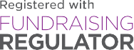

This event is held in aid of YoungMinds, registered Charity in England (1016968) and Scotland (SCO39700).




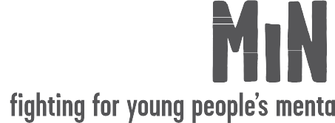
Come along and join the ﬁght for children and
We’re fundraising for
young people’s mental health.

Event: Location:

Date: Time: RSVP:

