

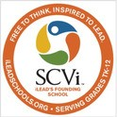
A Special Afternoon In The SCV


heart-centered
A Fundraiser To Support Youth & Teen Empowerment Programs
action project
Screening of the documentary "HEAL" & Q&A panel discussion
Located at - SCVi Charter School 28060 Hasley Canyon Rd.
Castaic, CA 91384
In the Shakespeare Theatre

Sunday, March 18th 12:30pm - 4pm

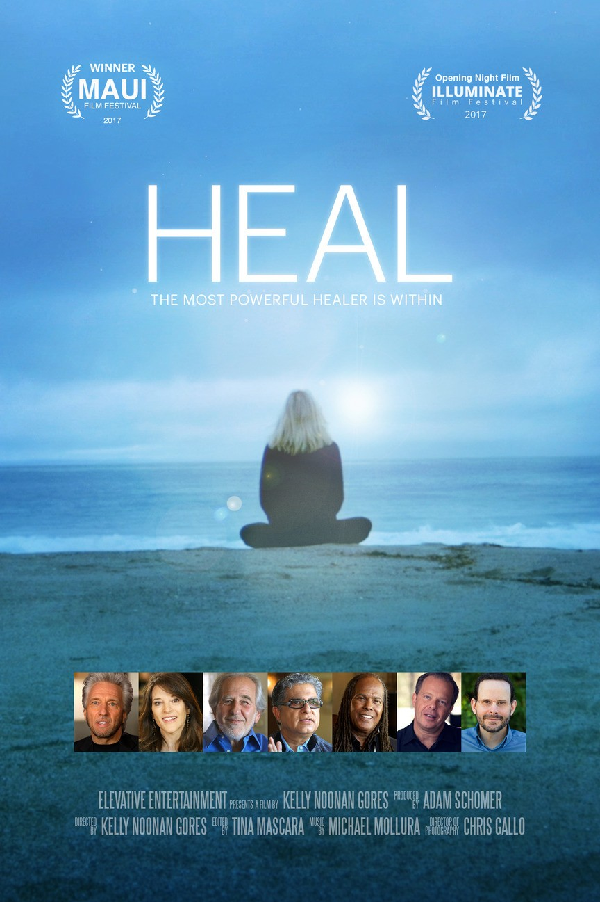

"HEAL" takes us on a scientific and spiritual journey where we discover that by changing one's thoughts, emotions and perceptions,the human body can heal itself from any
dis-ease."

All proceeds will be contributed SCVi Charter
School's youth & teen empowerment scholarship program.

Healing the our world starts in each one of us.

Purchase your tickets now at https://healscv.eventbrite.com

Tickets only $10

Schedule:

12:30 - 1:00
1:00 - 3:00
3:00 - 4:00
Special panel guests include: Patti Penn, EFT specialist & Eva her client - both featured in this film

Mary Tan, best selling author, adult & child empowerment coach
Claire Hartley, Co-Owner of Rising Lotus Yoga

Check-in & General Admission Seating Screening of the documentary "HEAL" Panel Discussion with Q&A

SCV wellness driven businesses will have an opportunity to be included in the digital resource guide given to all attendees & community with a small donation of $20.
We want to make this information accessible and is not limited to rage, race, gender, politics, or religion. This is about the collective wellness & individual empowerment.
For more information contact:
Terri 661-313-8373 or Christina 323-440-0174

