My goal is to raise $100 or more to help meet the overall goal of $800,000 (we are already halfway there!). This project is funded entirely by donations and involves no tax dollars or impact to our

Please check a box next to the amount that you are able to donate. For amounts of $100 or more your name will be placed at the entrance of the Cougar Stadium as well as placed in the program books.
Checks can be made out to Centennial High School Boosters/Turf Drive.






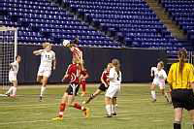




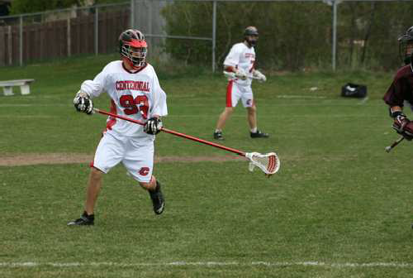



Contact Information:
Contact Name Street Address City State, ZIP Code Phone number Email address
Name wanted in game program and for personalized recognition at Stadium Entrance:

*Ex. Jones Family or John, Jill & Ryan Jones
If you have any questions, please contact:
Bob Kirchoff 651-470-6681
Mail this form and check back to:
Centennial High School c/o Activities Turf Drive 4707 North Road Circle Pines, MN 55014

On behalf of myself and Cougar Field Athletics - Thank you!
This is a tax-deductible donation under our 501c non-profit classification.
$100 Bronze
$250 Silver
$500 Gold
$1000+ Platinum
$ Other Amt.

