A REQUEST FOR YOUR HELP
“There is a time for building…”
Ecclesiastes 3:3
What’s the point of 30 New North Road?

DONATION FORM
I wish to make a donation towards the cost of renovating 30 New North Road into new Parish Rooms by sponsoring an item in the new building in the name of:


Would this building be missed?

Over the past six years our parish has settled into being a vibrant, prayerful and thriving community, with many activities going on across our three churches.
However, our function and meeting spaces are limited, and in some cases inaccessible to our older or infirm fellow
Please PRINT clearly the name of the ONE person or family name in whose name the ‘purchase’ should be recorded (alternatively, leave blank if you do NOT require the donation to be in the name of an individual or family)

YOUR DETAILS
Full name ( Mr. / Mrs. / Miss. / Other )
PARISH OF
THE HOLY REDEEMER
PARISH

parishioners.

We need to provide for them and for all
Address
parishioners, and by redeveloping this
beautiful house and returning it to use we can do that.

ROOMS
RENOVATION

Therefore I would ask you to support this parish fundraiser as generously as you
Postcode

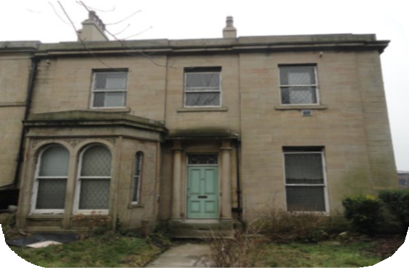Telephone Number

FUND

can.

Thank you.


Father Ian Smith
Parish Priest
Amount Donated

GIFT AID DECLARATION
(for completion if appropriate)
I wish my gift to the Parish Rooms Renovation Fund to be treated as a Gift Aid donation. I note that I must pay an amount of Income Tax or Capital Gains Tax at least equal to the amount of tax reclaimable on my donation to you during the current tax year.
Name (one tax payer’s name only here please)

Signature
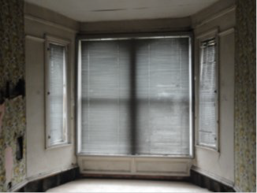

Date

The Parish of the Holy Redeemer is part of the Diocese of Leeds. Registered Charity #249404

All the information you need to know
to show how you can help develop new facilities for the parish

NEW PARISH ROOMS
The new parish rooms, at 30 New North Road, will be at the heart of every aspect of the church’s social and
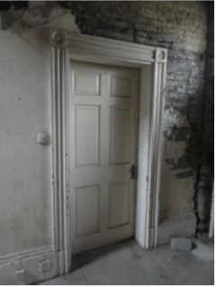

spiritual life for many years to come.
The new rooms will provide much needed ground floor meeting spaces, accessible to all.
In addition, development of the basement area will provide dedicated rehearsal space for the Choirs and musicians of the parish.
Finally, the first floor will be developed into two flats, which will provide future income for the parish.
WHY NOW?
First, the property had fallen into such a state of repair as to make it dangerous, so the roof has already been repaired and the exterior of the building made sound.
Secondly, there is a lack of suitable accommodation for the activities of the parish, and on too many occasions we have had to turn down opportunities for parish events due to lack of room.
Finally, we can no longer continue to do nothing about this property - and it is better that we put it to good use.

WHAT NEEDS DOING?
With this development, there will be a sympathetic modernisation of the inside of the property, which will enable the parish, and others, to use it for meetings, social events, courses and many other parish activities.

HOW MUCH WILL IT COST?
In total the parish needs to raise £75,000 to fully restore and furnish the building from its current state. Whilst this may seem a large amount, the space it will provide will be invaluable to the whole parish.
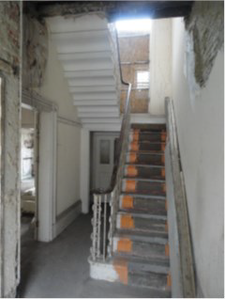

HOW CAN YOU HELP?
YOU have an opportunity to contribute to a wonderful development - a legacy for future generations - by sponsoring a part of the new building.
Sponsoring an essential item enable mean that individual donations will combine to help cover the cost of the redevelopment.
Sponsorship starts from a single brick at
£10 to the naming of a room at £10,000.
You can sponsor an item in memory of a departed friend or relative, in thanksgiving for a special event, as an unusual gift, or simply for yourself.
Families, schools and groups can help too by making joint purchases and by holding fundraising events.
Donors will receive a certificate of sponsorship, a letter of thanks and a Mass for Benefactors will be celebrated twice a year in the parish.

WHAT YOUR HELP BRINGS
By sponsoring an item you can donate a different amount depending on how much you wish to give:
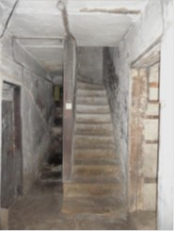

£10 for a single brick.
£50 for a door
£100 to renovate a window.
Alternatively you can sponsor something larger:
£500 for the lighting in one of the new meeting rooms
£1,000 to complete the electrics in one of
the new meetings rooms
£2,000 for a new boiler for one of the floors
£5,000 to furnish the new rooms
£10,000 to name one of the new meeting rooms
You may also wish to sponsor more than one item; for example £20 for 2 bricks.

WHAT TO DO NEXT!
To sponsor an item for the new parish rooms, please complete the form at the back of this leaflet.
You can either place it in an envelope marked ‘Parish Rooms’ into the Offertory Collection bags or send it to: Parish Rooms

Parish of the Holy Redeemer St. Patrick’s Presbytery,
34 New North Road, HUDDERSFIELD HD1 5JY
Cheques should be made payable to:

Holy Redeemer Parish

