
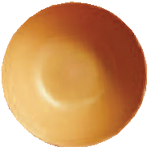








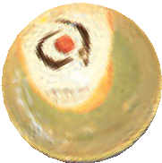
“filling bowls with food and love”
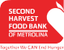






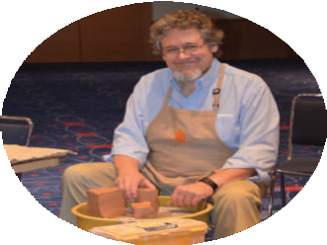





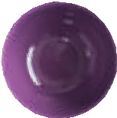

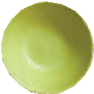





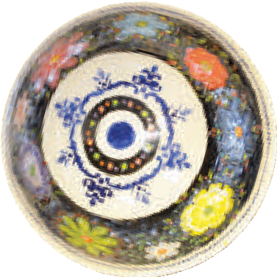

Empty Bowls is a fundraiser designed to raise awareness and funds in our battle to end hunger in the Metrolina region. Potters of all ages, skill levels and approaches to clay will donate hundreds of handmade pottery bowls. Guests will receive a delicious lunch, a handcrafted pottery bowl of their choice and a GoPlaySave Charlotte coupon book. The bowl then serves as a reminder that someone’s bowl is always empty and that we need to continue our efforts to alleviate hunger in our community. For the past several years this event has sold out and raised almost $100,000 for our organization!

Event to Benefit: Second Harvest Food Bank of Metrolina When: Friday, March 29, 2019 from 11:30am - 1:00pm Where: Charlotte Convention Center, Richardson Ballroom Guest Emcee: Maureen O’Boyle with WBTV News

We need your help! Second Harvest Food Bank of Metrolina is seeking gift certificates and product donations for the silent auction. Items may include, but are not limited to:

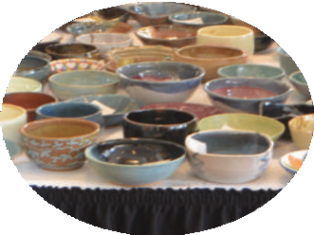
- Gift cards/certificates (retail, spa, admission tickets, restaurant, golf, hotel stays, travel, etc.)
- Gift baskets (spa items, food, beverages, pet products, toys, etc.)
- Individual items to be packaged into gift baskets

Should you wish to support our cause by generously donating an item, Second Harvest Food Bank of Metrolina will provide the following:

- Recognition in Empty Bowls program that over 500 attendees will receive
- A receipt for your donation including our Federal Tax ID number for your tax purposes
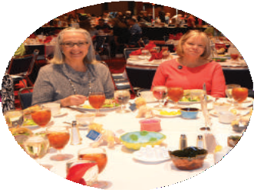

Please mail your donation to the following address: Second Harvest Food Bank of Metrolina Development/Wendy Nyberg
500-B Spratt Street Charlotte, NC 28206 OR
Contact Wendy Nyberg at wnyberg@secondharvest.org for pick up.

