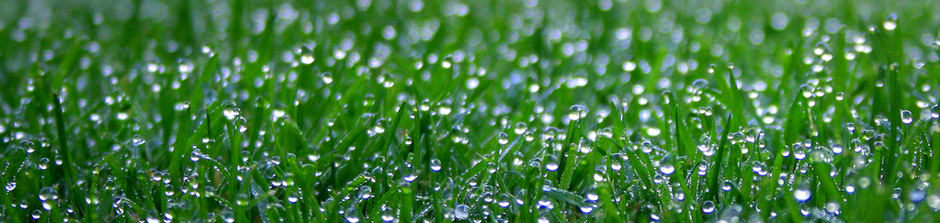

Special Offer: 10% off
your first service
General Maintenance
Lawn mowing and care ◊ Tree Surgery ◊ Path and driveway clearance ◊ Weeding and pruning
Landscaping
Hard landscaping ◊ Pond Installation ◊ Water feature installation ◊ Fence and pathway construction
Call Today:
562-654-5454

