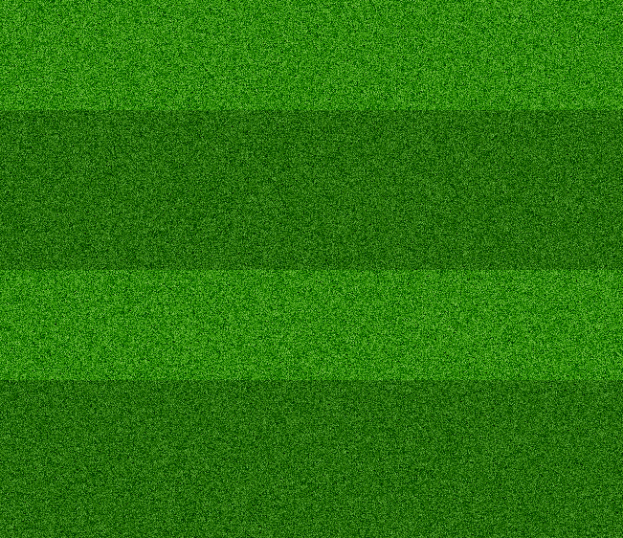

Free Estimates on first service
Special offers for regular clients
Your one Stop for High End Landscaping

Green Valley Landscapers
654-568-9882 ♦ abc@bcd.com ♦ www.bcd.com

