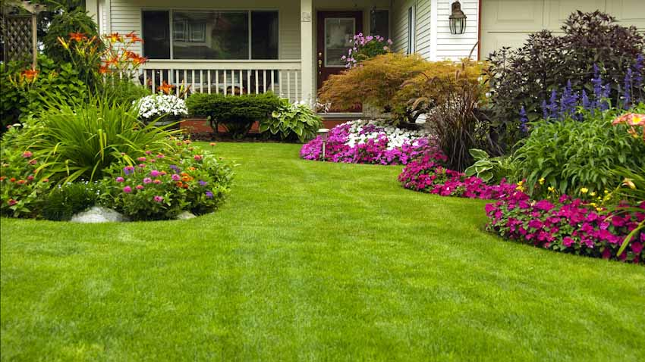
We are more than 20 years experienced in design and construction both local and international arena. we guaranty practicality, quality, sustainability, safety ,durability and cost effective using value engineering, review and management.

SPECIAL OFFER!
JULY ONLY! FIRST SERVICE 10 % OFF

- General Clean-up
- Mowing
- Shrub Trimming
- Bush Trimming
- Tree Trimming
- Flower Bed Installations
- Irrigation systems repair
- Landscape design & installations

Lawn care service

