
1
/2” Extra Plate Material
AMERICAN LEGION “PAY UP FOR LIFE”
/ RRD #4827 /
PT 1 FACE /
TAN,
468
286
BLUE
TEMPORARY MEMBERSHIP CARD
For questions regarding your American
Legion Membership or VA benefits, call
our Membership Service Number toll-free:
1-800-433-3318
Sample R. Donnelley
Temporary Member Number: 999999999
1
/2” Extra Plate Material
AMERICAN LEGION “PAY UP FOR LIFE”
/ RRD #4827 /
PT 1 FACE /
TAN,
468
286
BLUE
TEMPORARY MEMBERSHIP CARD
For questions regarding your American
Legion Membership or VA benefits, call
our Membership Service Number toll-free:
1-800-433-3318
Sample R. Donnelley
Member Number: 999999999

Page 4 of 4 decision to become a full-fledged member of The American Legion.
Serving those who served,
Daniel S. Wheeler
National Adjutant
P.S. To welcome you into The American Legion, I want to send you these 4 gifts:
•A Blue Star decal for you to display with pride if you currently have a family member serving in the Armed Forces
•Patriotic name-and-address labels
•An Armed Services Bumper Sticker
•A custom-designed Commemorative Lockback Knife honoring your
Branch of Service
To activate your membership, its full benefits, and receive your free gifts, remove the sticker from the front of this letter and affix it to your Activation Certificate. Then, mail your completed Certificate back today in the envelope
I’ve enclosed. Once we receive your completed Certificate, we’ll rush your Commemorative Knife to you and activate your full member benefits, discounts, and savings.

In recognition of your military service, and to welcome you into The American Legion, we want to send you this custom-designed
Commemorative Lockback Knife inscribed with your Branch of Service.
This extra-heavy-duty knife has a durable Polypropylene handle and is a full 8 ¹⁄2" inches when open but folds to a compact 4 ⁵⁄8". It comes with a Kelvlon™ belt pouch for carrying and has a limited lifetime warranty.
You’ll be proud to own this handsome tribute to your Branch of Service. Just take the sticker from your letter and affix it to your Activation Certificate. Then complete your Certificate – being certain to indicate your Branch of Service – and mail it back today in the enclosed pre-addressed envelope.
The American Legion makes every attempt to reach qualified veterans with our offer for membership. Because privacy laws prevent us from being absolutely certain that you are a qualifying veteran, you may have received this offer in error. If this is the case, please accept our sincere apology.
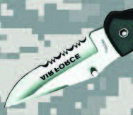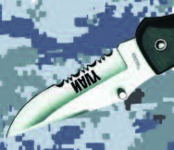As chartered by Congress, membership in

4827
PT 2 FACE COPY/IMAGING: 1510, 1511
LETTER /
286
BLUE W/SCREEN,
485
RED,
% 286 BLUE TONED,
10
,
BLACK
20
15
Important Notice:
In addition to the many discounts, savings, and member privileges
you receive as an American Legion member, you and your
dependents will also get expert assistance to help assure
that you get everything to which your family is entitled
from the U.S. Department of Veterans Affairs.
Save this card for when you
or your family have questions about
American Legion Membership benefits.
Place your
Branch of Service
sticker on your
Activation
Certificate to
receive your FREE
knife!
I am truly glad I located you.
You are
currently not receiving American Legion
benefits you may be qualified to receive as a
U.S. wartime veteran
. To immediately activate these
benefits, simply return your Activation Certificate.
Before you accept your nomination and your
benefits package, please verify that you
were on active duty in the U.S. military during
one or more of the periods listed on your
Activation Certificate.
Last year The American Legion
Department of Statename ...
•
Handled over 0,000 federal benefit claims
cases for veterans and their families.
•
Distributed $00,000 in emergency aid.
•
Provided honors for 0,000
veterans’ funerals.
ST
m
Dear Mr. Donnelley,
Congratulations, Sample R. Donnelley!
If you are a veteran who has served honorably
during wartime, you qualify for membership in
The American Legion and are hereby entitled to
all the benefits described in this package.
PT 1 CARD FPO
” to Label
4-1/4
SELECT
YOUR
BRANCH
OF SERVICE
/2” to Label
1
The American Legion is a singular honor reserved only

THE AMERICAN LEGION • BENEFITS DEPARTMENT • P.O. BOX 7017 • INDIANAPOLIS, INDIANA 46207-7017
Page 2 of 4 Page 3 of 4
for those who served our nation during wartime.
To reward you for your honorable service, The American Legion is authorized to offer you a full complement of benefits, multiple discounts on goods and services, and protection for you and your family.
Some of the many perks that await you as an American Legion member are:
- REDUCED rates at car rental agencies, moving companies, cruises, and thousands of hotels and motels.
- SAVINGS on eyewear for you and your family.
- DISCOUNTS on prescriptions through The American Legion drug plan. Plus ...
Access to a fully accredited American Legion Veterans Service Officer to help veterans obtain full VA medical, educational, and insurance benefits ... prepare your Vet claims and cut through all the red tape ... and get you accurate information on financial services.
The American Legion also helps veterans seeking career assistance through a network of partnerships. And The American Legion protects the interests of you, your family, and other veterans in Washington, D.C. For example, when the present administration tried to take away certain healthcare benefits, The American Legion was instrumental in derailing the proposal.
And in May 2014, in a strong protest over the treatment of our sick and wounded veterans, The American Legion called for the resignations of VA Secretary Eric Shinseki and two other top VA officials. Just weeks later, they resigned but while the change of executive leadership is a step in the right direction, there is still much to be done to save the VA.
4827

PT 2 BACK COPY 1513, 15XN
LETTER
BLACK
The American Legion continues to work hand in hand with the VA to ensure that veterans receive the quality and timely health care they earned. To that end, The American Legion’s Veterans Benefits Center events will continue across the country through 2015.
Your membership in The American Legion is the best way to show your support for your fellow veterans.
Yes, you can certainly profit from membership in The American Legion. But you will also help your fellow veterans, their widows, and orphans overcome hardship.
And your membership will also help your community by supporting everything from blood drives and hospital services to baseball and scouting.
Many veterans would give anything to join The American Legion. But unlike you, they don’t have the distinction of being a wartime veteran. So please, for your sake, don’t pass up this limited opportunity to stand with your fellow warriors in The American Legion. Activate your American Legion membership today and enjoy all the benefits described in the enclosed Benefits Summary.
That’s right, you get all the benefits, all the services, and all the camaraderie with membership in The American Legion. All for only pennies a day! And if you take advantage of just a couple of the many discounts, you’ll most likely earn the cost of your entire membership back.
So there’s no time like the present to join The American Legion. Please complete the Activation Certificate I’ve enclosed for you and return it to me in the envelope provided. You will not regret your
Page 4 of 4
is only $30 per year – that’s about 8.2¢ per day – and take advantage of the
many member benefits that will pay back your annual dues many times over!
Please don’t wait to respond.
You know that while serving our country, others were content to enjoy the benefits of your sacrifice. The same is true with your membership in The American Legion.
We can do the job without you, but we will be much stronger with you.

Please don’t delay any longer. I’m asking you – urgently – to reactivate your membership in The American Legion. Please complete your Activation Certificate, and mail it back with your $30 annual dues today.
Thanks.
Sincerely,
Daniel S. Wheeler
National Adjutant
P.S. You’ll find that I’ve enclosed some free address labels and a decal as a thank you for your past membership. I hope you’ll enjoy them, but please

treat the attached calling card more carefully. It has our Membership Support Center contact information and should be put in a safe place for when you or your family may have questions regarding your American Legion Benefits. And please, mail your completed Activation Certificate back today with your $30 annual dues. We need you back. I’ve enclosed a pre-addressed envelope

to speed your reply.

information for our Membership Support Center.
4827

PT 2 FACE COPY/IMAGING: 1510, 1511
LETTER /
BLUE W/SCREEN,
286
RED,
485
% 286 BLUE TONED,
10
,
BLACK
20
15
Important Notice:
In addition to the many discounts, savings, and member privileges
you receive as an American Legion member, you and your
dependents will also get expert assistance to help assure
that you get everything to which your family is entitled
from the U.S. Department of Veterans Affairs.
Save this card for when you
or your family have questions about
American Legion Membership benefits.
Place your
Branch of Service
sticker on your
Activation
Certificate to
receive your FREE
knife!
In recognition of your service, patriotism and commitment to
our country, and to the United States Army, it’s my honor to award
you with the enclosed “Certificate of Military Service.”
Your military service made a difference.
Today, our country is free because of the service of people
like you. You can take pride in knowing that your military service
helped make the United States of America the greatest country
on Earth.
Yet your membership in The American Legion has now expired.
Reactivating your membership –and the accompanying benefits –
is easy. Just fill-in the Activation Certificate I’ve enclosed, and mail it
back today.
Your benefits will be reactivated quickly.
And with hope that you won’t be leaving us, I’ve attached the contact
Dear Sample R Donnelley,
Sample R. Donnelley
1234
Any Street
Cityname, ST 56789
To honor your service in the Coast Guard, The American
Legion provides you and your family with a full complement of
member-only services, added benefits and discounts.
ST
m
PT 1 CARD FPO
” to Label
4-1/4
SELECT
YOUR
BRANCH
OF SERVICE
/2” to Label
1
Keep this card in a safe place so it will be handy anytime you or your family need help – or have questions – about your member benefits. Our Member Support
THE AMERICAN LEGION • BENEFITS DEPARTMENT • P.O. BOX 7017 • INDIANAPOLIS, INDIANA 46207-7017
Page 2 of 4 Page 3 of 4

Specialists can use their expertise and experience to ensure that you’re taking advantage of all The American Legion benefits and programs that you’re entitled to and they can connect you with other resources when dealing with veteran issues such as VA benefits.
Additionally, by reactivating your membership in The American Legion today, you’ll get added veterans benefits, member-only services and exclusive savings including:
- Reduced rates at car rental agencies, moving companies, cruises,and thousands of hotels and motels
- Discounts on eyewear for you and your family
- Additional savings through The American Legion’s prescription drug plan
- Subscription to our monthly publication, The American Legion Magazine
You can see more of the benefits of membership on the Summary of Membership Benefits page that I’ve also enclosed. It’s a long list of savings and benefits, but reactivating your membership serves an even greater purpose.

Why your membership matters
Today, The American Legion is the nation’s most influential, effective and

dependable advocate of veterans issues... fighting for better active-duty pay...

improved housing for active-duty families... improvements to help the VA’s medical system... plus our ongoing efforts to help you and your family get the full medical and educational benefits you’ve earned.
No other organization does more for America’s veterans than The American Legion. Last year alone, we...

- Managed 8,496 disability claims appeals for veterans and provided direct financial support to struggling military families.
- Attended more than 100 different congressional hearings and worked with Congress to pass 13 bills that benefit veterans and their families including legislation to improve GI Bill benefits, caregiver relief,
4827

PT 2 BACK COPY 1513, 15XN
LETTER
BLACK
in the U.S. Armed Forces.
- Distributed comfort items for troops recovering from war wounds in our military hospitals and transition units through Operation Comfort Warriors.
- Participated in 116 veteran job fairs to help veterans in need of work.
- And currently, we continue to work hand in hand with the VA to ensure that veterans receive the quality and timely health care they earned. To that end, The American Legion’s Veterans Benefits Center events will continue across the country through 2015.
Friend, there’s no better way to honor your fellow veterans, your family and your community than by reactivating your membership in The American Legion.
Even if you haven’t taken advantage of your member benefits, or don’t have time to visit your local Post, we need to include you on our roster.
Because much of our influence in Congress comes from our large number of members, if you leave us, it can hurt our political effectiveness.
And with an increasing number of veterans returning home from Iraq and Afghanistan, the aging population of veterans from earlier wars, plus planned budget cutbacks, this is not the time to weaken our influence.
I’m urgently asking you to reactivate your membership today.
You know the sacrifices the brave men and women still on active duty – along with their families – make every day.
You also know how difficult it is for active duty personnel to speak out for themselves. Even retired veterans find it tough to get decent medical care and other promised benefits through VA.
Yet The American Legion always finds a way to get things done. The American Legion makes a difference – for you, your family and for your fellow veterans – and we can’t afford to lose you.
Please, reactive your membership now. Membership in The American Legion

VA medical facilities and career opportunities for those who served

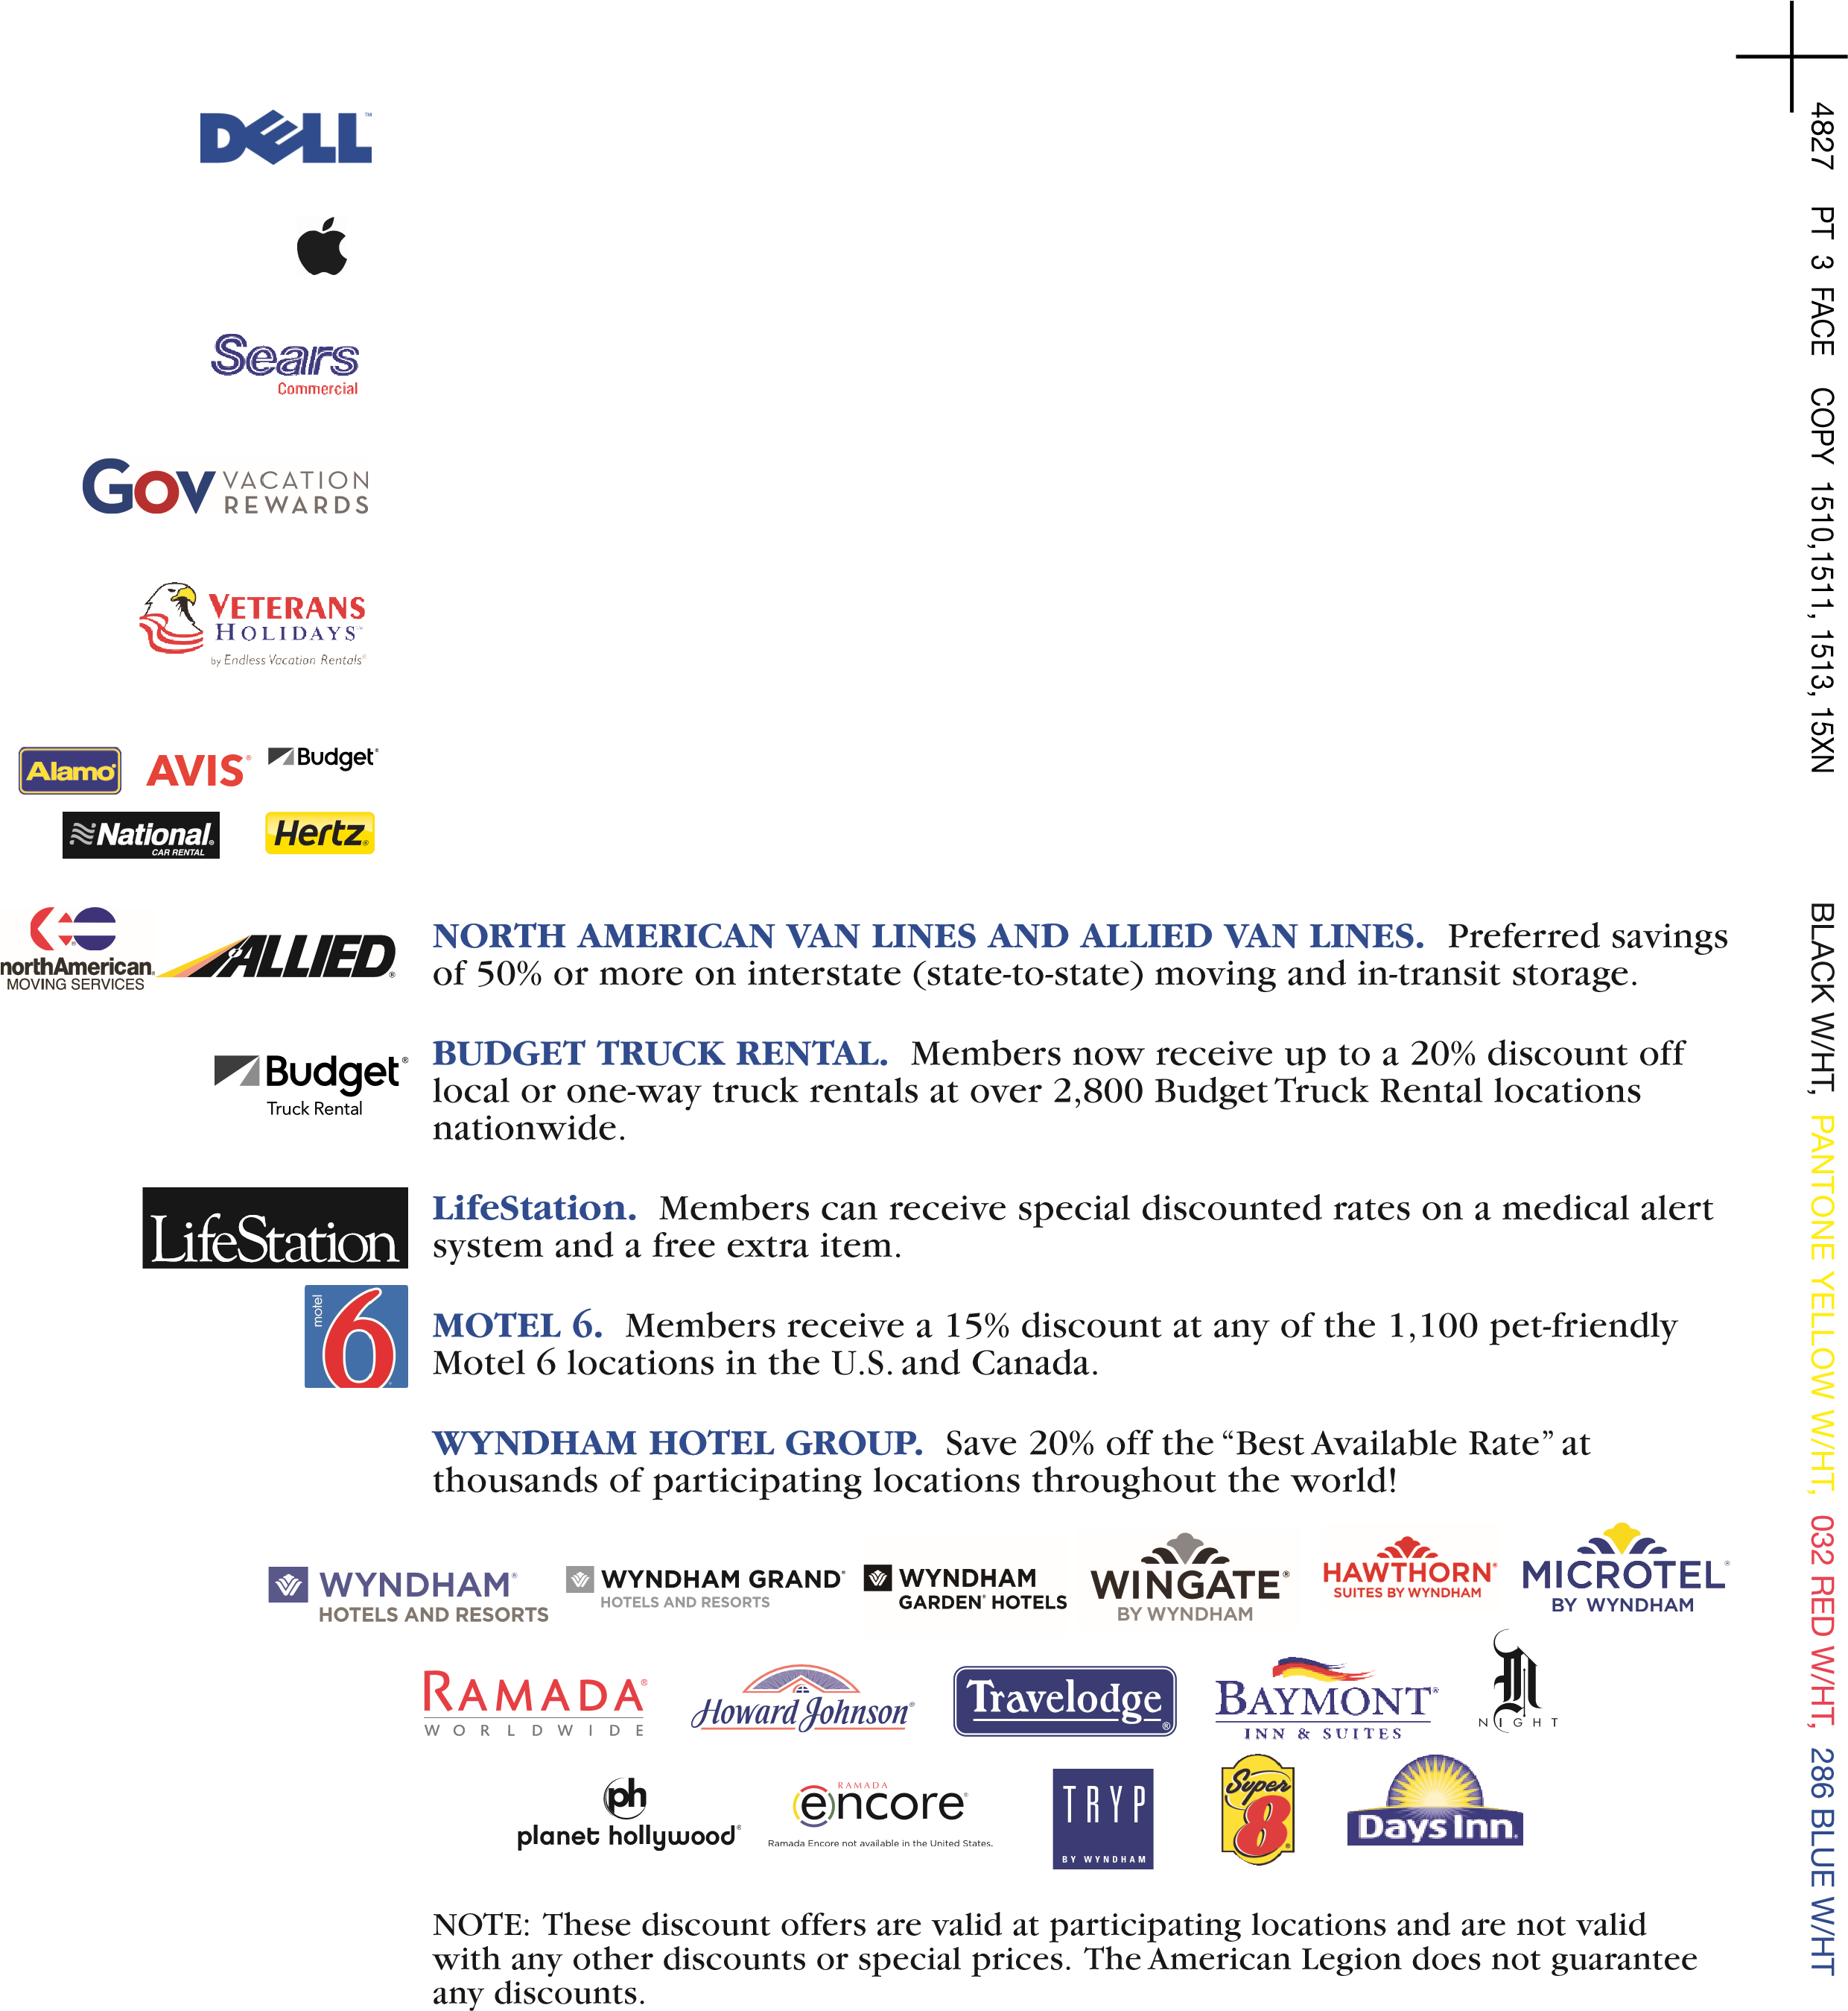
DELL COMPUTERS. Members can save up to 30% off tablets and computers and receive discounts on electronics/accessories.
APPLE COMPUTERS. Now you can save up to 17% on select Apple and third party products.
SEARS COMMERCIAL. Exclusive member discounts on appliances and major household items are available through a toll-free number.
A Blue Star Service Banner displayed in the window of a home is an American tradition. The banner lets others know that someone in the home is proudly serving on active duty in the
U.S. Armed Forces. Order your Blue Star Banner from The American Legion National
Emblem Sales. Call toll-free 1-888-453-4466 or order online at www.emblem.legion.org.
GOV VACATION REWARDS. Members can get the best discount available on travel including airfare, hotel, car rental, vacation packages, cruises, and more.

VETERANS HOLIDAYS. This program offers members the opportunity to rent a furnished condominium for 2-8 people, for an entire week, for less than they would pay for a single hotel room.
AUTO RENTALS. Members can receive special discounts with AVIS, BUDGET, ALAMO, HERTZ or NATIONAL CAR RENTAL. Save 5-25% on daily, weekly and monthly rates. Note: These discount offers are valid at participating locations and are not valid with any other discounts or special prices in the U.S.

BENEFIT ASSISTANCE -
Helps all veterans in obtaining full veteran medical and educational benefits,
as well as assistance in preparing VA claims.
VETERANS REPRESENTATION -
The American Legion is the most effective and dependable
advocate of veterans issues and is fighting for better pay for those on active duty and improved
housing for their families. In May 2014, to protest the VA’s poor oversight of its medical services, The
American Legion called for the resignations of top VA officials. Sick and wounded returning from
deployment must have timely and quality medical care!
VETERANS EMPLOYMENT -
The American Legion works with the Department of Labor on National
Employment and Training Programs for veterans and with the President’s Committee on Employment
of People with Disabilities and its Committee on Disabled Veterans.
MEMBERS’ MONTHLY MAGAZINE -
You’ll receive a full year’s subscription to
The American
Legion Magazine
. Each issue is packed with news, articles and stories designed for America’s veterans.
myLegion.org
-
This website is designed to connect members of The American Legion to their
Post and Department (state) leadership, other veterans with similar interests, and the vast array of
services offered at every level of the organization.
DISCOUNT PRESCRIPTION DRUG PROGRAM -
Members and dependents can save up to 20% or
more through CVS/CAREMARK.
LIFELINE SCREENING-
Member discounts on potentially life-saving health screenings.
Summary of American Legion Benefits Reserved for U.S. Military Veterans
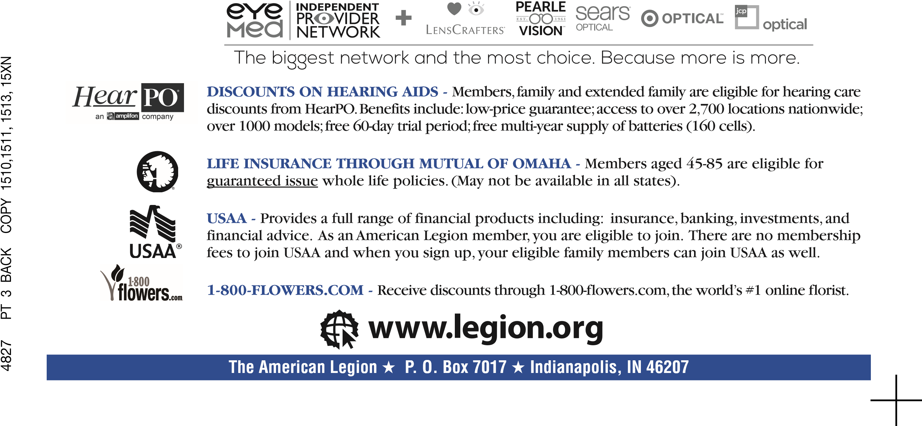
EYE CARE/WEAR PLAN - EyeMed Vision Care provides discounts on the costs of eye examinations and eyewear. Members and dependants can save up to 40% off vision care products and services purchased at network locations.
BLUE W/SCREEN,
286
BLACK


NATIONAL ADJUTANT
C
e
r
t
i
f
i
c
a
t
e
o
f
N
o
m
i
n
a
t
i
o
n
FOR HONORABLE SERVICE IN THE
UNITED STATES ARMED FORCES
AND FOR OUTSTANDING SERVICE AND LOYALTY
TO THE UNITED STATES OF AMERICA
THIS CERTIFIES THAT
UPON MEETING THE STRICT REQUIREMENTS
SET FORTH BY THE
CONGRESS OF THE UNITED STATES
FOR MEMBERSHIP IN THE AMERICAN LEGION.
SAMPLE R. DONNELLEY
PT 4 FACE COPY 15XI-15XN, 1513 IMAGING 15XK, 15XL, 1513
50
% COOL GRAY 5 TONED HT,
139
GOLD W/SCREEN,
286
BLUE W/HT,
BLACK
NATIONAL ADJUTANT
FOR HONORABLE SERVICE IN THE
UNITED STATES ARMED FORCES
AND FOR OUTSTANDING SERVICE AND LOYALTY
TO THE UNITED STATES OF AMERICA
THIS CERTIFIES THAT
HAS MET THE STRICT REQUIREMENTS
SET FORTH BY THE
CONGRESS OF THE UNITED STATES
FOR MEMBERSHIP IN THE AMERICAN LEGION.
SAMPLE R. DONNELLEY
PT 4 FACE COPY 15XI-15XN, 1513 IMAGING 15XK, 15XL, 1513
50
% COOL GRAY 5 TONED HT,
139
GOLD W/SCREEN,
BLUE W/HT,
286
BLACK
C
e
r
t
i
f
i
c
a
t
e
o
f
M
i
l
i
t
a
r
y
S
e
r
v
i
c
e
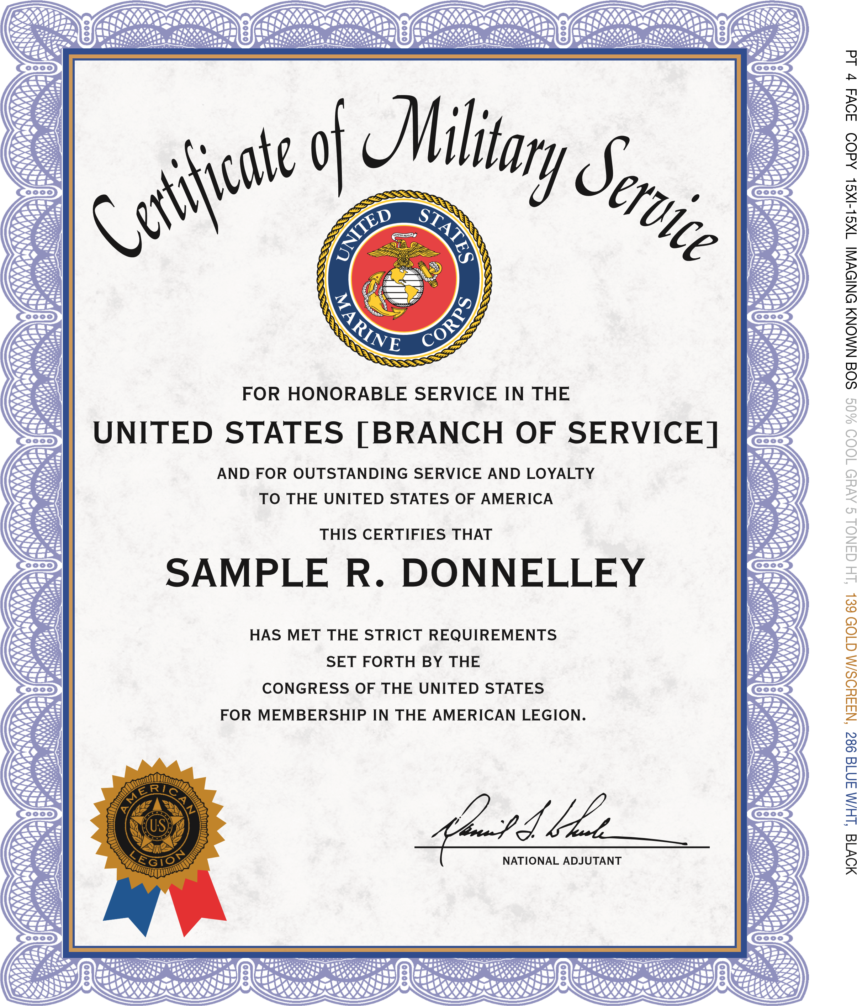

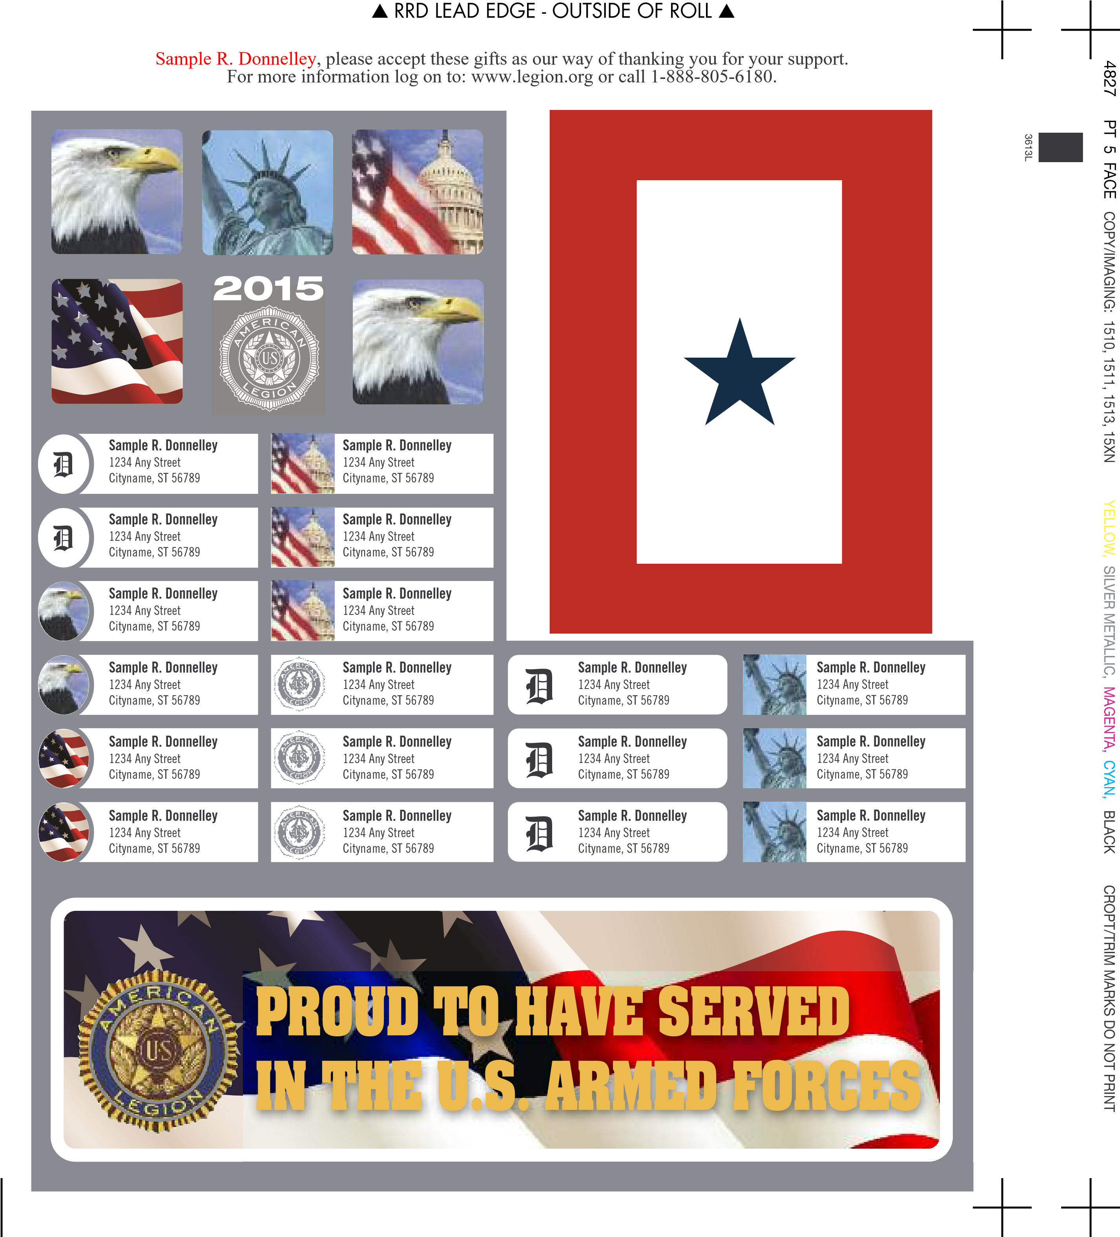

Questions & Answers
The American Legion
Q. How do I join The American Legion?
A. Simply complete the enclosed Activation Certificate and mail it back today with your annual membership dues. A pre-addressed envelope is included to speed your reply. You can also join online by going to www.legion.org/mailoffer or over the phone by calling 1-888-805-6180.
Q. How do I know if I qualify for membership in The American Legion?
A. Look on your Activation Certificate. If it lists your dates of military service, and if you served honorably, at least one day of active duty, you qualify for Legion membership. If you are still serving on active duty, in the Reserves or National Guard, you also are eligible to join.
Q. Why is membership in The American Legion limited to certain periods?
A. The American Legion was chartered by the U.S. Congress in 1919 as an organization of wartime veterans. Our membership eligibility dates parallel dates set by Congress for wartime service.
Q. Why should I join The American Legion?
A. Your membership in The American Legion allows you to take full advantage of your status as a wartime veteran and receive additional American Legion benefits to which you are entitled. With your membership, you also support the troops presently serving and honor the other men and women in the United States military who have given so much for our country. And as a Legionnaire you’ll have the opportunity to build friendships and camaraderie with fellow wartime veterans and continue your service to America.
CROPT/TRIM MARKS DO NOT PRINT
Q. What types of service activities are Legionnaires involved with, and how do they contribute to my community?


A. The American Legion was instrumental in the creation of the Veterans Administration (VA) and having the VA elevated to a cabinet level agency and designated as the Department of Veterans Affairs. The Legion is also universally recognized as the originator of the GI Bill of Rights and it continues to work to maintain the rights and benefits earned by veterans through service to their country. Legionnaires are also deeply involved with community activities ranging from hospital services and blood drives to youth programs such as the Boy Scouts, the National High School Oratorical Contest, American Legion Baseball, scholarships and the annual American Legion Boys State/Boys Nation programs.
4827

PT 5 BACK COPY 15
13
, 15XN
2965
BLUE
about

RRD LEAD EDGE

Q. If I join The American Legion, how involved in its service programs will I become?
A. That’s strictly up to you. Some members are more involved than others, but all members are encouraged to find a level of involvement that’s comfortable for them.

4827 PT 6 BACK COPY 15XI-15XN, 1513, IMAGING 1513

20% 465 TAN TONED SEAMLESS, 20% PROCESS YELLOW TONED, BLACK W/SCREEN
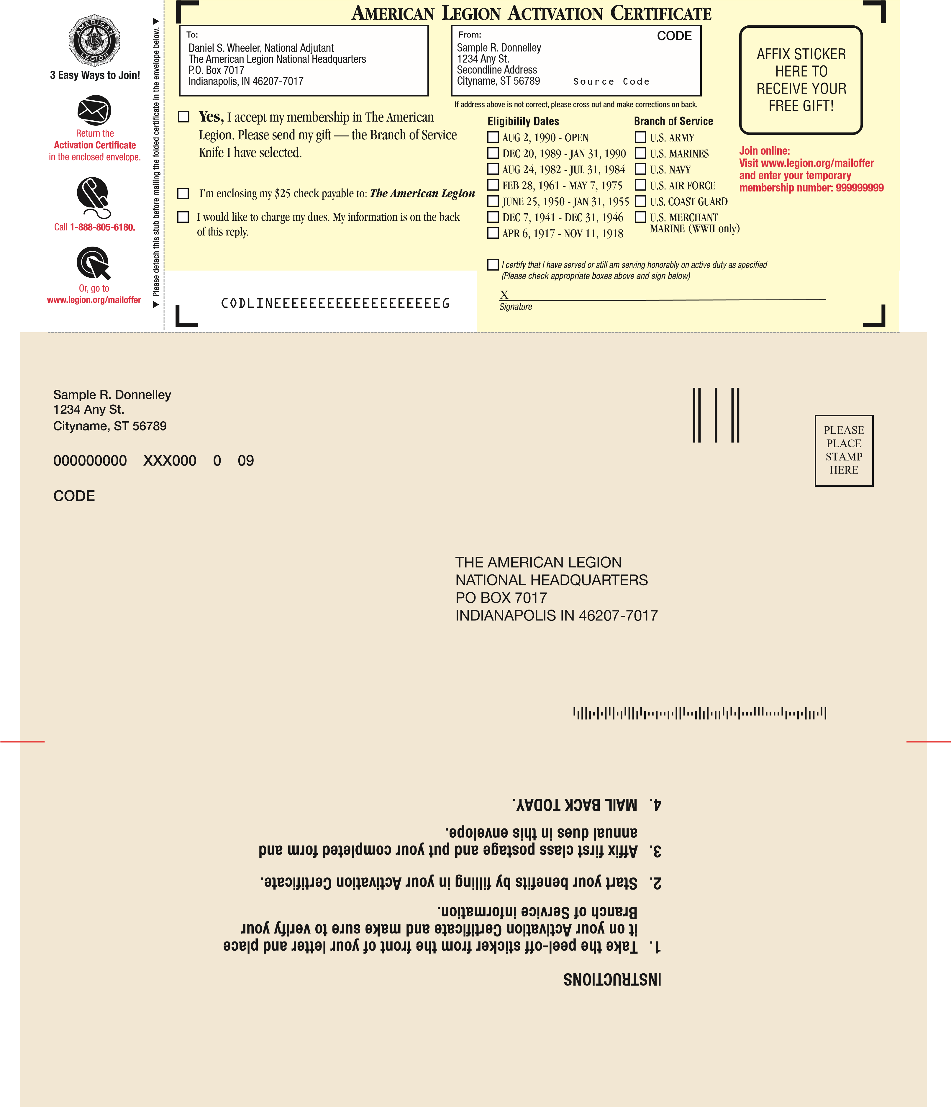
4827 PT 6 BACK COPY 15XI-15XN, 1513, IMAGING 15XN

20% 465 TAN TONED SEAMLESS, 20% PROCESS YELLOW TONED, BLACK W/SCREEN
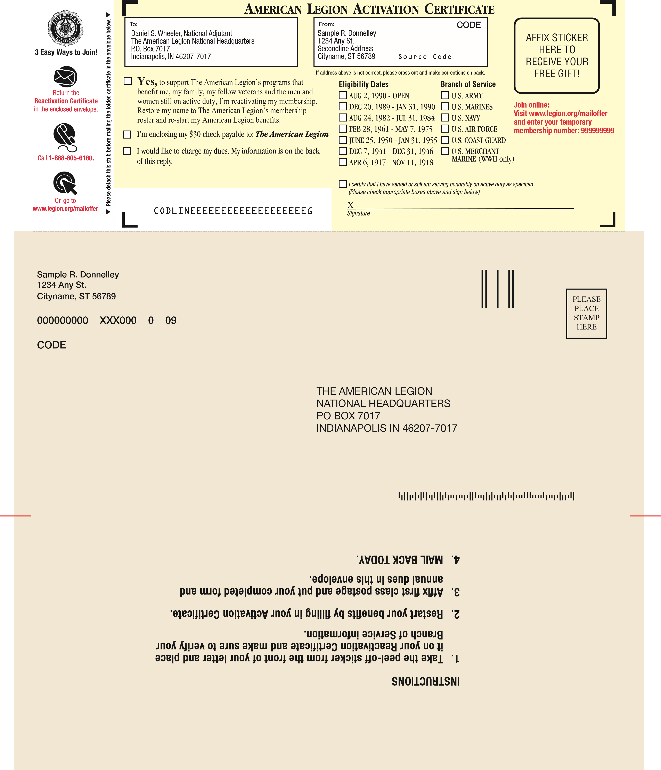

IMPORTANT INFORMATION
Credit Card Information:
Visa

MasterCard
Discover
AmEx Account No._______________________________ Exp. Date_______
Date of Birth:
-
-
Phone Number:
-
-
Email Address:____________________________________________________________________
X
SIGNATURE
DATE
SECURITY CODE
MM
D
D
YY
Please Make Any Address Corrections Here if Necessary:
Name
______________________________________________________________________
Address______________________________________________________________________
City___________________________________________ State _____________ Zip __________
THE AMERICAN LEGION
NATIONAL HEADQUARTERS
P.O. BOX 7017, INDIANAPOLIS, IN 46207-7017
By entering your email you are agreeing to receive future communications from The American Legion. We do not rent or sell your email address or any of
your personal information to any third party.
4827
PT 6 FACE COPY
ALL BUT 15PA
BLACK W/SCREEN

Female:

Male:

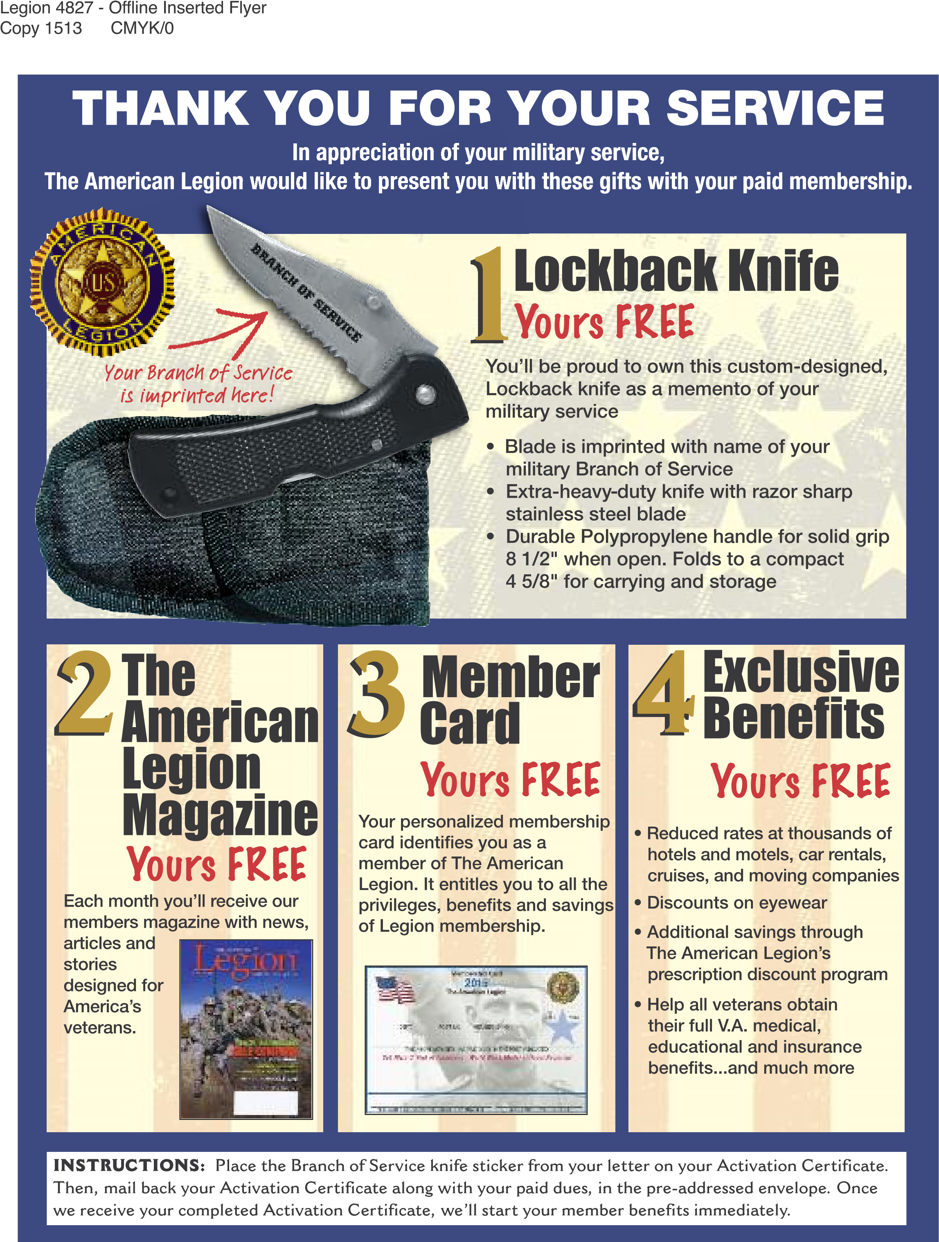

4827 PT 7 BACK COPY 15XI-15XL, IMAGING UNKNOWN BOS 40% 1205 YELLOW TONED, BLACK W/HALFTONE, 1807 RED

NONPROFIT ORG
U.S. POSTAGE
PAID
THE AMERICAN
LEGION
The American Legion National Headquarters
P.O. Box 7017 • Indianapolis, IN 46207
Certificate of Military Service Enclosed
for
Service. Patriotism. Commitment.
Sample, in recognition of your service
in the United States Armed Forces
Sample R. Donnelley
1234
Any Street
Cityname, ST 56789-1234
4827 PT 7 BACK COPY 15XI-15XN, IMAGING 15XI, 15XJ, 15XM, 15XN 40% 1205 YELLOW TONED, BLACK W/HALFTONE, 1807 RED
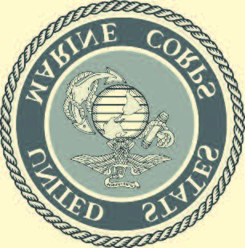
NONPROFIT ORG
U.S. POSTAGE
PAID
THE AMERICAN
LEGION
The American Legion National Headquarters
P.O. Box 7017 • Indianapolis, IN 46207
Certificate of Military Service Enclosed
for
Service. Patriotism. Commitment.
Sample, in recognition of your service
in the United States Marine Corps
Sample R. Donnelley
1234
Any Street
Cityname, ST 56789-1234

