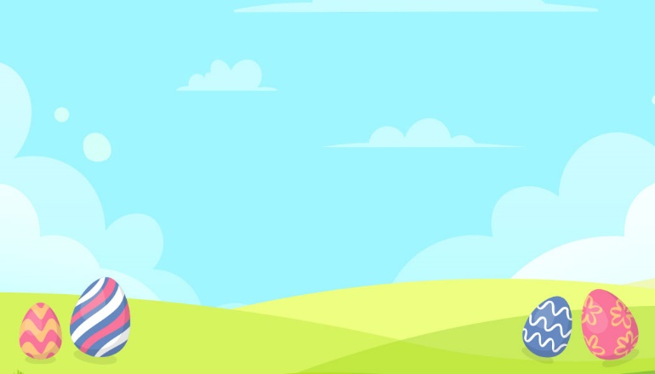
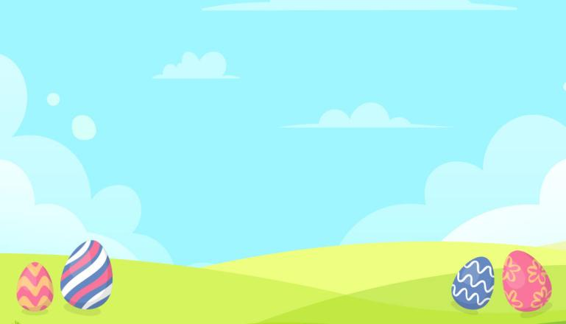
Mary
Harley
Mary
Harley
Simon
Hi, My name is
Happy Easter Day!
Happy Easter Day!
Hi, My name is
John
Hi, My name is
Happy Easter Day!
Hi, My name is
Happy Easter Day!
Simon
Hi, My name is
Happy Easter Day!
Happy Easter Day!
Hi, My name is
John
Hi, My name is
Happy Easter Day!
Happy Easter Day!
Hi, My name is

