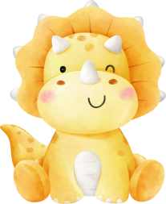
Hello!
My name is,
OLIVIA

