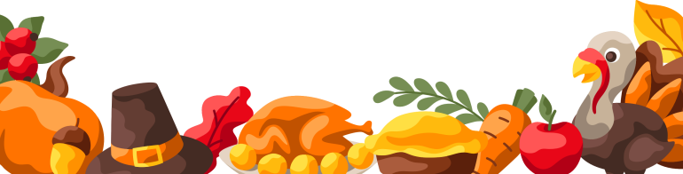
HAPPY THANKSGIVING
SAMIRA HADID

