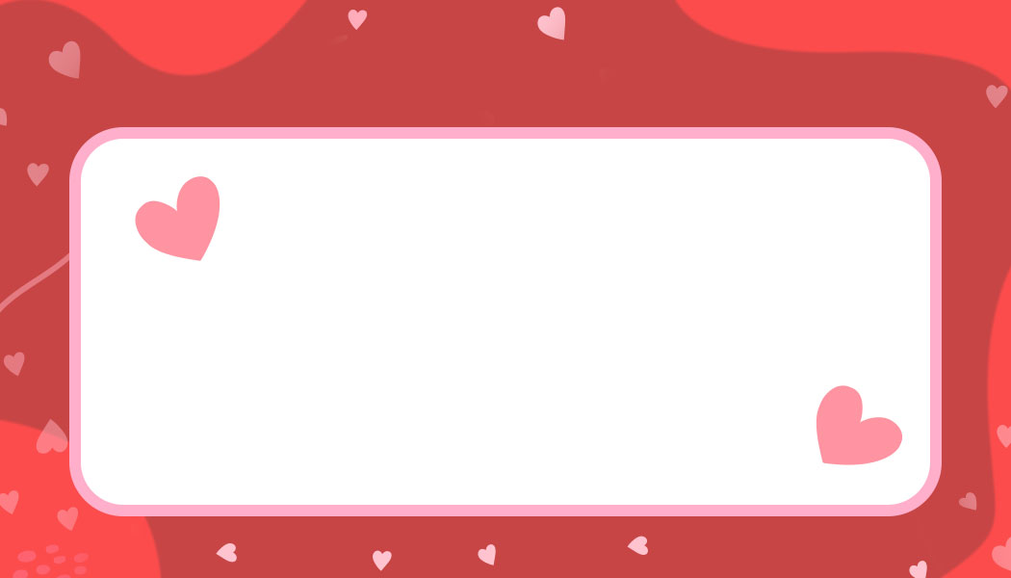
Happy Valentines Day!
Happy Valentines Day!
Happy Valentines Day!
Anne Marie
Scott
Mary
John
Happy Valentines Day!
Happy Valentines Day!
Happy Valentines Day!
Mary
John
Happy Valentines Day!
Scott
Anne Marie
Happy Valentines Day!

