
Pretend Passport American
by Donna Ward/Northwoods Press
Pretend Passport Instructions:
Cover:
Print cover page. Make a horizantal fold to show cover.
Make a vertical fold to make into booklet. Use a glue stick around the underneath edges.
Inside Pages:
Inside pages can be plain white paper, printed in grayscale, or printed in colour as shown. Print two sided and cut, or print one sided and fold as in cover.
Staple inside pages to the cover or stitch binding using thread.
There should be 16-24 inside pages in total. Each page counts as 4 inside pages.
Trim edges of booklet with paper cutter or steel ruler and box cutter on a cutting board. There is a print trim allowance around edges.
For large quantities, an instaprint service might be more economical than a home printer.
History of Passports
A passport is a document which certiﬁes the identity and nationality of its holder for the purpose of international travel. It is issued by a national government.
One of the earliest written records of a passport type document was in the Old Testament in Nehemiah 2:7-9 at the time of the Persian Empire, about 450 BC. The king’s ofﬁcial, Nehemiah, asked to travel to Judea, and King Artaxerxes I gave him a letter to guarantee safe travel through foreign lands.
Passports as we know them today, originated from a conference by the League of Nations in 1920. It was recommended at that time that passports be issued in French and one other language. Now, it is recommended that passports be issued in French or English, or in the national language of the issuing country and in French or English.
Created by Donna Ward/Northwoods Press. Some rights reserved. www.donnaward.net
Free Printables: https://www.donnaward.net/news.php?cat_id=6
Not to be sold.
This ﬁle is licensed under Creative Commons Attribution ShareAlike 2.0 License (cc-by-sa-2.0). In short: you are free to share and make derivative works of the ﬁle under the conditions that you appropriately attribute it, and that you distribute it under this or a similar cc-by-sa license. http://creativecommons.org/licenses/by-sa/2.0/
Bald Eagle Day 137 - courtesy of Steve Ryan, Groveland, CA, USA licensed under cc by sa, retrieved from Wikimedia Commons

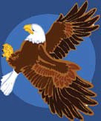
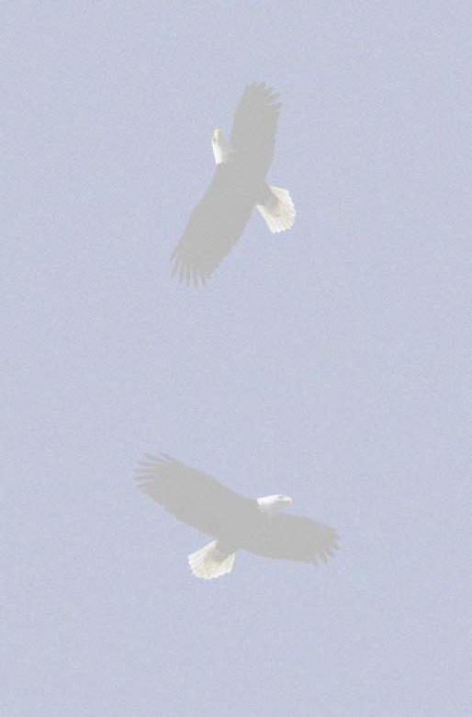
Cover Page
STATES OF

Donna Ward/Northwoods Press www.donnaward.net

UNITED AMERICA

PASSPORT

United States of America

Surname/Nom

Given names/prénoms

Nationality/Nationalité

Date of Birth/Date de naissance

Sex/Sexe Place of birth/Lieu de naissance

Date of issue/Date de délivrance

R5039402345967<1USA30492340<<<<<<<<<<<<<<<<<<<<<<<<<<<<<<<<<<<<<<00

Photo

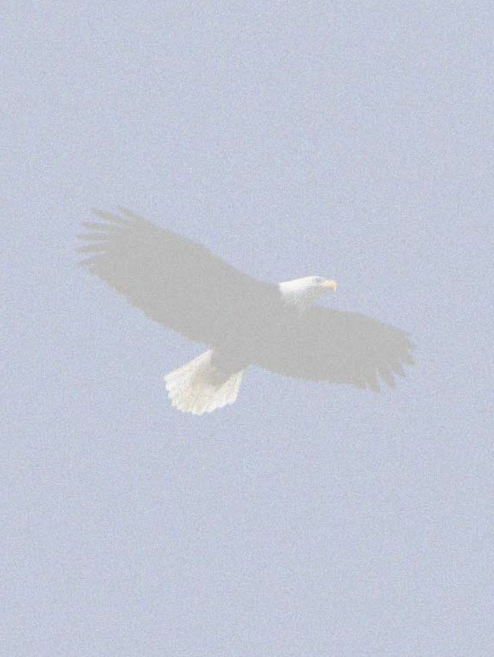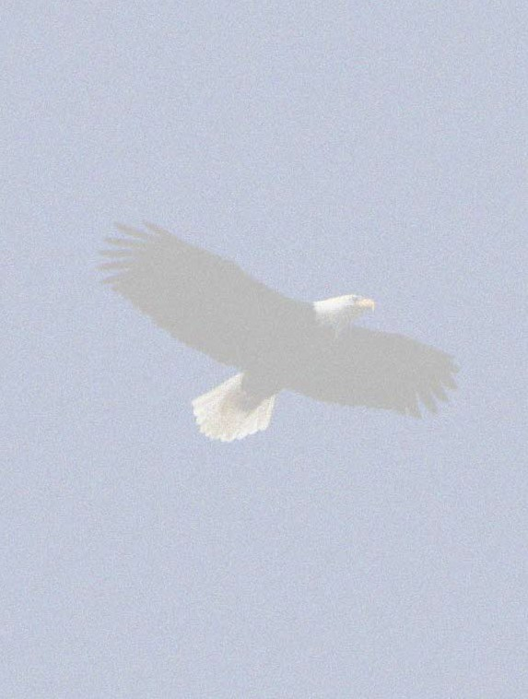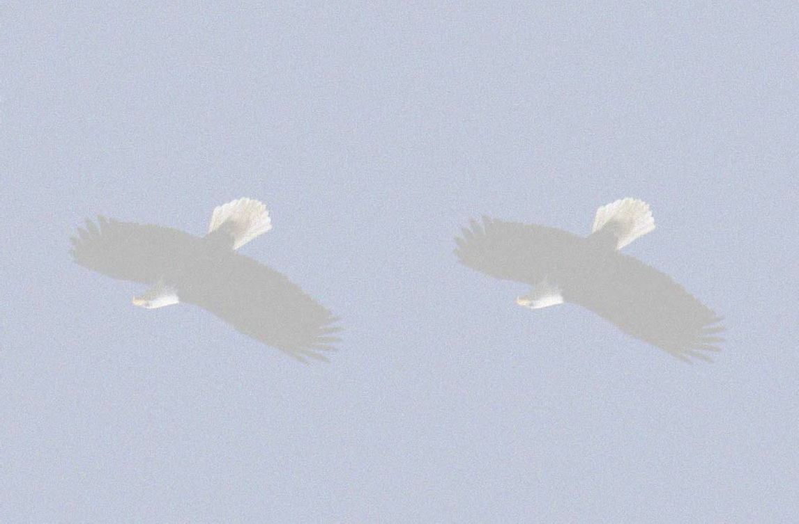
Inside Pages

