
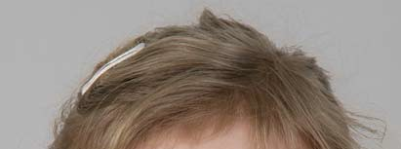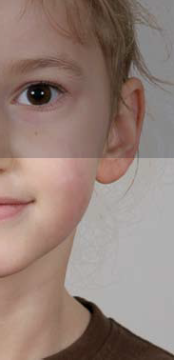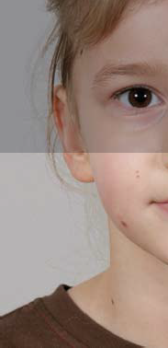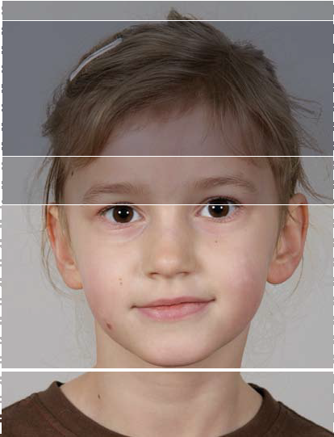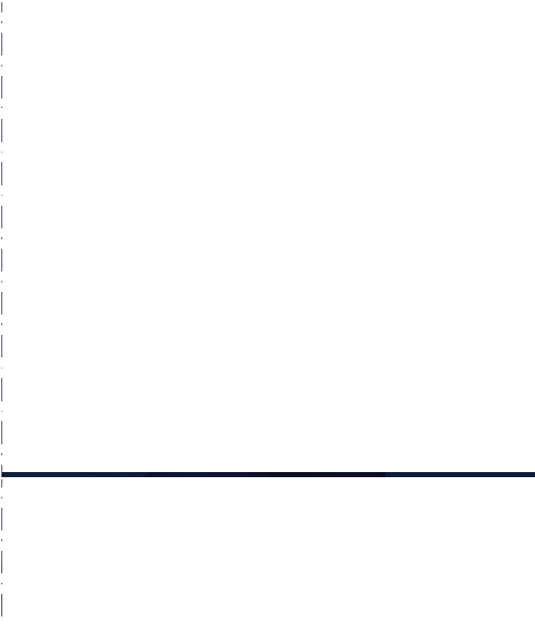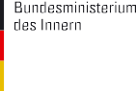
PASSPORT PHOTO TEMPLATES FOR CHILDREN AGED 6 TO 9
Step 1
Step 1: example
Maximum height of eyes
Minimum height of eyes
Middle of the nose within dark grey band
Step 2
Step 2: example
Maximum height of face tolerated
Optimal height of face no more than 36mm
Optimal height of face no less than 22mm
Minimum height of face tolerated
Chin line

Step 1: CHECK EYE AREA
- Line up template with upper left edge of photo
- Does the photo measure 35 x 45mm?
- Do the eyes lie within the horizontal grey band?
- Are the eyes roughly level?
- Are the eyes open and clearly visible?
- Does the middle of the nose lie within the vertical dark-grey band?
Step 2: CHECK SIZE OF FACE
- Move template so that the chin line touches the bottom of the chin
- Does the top of the head lie within the darker grey band (ideal face height)?
- Does the top of the head lie within the lighter grey band (allowable face height)?
POSITION OF HEAD AND FACIAL EXPRESSION
- Is the head straight (not tilted or turned)?
- Head and shoulders facing forward?
- Neutral facial expression?
- Mouth closed?
FOCUS AND CONTRAST
- Is the photo in sharp focus with proper contrast?
LIGHTING
- Are face and background uniformly illuminated (no shadows)?
BACKGROUND
- Plain background?
PHOTO QUALITY
- Black-and-white or colour photos are acceptable
- With colour photos: does the colour reproduce the natural skin tones?
- Is the photo clean, undamaged and free of creases?
GLASSES
- Are the eyes clearly visible and not covered?
PLEASE NOTE:
For children aged 5 and under, it is not necessary to capture
a facial biometric. Photos of children aged 5 and under must be 35 x 45mm and fulfil only the requirements for frontal view, focus and contrast, lighting, background and photo quality listed above.

