

PASSPORT INVITATION TEMPLATE (5 pages)
by Aylee (www.ayleebits.com)

This template including all its components are licensed under a Creative Commons Attribution-Noncommercial-Share Alike 3.0 License.

By receiving and/or using this template, you agree to the following terms:

- You will provide credit to the author or designer and a link to www.ayleebits.com.

- You may not use this template for commercial purposes. No form of revenue must result from the use of this template.

- You must keep this page (first page) intact when sharing this template.

- If you alter, transform, or build upon this work, you may share the resulting work only under the same or similar license, and must comply with the previous terms.
This template makes a passport that has no print on the back of cover. If you want to print text on the back of the cover and glue pages, use template #1.

INSTRUCTIONS

- Edit the template according to your specifications. Use the page numbers as reference for the order of the pages. For additional pages, use page 5 and copy as many times as needed.
- Print page 3 on the back of page 2.
- Print page 5 on the back of page 4.
- For the additional pages, print the additional pages (page 4 and 5) back to back.
- Cut on gray solid lines.
- Stack together and fold in the middle.
- Attach the pages either by stapling or sewing in the middle.

Please be aware that this template does not include support and tutorials on programs/software needed to use this template. Consult the program/software manufacturer for help.

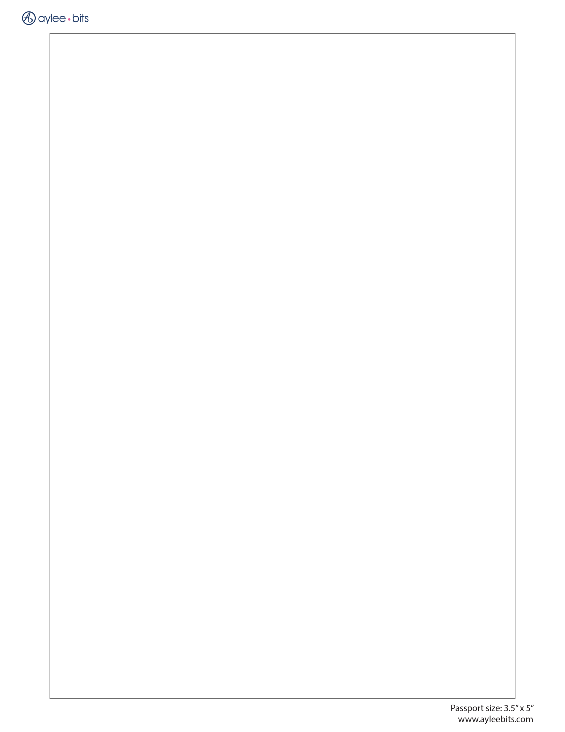
Insert an image,
your monogram or logo here.
Insert an image,
your monogram or logo here.
Page 1 (cover)
PASSPORT
BRIDE and GROOM
BRIDE and GROOM
PASSPORT

8
HEADING
HEADING
8
BRIDE’S NAME
GROOM’S NAME
Names
COUPLES’ NAMES

Date of Wedding Time of Wedding
3 MAY 2008 4:00 PM

Location of Wedding Place of Wedding
HILTON BARBADOS ST. MICHAEL, BARBADOS

Passport Number
070707

Accommodations / Travel Info
See page #
BRIDE<GROOM<<LOCATION<<DATE<<<<<<<<<<<<<<<<<<<<<<<<<<<<<<
BRIDE<GROOM<<LOCATION<<DATE<<<<<<<<<<<<<<<<<<<<<<<<<<<<<<
Names
COUPLES’ NAMES

Date of Wedding Time of Wedding
3 MAY 2008 4:00 PM

Location of Wedding Place of Wedding
HILTON BARBADOS ST. MICHAEL, BARBADOS

Passport Number
070707

Accommodations / Travel Info
See page #
BRIDE’S NAME
GROOM’S NAME
Page 2

7
7

Bride’s Name
and
Groom’s Name

invite you to join them
on a joyful journey
as they unite in marriage
May 3, 2008
at 4:00 in the afternoon

Hilton Barbados
Needham's Point
St. Michael, Barbados

Cocktails, dinner and dancing to follow

_____________________________________
SIGNATURE OF BEARER(S) / SIGNATURE DU TITULAIRE

Bride’s Name
and
Groom’s Name

invite you to join them
on a joyful journey
as they unite in marriage
May 3, 2008
at 4:00 in the afternoon

Hilton Barbados
Needham's Point
St. Michael, Barbados

Cocktails, dinner and dancing to follow

_____________________________________
SIGNATURE OF BEARER(S) / SIGNATURE DU TITULAIRE

HEADING
HEADING
Page 3 – print on the back of page 2
3
3
6
6
HEADING
HEADING
HEADING
HEADING
Page 4
Page 5 – print on the back of page 4
5
5
4
HEADING
HEADING
HEADING
HEADING
4

