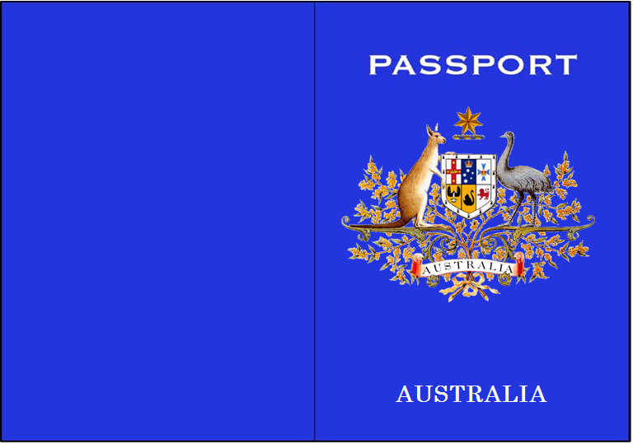
PHOTO
Passport
Surname:
Given Name:

Nationality:
Gender:
Date of Birth:
>>>>239>>>>>>>>>>>>>>>>>>>>>>>>>>>>>>>>>>>>>>>WG29110800734459Y4>>>>>>>>>>>>>>>>>>>>>>

1
2
3
4
5
6
7
8
9

