AUSTRALIAN PASSPORT PHOTO GUIDE - 2008

ADULT/CHILD PHOTO GUIDE INFANT (UNDER 3 YEARS) PHOTO GUIDE

Photograph Dimensions 35mm - 40mm Width
Place guide over the applicant’s photo and check the chin to crown measurements
Photograph Dimensions 35mm - 40mm Width
Place guide over the infant’s photo and check that head size is within shaded area

36 mm 32mm
Photograph Dimensions 45mm - 50mm Height

Bottom of chin

Th e c h in to cr ow n measurement (the vertical black dashed line) must be between 32mm and 36 mm
Definition of CROWN: The crown is where the top of the head / skull would be if it was visible
Th e c h in to cr ow n measurement (the vertical black dashed line) must be between 32mm and 36 mm
For infants under the age of 3 years, the head must fit within the shaded area

ADDITIONAL PHOTO REQUIREMENTS
INFANT PHOTO REQUIREMENTS

- Neutral expression, mouth closed
- Good quality gloss prints only
- Hair out of face, edges of face visible
- Look straight at the camera
- No head coverings (except religious purposes)
- No reflections on glasses or face
- Nothing obscuring eyes
- Prescription lenses only
- No shadows or red-eye
- Plain light background
- No hands in photograph
  - Look straight at the camera
  - No flash reflections on glasses or face
  - Plain light background
  - No hands in photograph
  - Good quality gloss prints only
  - No shadows

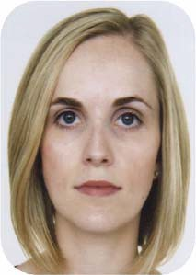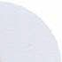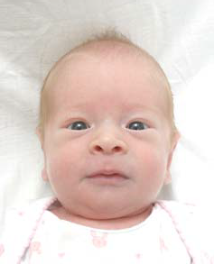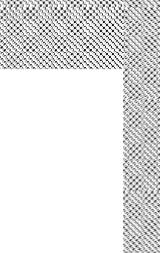
Do not cut, crop or trim the photo or staple the photo to the application. If the photograph does not meet the photograph or head size requirements, or fail to comply with the minimum infant threshold, the photograph should be rejected.

