
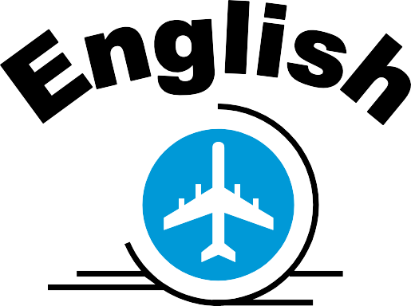

Rules:

- Mistakes are okay!
- Try to speak.
- Ask questions.

“I want to learn more and more!!”

Rules:

- Mistakes are okay!
- Try to speak.
- Ask questions.

“I want to learn more and more!!”

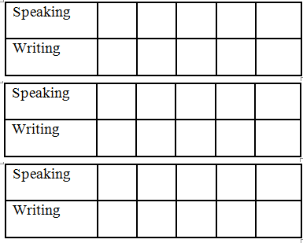
Hobby: _____________________
Hobby: _____________________
Visas
Name
Class
Birthday:

Club:

Visas
Name
Class
Birthday:

Club:

