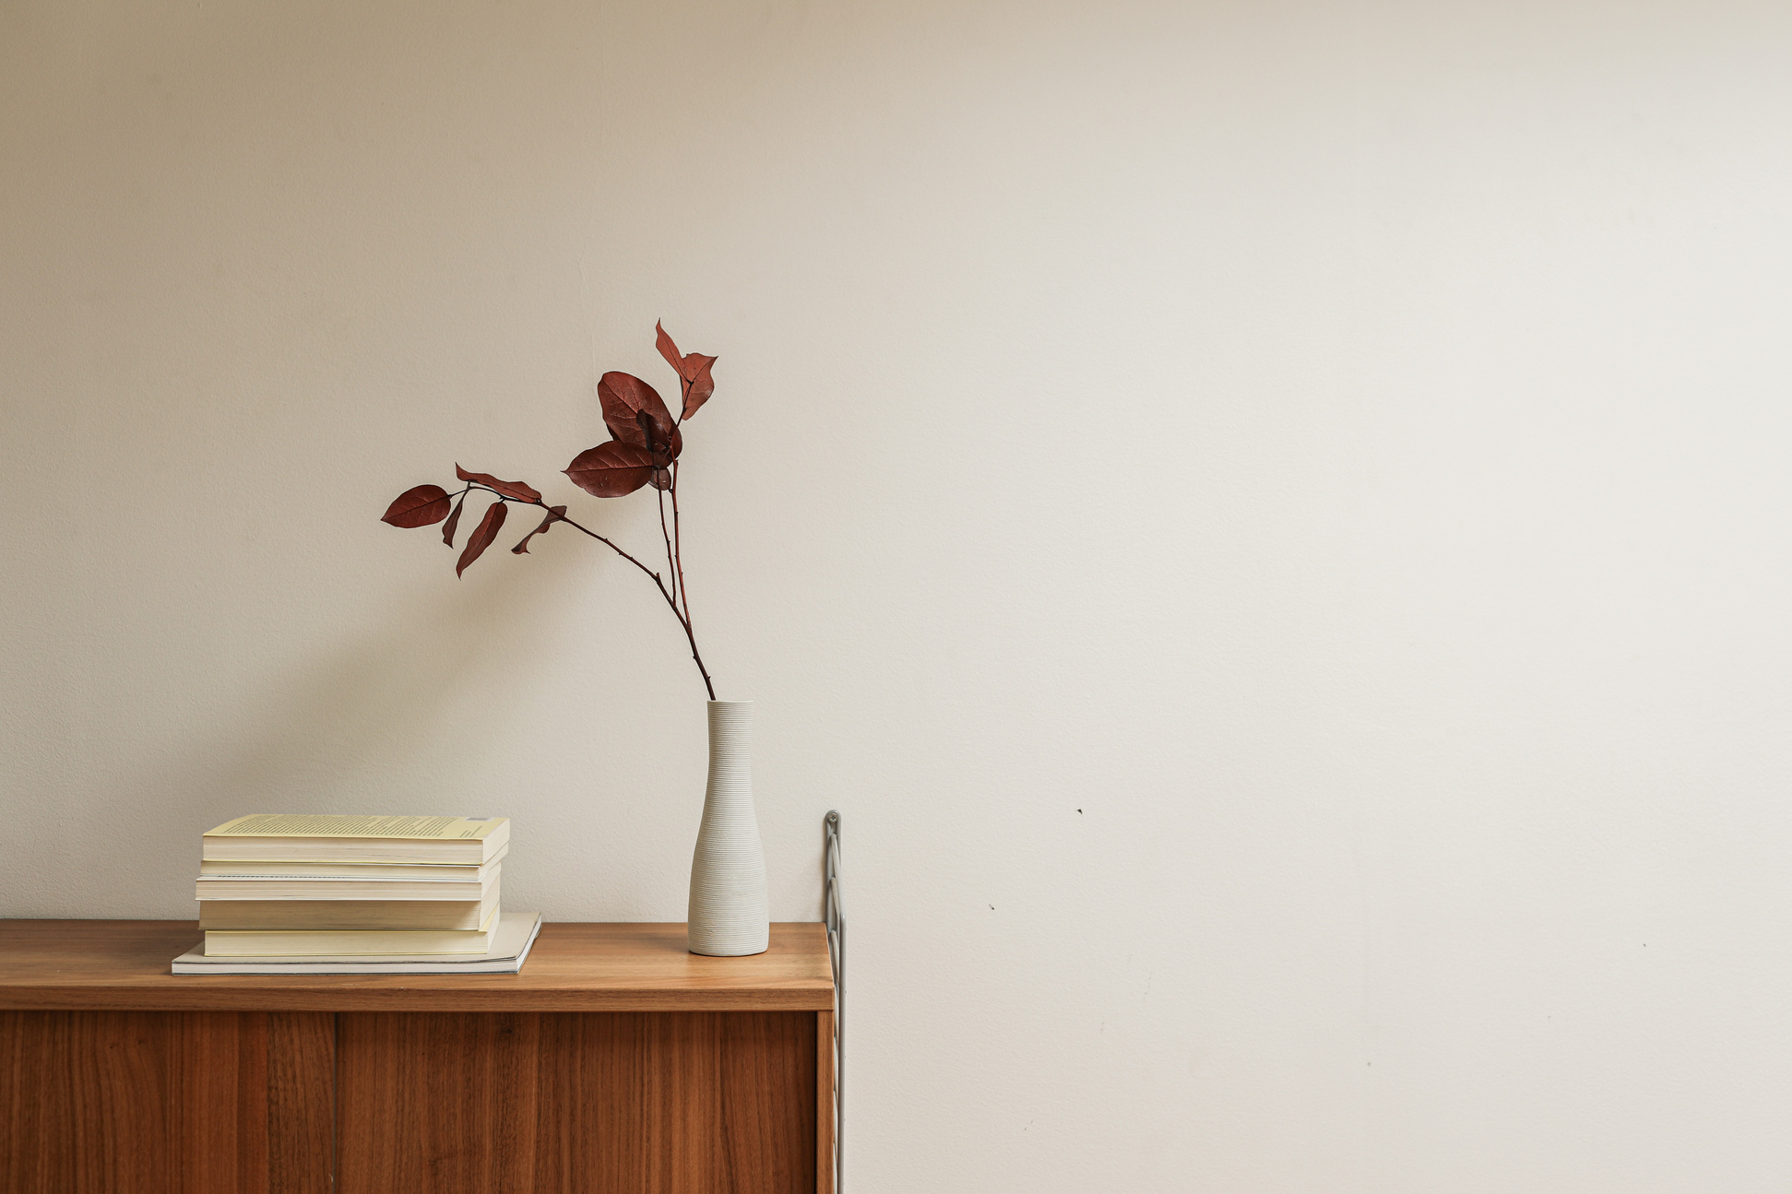
In life, is an art, the beauty moves in curves.
to
In life, is an art, the beauty moves in curves.
to

