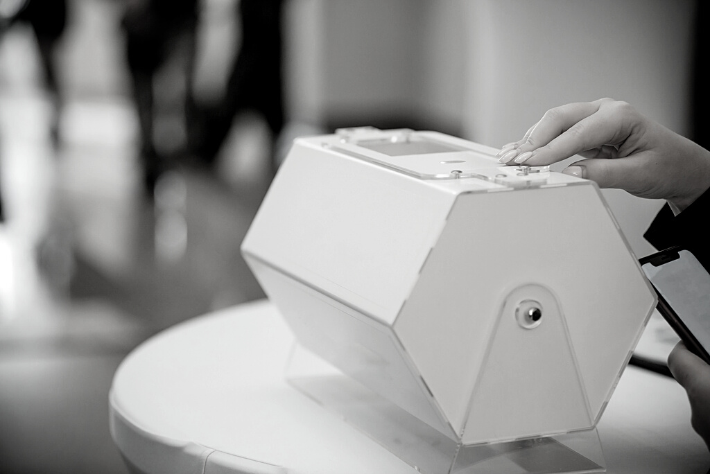


RAFFLE TICKET
Your chance to win 50% of the bounty + have the other 50% support our charity
$5 / TICKET
50/50
NAME: __________________
CONTACT: _______________ SIGNATURE: ______________ A
- This ticket admits only one person.
- Tickets cannot be exchanged or transferred under any circumstances.
- Lost or damaged ticket(s) will not be entertained.
Terms and Conditions
RAFFLE TICKET
50/50

