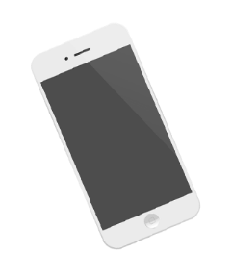
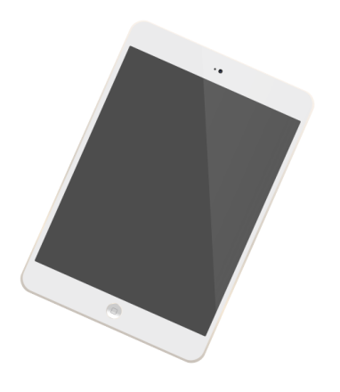
TECH SHOPPING CENTER
GIVEAWAY
Drawing on January 5 2019
Join the raffle and be one of the 10 winners.
GADGET
EMAIL:
ADDRESS:
PHONE:
NAME:

