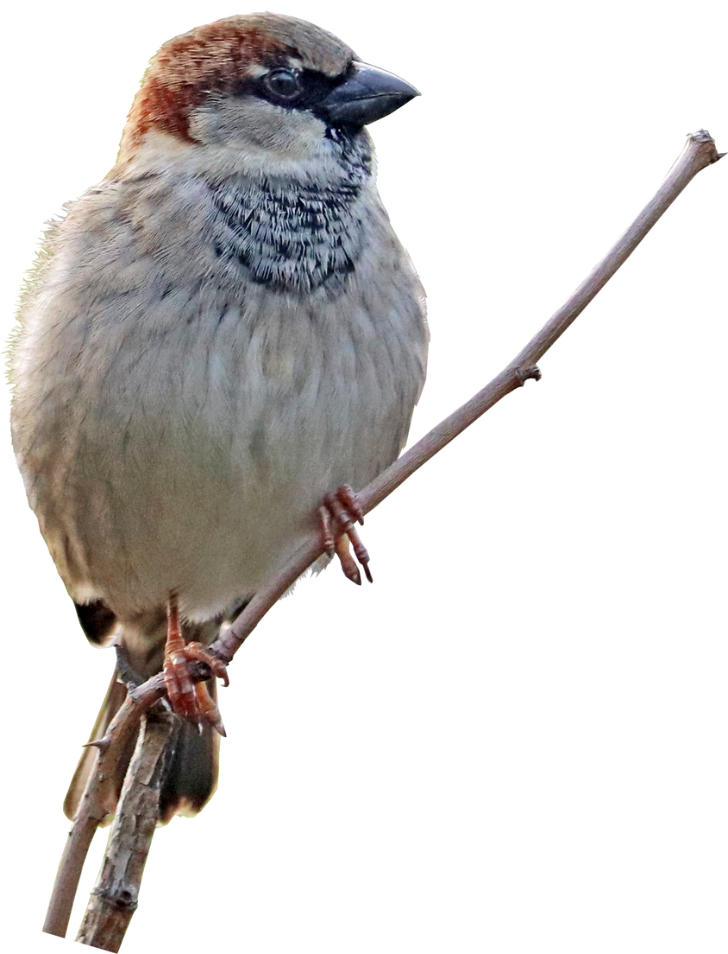




AUTHORS
Be proud of your work! Add the names of the people involved in this study. Don't forget to include titles and honorifics. We're proud of those too.
AFFILIATIONS
We're also proud of the institutions that we are with and support our research. Let's let them know by adding their names and logos here.
Item 1
Item 2
Item 3
15
10
5
0
Animal research poster
Many technologies and breakthroughs would not be possible without research. It is important to keep members of the community informed about the latest updates. One way to do that is through research posters.
01. Introduction
Posters are popular method of presenting research findings in a concise and visually pleasing manner. They are commonly used in conferences and meetings. Start by introducing the subject of your research and/or your hypothesis. What are the questions about this topic that you want to answer? What new things can it contribute to the existing literature?
02. Objective
It is important for your readers to know what you want to achieve with your research. State this as clear as possible.
Related literature
Research is often built on something that is already out there. Cite key references that you looked at while conducting your study.
03. Methodology
Let people know how you did your study. Methods can vary depending on the subject or results you want to see. These methods can include:
- Interviews
- Surveys
- Comparison studies
- Experiments
You can also show studies of existing literature that were used as references.
04. Results/Findings
Results show the outcome of the research and should answer the question or hypothesis stated in the introduction.
- State what you've found from your study.
- You can also list your findings in bullets.
IMPORTANT!
Avoid using too much technical detail or using excessive jargon when presenting them.
05. Analysis
Expand on your findings by discussing what methods were used to analyze your data. It can get technical so keep it simple and direct to the point. Use bullets for emphasis. Include key graphs, tables, illustrations, and other images that support the study and show a visual analysis of the data. Make sure they are large enough to be seen from a distance but not clutter the poster.
06. Conclusion
Summarize your study and let the viewers know two to three key findings. You can also add a description of each that can give them an idea of what comes next. This section can also include any implications of the study, and if there are any actions or recommendations for future study.
Use illustrations to showcase your data in a visual form.
Use illustrations to showcase your data in a visual form.
Graphs are great in helping make numbers easier to understand.

