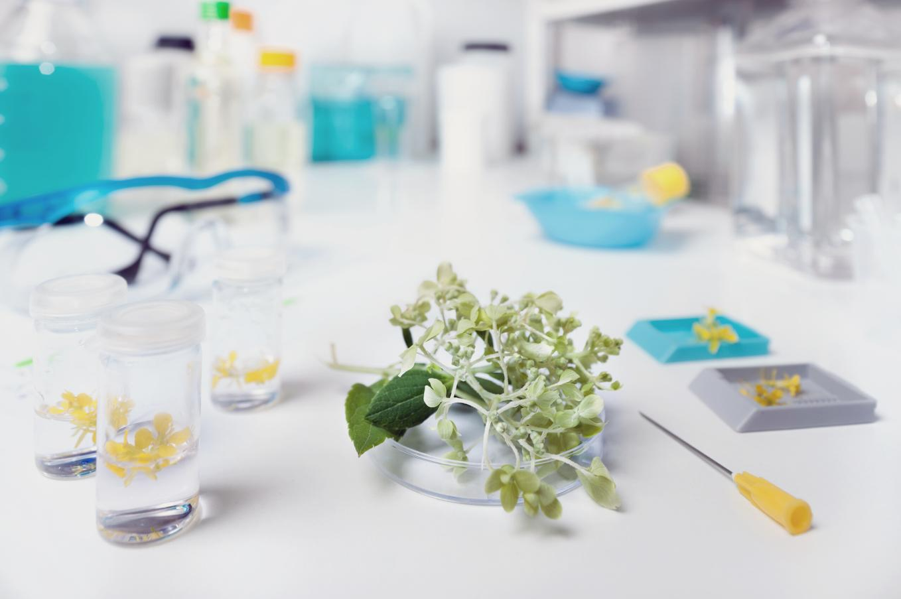
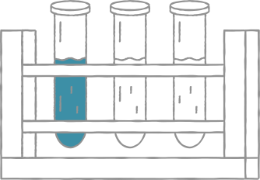
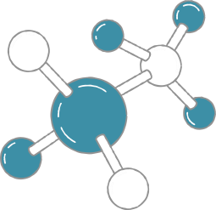
Biology
research poster
Don't forget the names of the research authors and co-authors. Use full names and include any titles or honorifics the authors may have, as well as the university or research institution they are representing.
Authors
Researches are often under or on behalf of a university, an organization, or academic/research institutions. When available, include their logos with the names.
Affiliations
Use graphs to show visualization of your data's analysis.
Illustrations are also great aids
to help your research poster.
This section gives an overview of the research. Start with the background: What are you studying and why? What is the importance of the research to the field or specific industry, and what can it contribute to the existing literature? Be mindful of the space of the poster. Include the important information, but be as straightforward as possible.
Introduction
In this section, state what is the purpose of your study.
Objective
Describe how you've conducted your research. What is the strategy of the team? What methods were used? Were there any special technology applied?
Methodology
Results show the outcome of the research and should answer the question or hypothesis stated in the introduction. State what you've found from your study.
Results
In a regular research paper, the analysis section is one of the longest parts as it builds on the information that supports the objective and thesis. With a research poster, you can trim down the analysis to the most important parts. Use bullets to emphasize points. Include key graphs, tables, graphics, and other images that support the study and show a visual analysis of the data.
Analysis
To wrap up your poster, present two to three key findings. You can also add a brief explanation or narrative to these that can encourage conversation or dialogue with the audience. These findings can be actionable items that can lead to implementation, policy creation, or further study.
Conclusion
References can take up a lot of space, so cite only the key references used in the study.
Related literature

