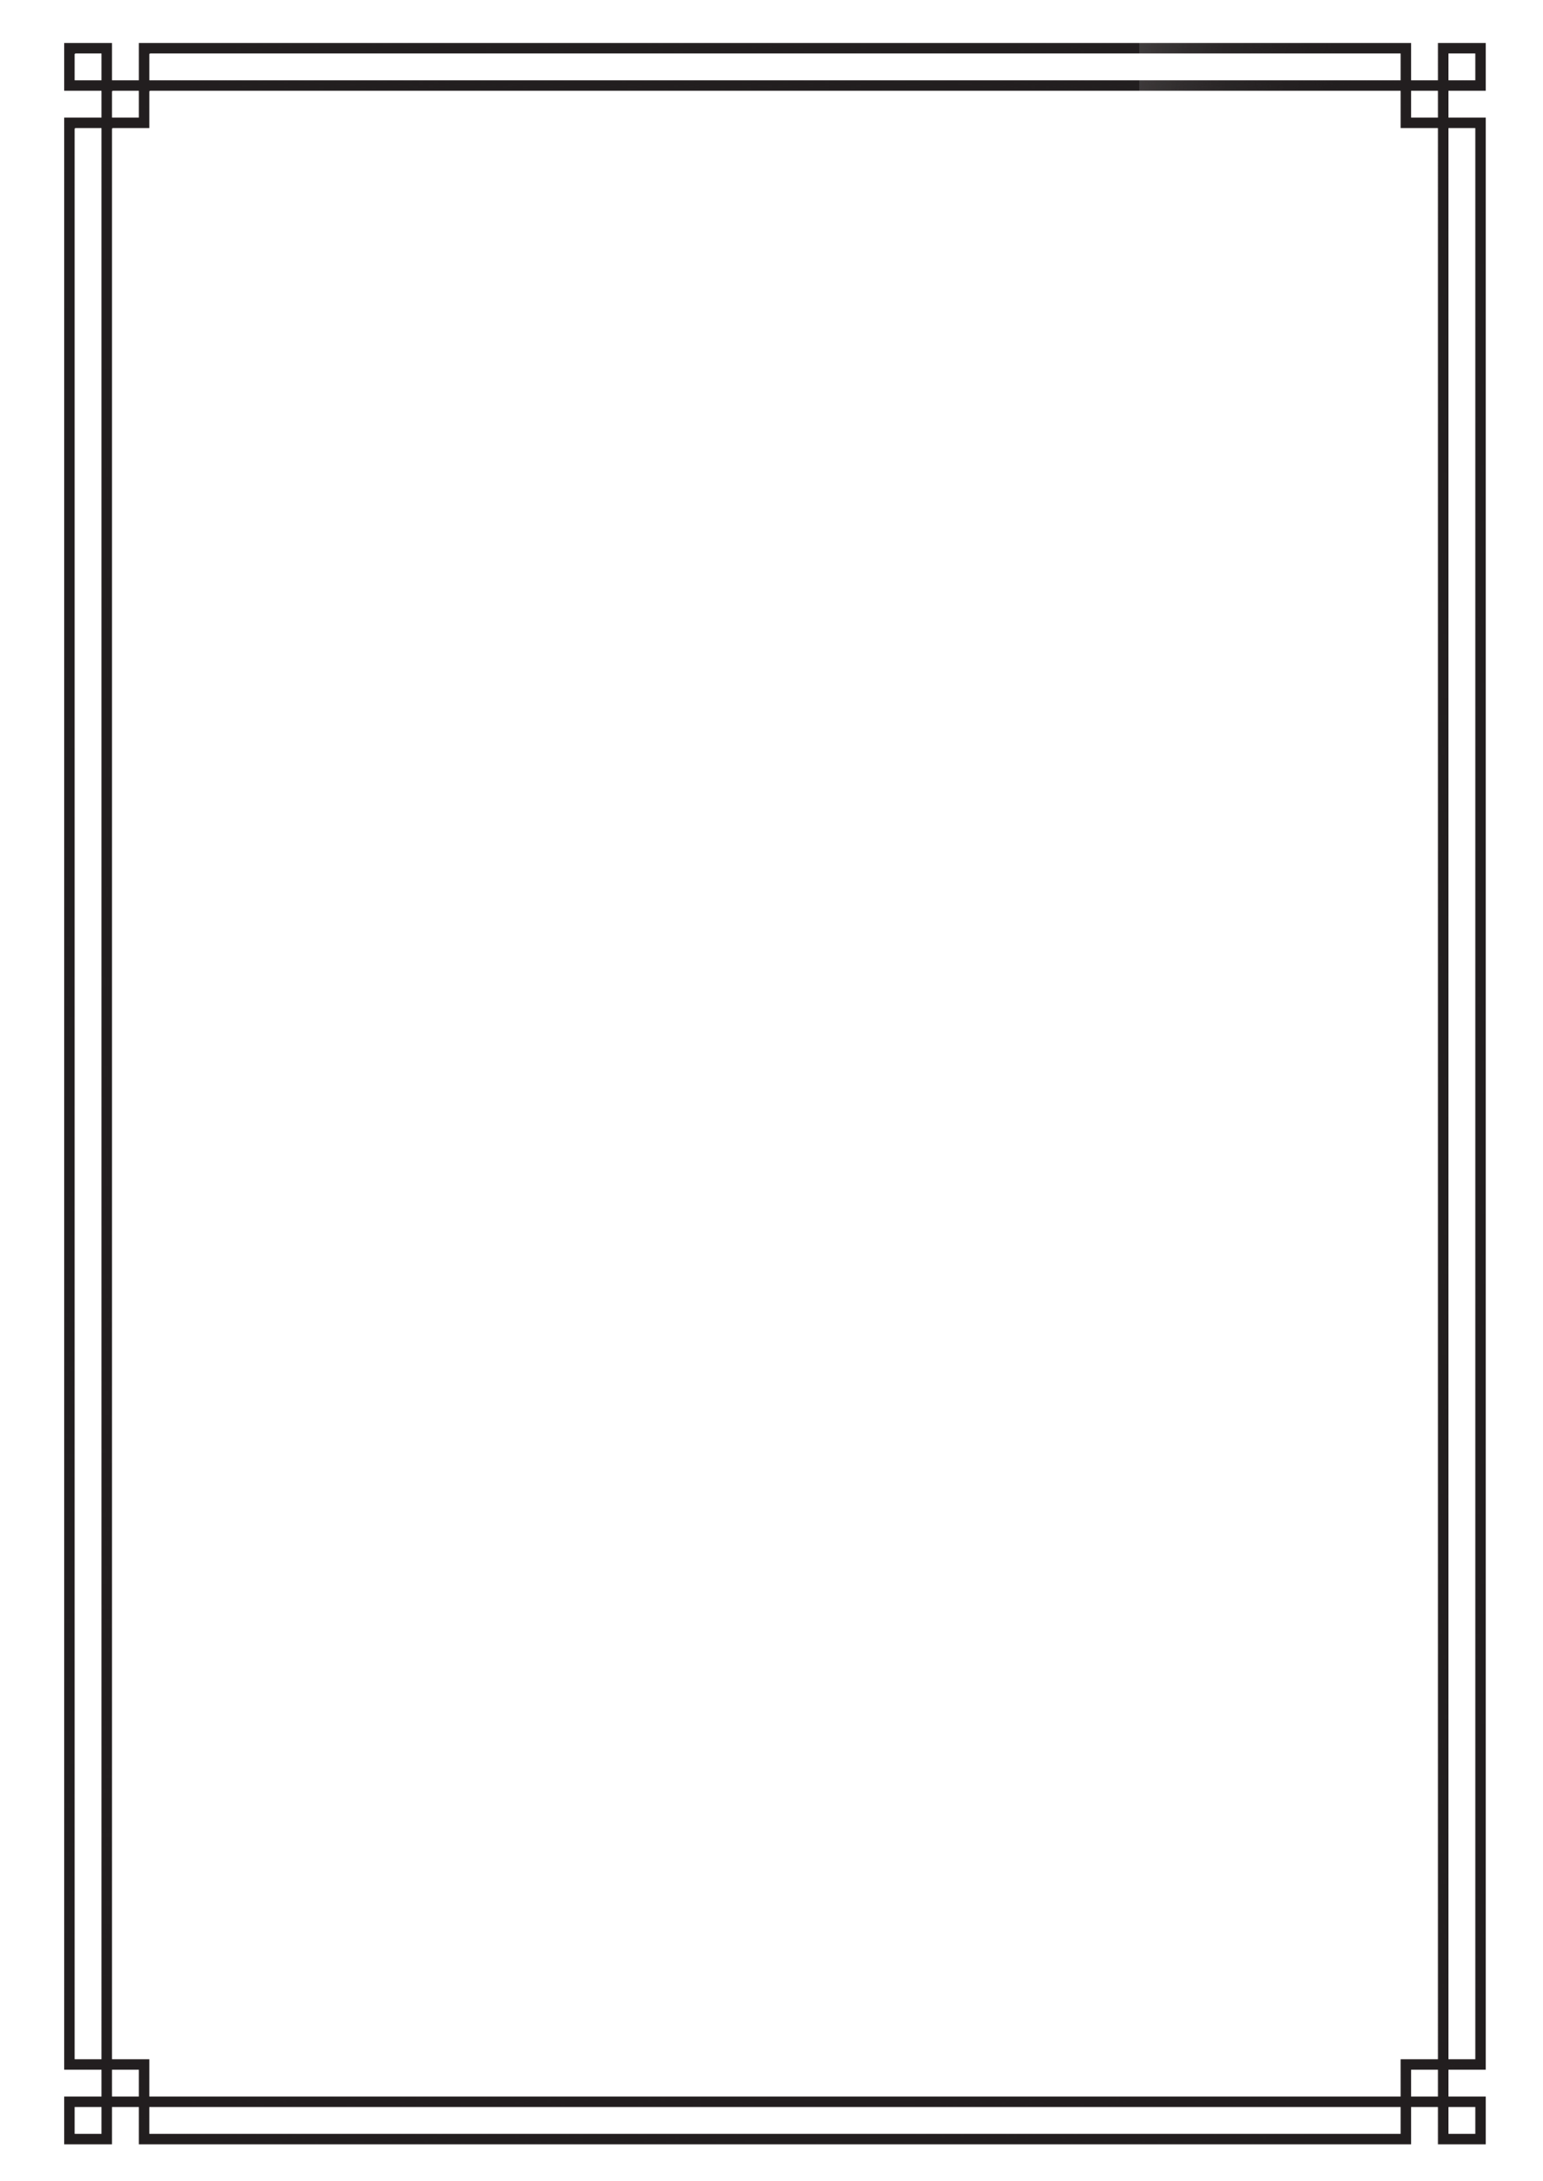
WANTED
REWARD
$10 000
For the high crime of
stealing the bank

