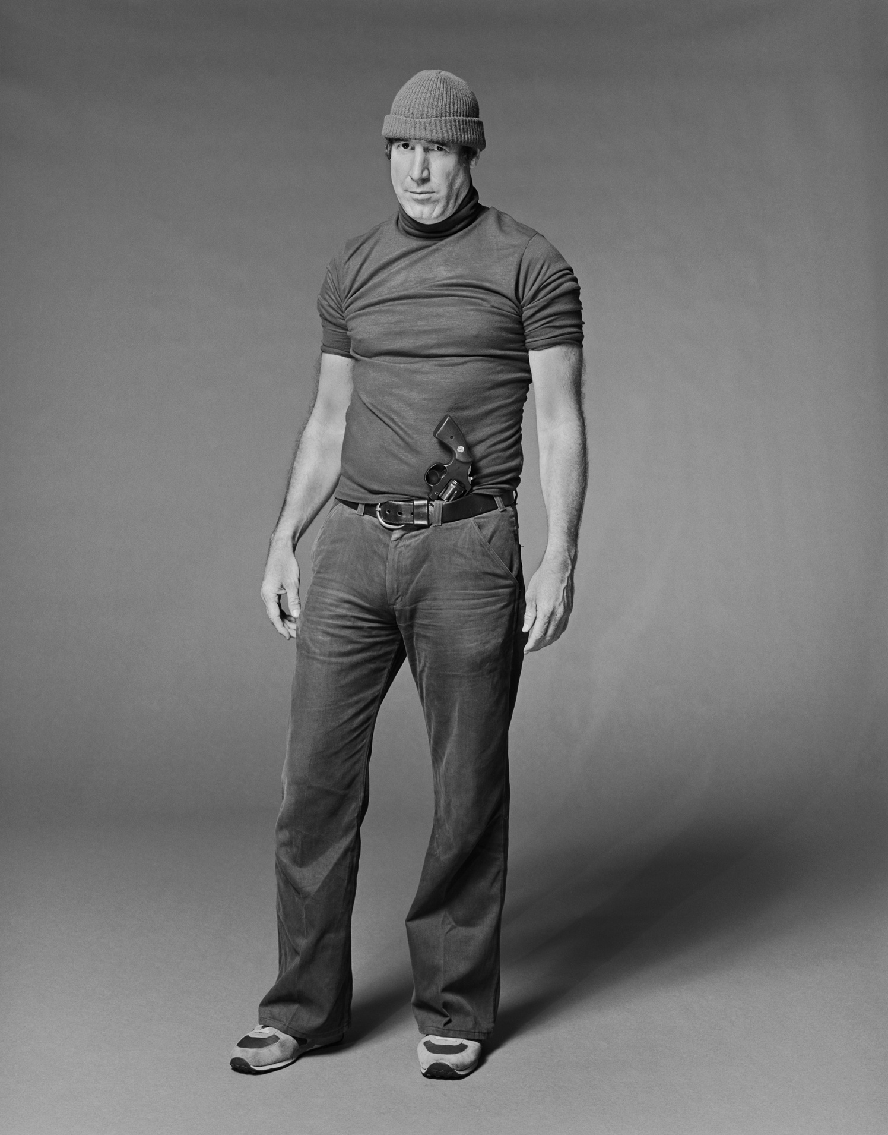
WANTED
BY THE FBI
UNLAWFUL FLIGHT TO AVOID PROSECUTION - MURDER
FULL NAME
Age:
Height:
Weight:
Build:
Hair:
Occupation:
Marks:
Eyes:
Complexion:
Race:
Nationality:
40
5’8”
150 Pounds
Slender
Blonde
Operator
Scar on left shoulder
Blue
Tan skin
Caucasian
American
CAUTION:
Lorem Ipsum is simply dummy text of the printing and typesetting industry. Lorem Ipsum has been the industry's standard dummy text ever since the 1500s, when an unknown printer took a galley of type and scrambled it to make a type specimen book.
IF YOU HAVE ANY INFORMATION CONCERNING THIS PERSON PLEASE CONTACT YOUR LOCAL FBI OFFICE IMMEDIATELY

