
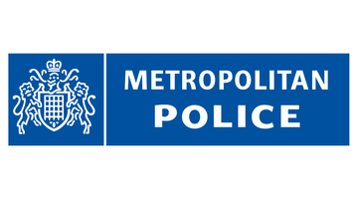
WANTED
Name: Ali Romad
Age: 28
Wanted for: Aggravated burglary
Last known location: NW10
IF YOU HAVE ANY INFORMATION CONCERNING THIS PERSON PLEASE CONTACT THE POLICE IMMEDIATELY AND HELP US TO KEEP OUR COMMUNITY SAFE

