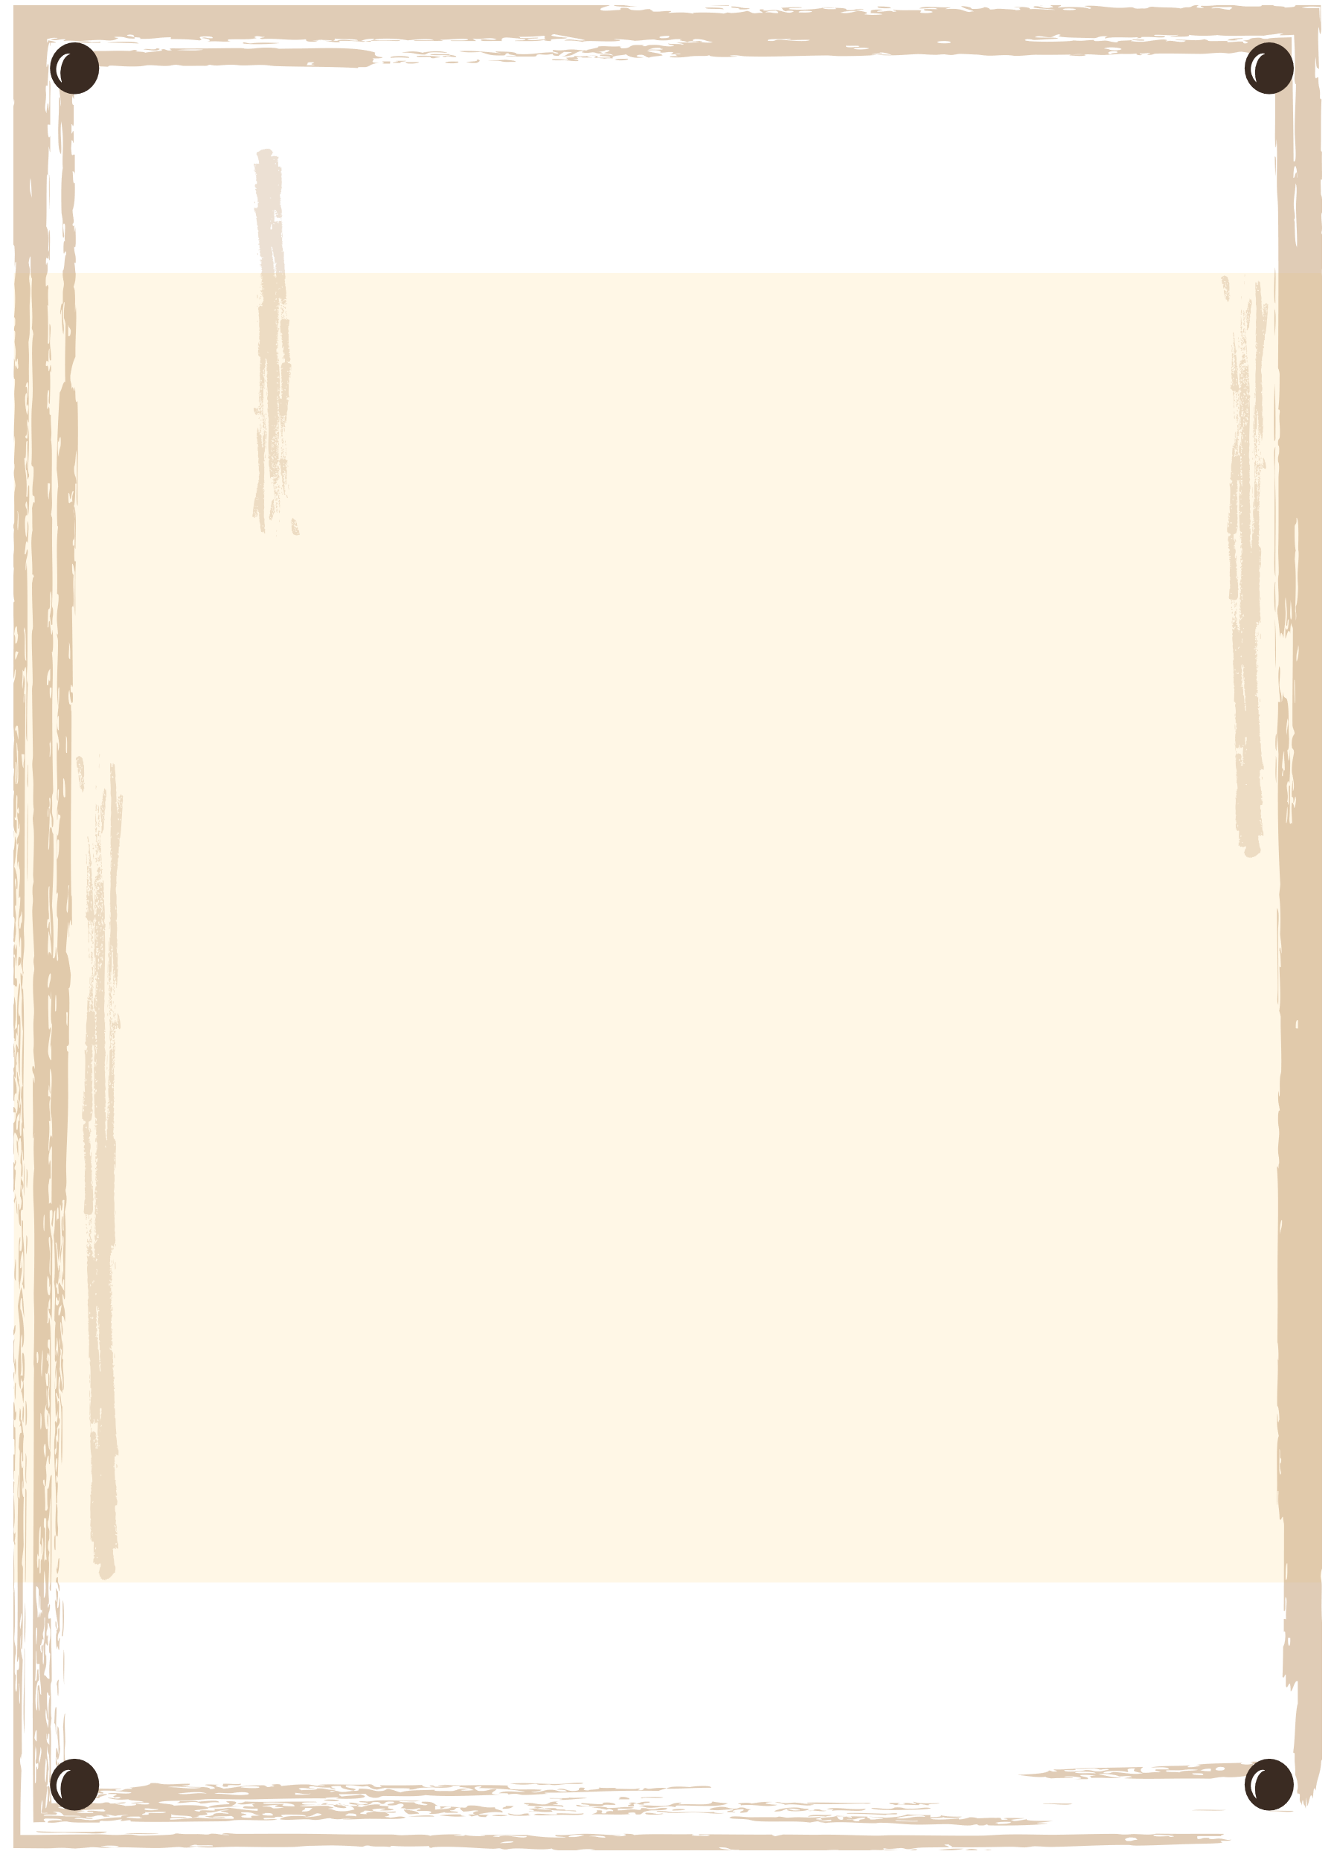
WANTED
FULL NAME
$10000
REWARD

