SCREENPLAY FORMAT Some general rules:
1 ¹/2 inch left margin
1 inch right margin
Capitalize the names of characters when they first appear in the narrative and each time they speak.
Capitalize sounds, special effects, and specialized props. (This assists a production manager in analyzing and budgeting the script.) Center the capitalized name of the person speaking.
Indent dialogue under the centered name.
Most new scenes begin with a capitalized, three-part header which identifies:
EXT. or INT. LOCATION DAY or NIGHT
Commonly-used Abbreviations:
Ext. Exterior
Int. Interior
CU Close up
MS Medium Shot
Long Shot
POV Point of View
WSU's Ablah Library and the downtown branch of the City Library have several film scripts which can be checked out.
SAMPLE SCRIPT INT. WAREHOUSE NIGHT
MARY, a psychic, is sitting at a small table, in a dimly lit room, sorting TAROT CARDS. TODD approaches the table, from the darkness.

MARY
(not looking up) Back so soon?

TODD
(sitting in the chair, opposite Mary) She's going to stay in the ü•uck, so we'll need to make this quick.

MARY
You've already paid. It's all the same to me.
(sweeps up the cards) L£t's forget the cards then and go a different direction.
TODD Okay. Whatever works.
Mary places two long, silver NAH-IS in the center of the table, at a right angle to each other. We hear a ü-uck door SLAM in the parking lot.
MARY
You and Teresa are in geat conflict.

TODD
I don't guess that observation takes any supernatural powers.

MARY
What you don't recognize is that people—some you've la-lown, some not—are gathering to impact your relationship.

TODD
What people? How many?
Mary places several nails in a circle around the two that represent Todd and Teresa. In the background we see people emerging from the dark, to encircle Mary and Todd.
EXT . PARK SLOPE BROWNSTONE DAY
It's spring and the trees are full of blossoms .
 INT . APARTMENT - LIVING ROOM - DAY
CARA , 8, and her sister ALLIE, 4, sit on the sofa. Cara' s J reading to Allie from a book about fairies of the world.
CARA

Caer is a beautiful fairy who disguises herself as a swan. You will know a swan is Caer if it has gold j ewelry. Caer comes from Ear— land. It's in Delaware.
ALLTE
Oh. Read about the pixies .
Cara throws the book on the floor .
CARA
I read you the pixies yesterday! I'm sick of pixies! Anyway, pixies are stupid! So are fairies! They're for little girls!
ALLIE I'm a big girl.
CARA
No you 're not, you 're a little girl and you 're stupid.
ALLIE No I'm not!

CARA
(imitating her ) No T 'm not!
MOMMY (0. s.)
Girls! Cara, stop being mean to your sister! I can't stand it anymore !
CARA
I'm not reading your dumb, stupid, stupid—head book anymore! I 'm gonna play with my Cool American Teenager dolls !
2 .
ALLIE
I wanna play with the Cool American Teenager dolls too.
CARA
You can 't! You're too little and stupid!
INT. APARTMENT OFFICE DAY
DADDY, late 30s, IS playing Solitaire on his computer . MOMMY, late 30s, pops her head in. He immediately switches his screen to A WORD PROCESSOR . . . in which is a mangled attempt at a screenplay. The format's a mess. He types, tabs r deletes, indents with the spacebar backspaces and it still doesn't look right.
MOMMY
Time to take the girls to the park.
DADDY I'm writing.
MOMMY
No, you were writing. . . now you 're taking the girls to the park.
DADDY
Now T 'm taking the girls to the park, right .
He frowns and gets up.
MOMMY
Just keep one at one end of the park and the other at the other and they'll be fine .
EXT. PROSPECT PARK - DAY
Daddy, Cara and Allie turn a corner and walk to the park entrance . Cara pirouettes and leapS, her version of ballet dancing. Ä11ie tries too and stumbles to the ground. Cara laughs. Daddy helps Allie up and shoots Cara a look, which she ignores .
EXT. PROSPECT PARK - LAKE DAY
Daddy's laying on picnic blanket and pecking away at a laptop .
FINAL DRAFT
16 - Tutorials
Here is an excerpt of a script which contains most of the basic script elements:

SCENE
HEADING EXT. STUDIO PARKING LOT DAY
ACTION WR ITER and an AGENT are walking f rom the park ing
lot towards an office.
CHARACTER

AGEN T

PARENTHETICAL (whi spers)
DIALOGUE Just follow my lead. I know you' re ready to do this pitch.

TRANSITION
DI SSOLVE TO :
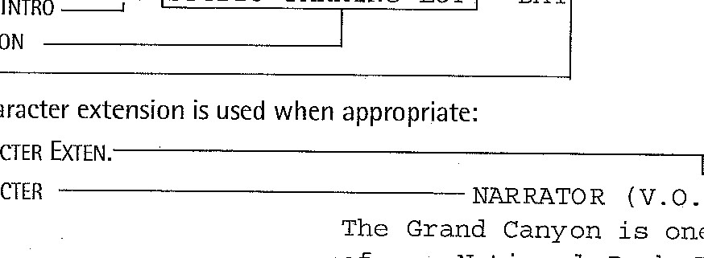
The parts of a scene heading are:
A
character
CHARACTER
O.)
one
of
the
jewels
of
our
National
Park
Syst
em.
SCENE
INTRO
EXT.
STUDIO
PARKING
LOT
DAY
LOCATION

CHARACTER
For a complete discussion of elements, see the Elements section.

