Things that upset me
Insert list here

Things you can do to calm me down 
Insert list here of different ways/strategies that can be helpful to use if I become upset

Please share this book with people who don’t know me very well
Acknowledgements to www.charliesgraphics.com for the images in this booklet
Moving on up

I have put this booklet together with the help of my friends, family, teachers and support staff to help you understand me a little better when I move on up to secondary school. I hope that as time passes everyone who knows me will have something to add to it. If you have anything you would like to add, or if there is anything else you think would be useful to have included, could you please phone my parents or carers

My name is………………….
Insert my picture

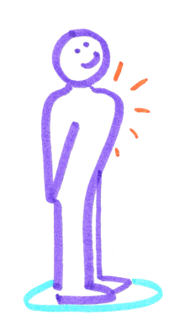

About me 

Please work with me and focus the work around the following questions

When is my birthday?
Where was I born?
All about my family for example – my mum, dad, bothers/sisters, relatives
Where do my relatives live?
Have I got any pets?
What are my favourite toys?
What is my favourite colour?
What are my hobbies and interests?
My school history (mention previously attended schools)
Do I attend any out of school activity clubs?
Who are my friends?

How I communicate 

For a child who has speech, language and communication difficulties you will need to inform the reader of this booklet how they best to communicate with them for example do they use PECS, Makaton etc

Please type here what their needs are and what support they receive for example speech and language therapy groups

What people like and admire about me (people who work and know me should think of words to describe me and type them in the box)

Things I like to do that are FUN! 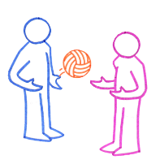

Please display pictures of me having fun here …..

Food – my likes and dislikes 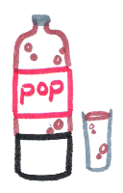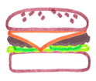

Please list the food I like and dislike

Foods I can’t eat! 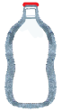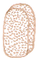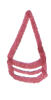
Please list the food I can’t eat

My Photo album 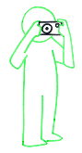
Please work with the child to gather or take pictures of them showing their likes and dislikes

For example:
What they are good at in school – favourite lessons
What they don’t like – particular lessons, foods, activities

What people say about me 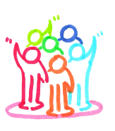
Insert comments here

What I want to be when I grow up? 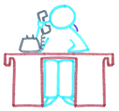

The best ways to support me …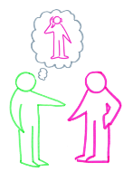

My health needs 
Please insert my health needs and parent/carer contacts

Things I do for my family 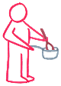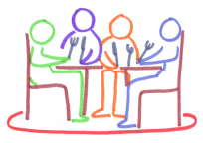
Insert comments here

Things I do for others 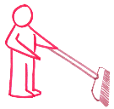
Insert comments here

My top 10 favourite things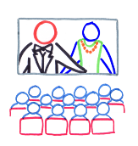 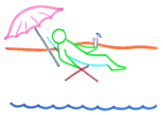
Insert list here

