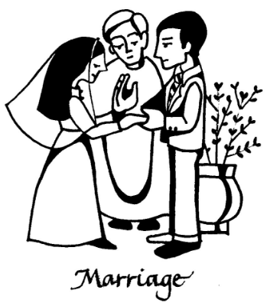
Our Wedding Mass

Mary & Joseph
St. ???? Church
Date
WEDDING PARTY

Celebrant: Fr. ???

Bride: ??

Groom: ??

Bridesmaids: ??
??
Best Man: ??
Groomsman: ??
??
Flower Girl: ??
Page Boy: ??

Readers: ??
??
Prayers of the Faithful: ??
??
??
??
Communion Reflection:??
Music: ??


Entrance:
(Song)

INTRODUCTORY RITE

Ceremony of Light (Optional)
(Song)
?? and ?? each light a candle
as a sign of their individual lives
which will soon become one in the bond of marriage

PENITENTIAL RITE

Opening Prayer

LITURGY OF THE WORD

First Reading

???????????????????????????????????
??????????????????????????????????????????????????????????????????????????????????????????????????????????????????????????????????????????????????????Insert chosen First Reading here ?????????????????????????????????????????????????????????????????????????????????????????????????????????????????????????????????????????????
The Word of the Lord.
All: Thanks be to God.

Responsorial Psalm
(Song)

Second Reading

????????????????????????????????????????

????????????????????????????????????????????????????????????????????????????????????????????????????????????????????????????????????????????????????????????????????????????????????????????????????????????????????????????????????????????????Insert preferred Second Reading here ???????????????????????????????????????????????????????????????????????????????????????????????????????????????????????????????????????????????????????????????????????????????????????????????????????????????????????????????????????????????????????????????????????????????????????????????????????????????????????????????????????

The Word of the Lord.
All: Thanks be to God.

Gospel Acclamation
Alleluia

Gospel

?????????????????????????????????????????????

??????????????????????????????????????????????????
?????????????????????????????????????????????????
????????????????????????????????????????????
??????????????????????????????????????????????????
???????????????????????????????????????????????????
???????????????????????????????????????????????????
Insert Gospel of your choice here
??????????????????????????????????????????
????????????????????????????????
??????????????????????????????????????????????
?????????????????????????????????
?????????????????????????????
??????????????????????????????????????????????
???????????????????????????????????????????????????
???????????????????????????????????????????????????
???????????????????????????????

- The Gospel of the Lord.
All: Praise to you, Lord Jesus Christ.

Homily

RITE OF MARRIAGE

Choose from options attached
?
?
?
?
?
?
?
?
?
?

Declaration of Consent

?
?
?
?
?
?
?
?

Blessing of the Rings

??
?
?
?
?
?
?
?
?
?
?
?
?
?
?
?
?
?
?
?

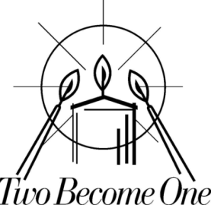
Candle Ceremony (Optional)
(Song)

?? and ?? now light a single candle from their individual candles to signify their new life together
Prayer for the Newly Married Couple (Optional)

?
?
?
?
?
?
?
?

PRAYERS OF THE FAITHFUL

?
?
?
?
?
?
?
?
?
?
?
?
?
?
?
?
?
?
?
?
?
?
?
?
?
?
?
?
?
?
?
?
?
?
?
?
?
?
?
?

Offertory Procession
(Song)

LITURGY OF THE EUCHARIST

COMMUNION RITE

Nuptial Blessing

Sign of Peace
(Song)

Communion
(Song)

CONCLUDING RITE

Signing of the Marriage Register
(Song)

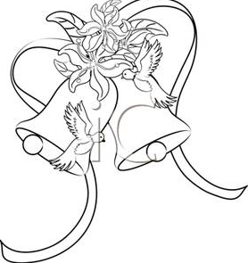

Recessional
(Song)

