RESPONDENT ID #
ED NO | -  HHOLD | PERSON

Literacy Survey
LOCATOR BOOKLET

Instructions: The next part of the survey is an exercise booklet for you to complete. It contains 49 questions. The exercises require you to read and answer questions about different topics that involve real life situations.

What do you have to do?

• Use the information provided about each topic to answer the question or questions in the exercise booklet.

• There might be some questions for which you have the choice of using a calculator to find the answer. If so, you will be provided with a calculator to use if you wish.

• If a question requires a numerical answer, you should estimate or round your answer using the same level of accuracy as you would in real life. You may do calculations in the open space anywhere on the page.

• Please provide your answer in the exercise booklet on the lines that are provided or according to the instructions that are given for each question. You may be asked to:

– write your answer in the space provided,
– circle information, or
– underline information.

• You should complete the questions in the order they appear. If you can’t answer a particular question, just move on to the next one.

You may find some questions easy and some more difficult. It’s all right if you can’t do all of them, but it’s important that you try each one.

Preschool Rules

Welcome to our Preschool! We are looking forward to a great year of fun, learning and getting to know each other. Please take a moment to review our preschool rules.

• Please have your child here by 9:00 am.
• Bring a small blanket or pillow and/or a small soft toy for naptime.
• Dress your child comfortably and bring a change of clothing.

• Please no jewellery or candy. If your child has a birthday please talk to your child’s teacher about a special snack for the children.
• Please bring your child fully dressed, no pajamas.
• Please sign in with your full signature. This is a licensing regulation.
Thank you.
• Breakfast will be served until 7:30 am.

• Medications have to be in original, labeled containers and must be signed into the medication sheet located in each classroom.
• If you have any questions, please talk to your classroom teacher or to Ms.
Marlene or Ms. Tree.

Questions 1 - 3. Use the list of preschool rules on the opposite page to answer questions 1 through 3.

1. What is the latest time children should arrive at preschool?

2. What are the two rules about taking medicine to the preschool?

3. Underline the statements that explain the rules about clothing including jewellery and candy.

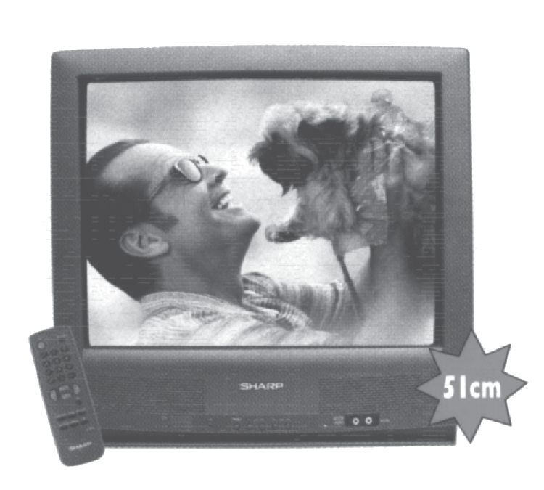

SALE
15% off

27”

Question 4. Refer to the advertisement on the opposite page to
answer question4.

4. How much would you have to pay for this TV during the sale?

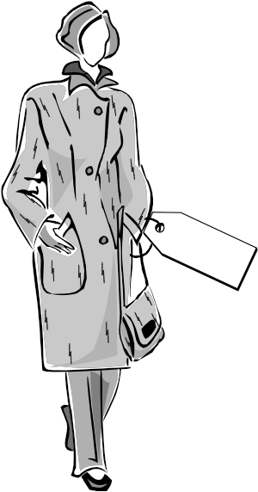SALE
10% off

Question 5. Refer to the advertisement on the opposite page to answer
question 5.

The regular price of the coat advertised is $80.

5. What is the price during the sale?

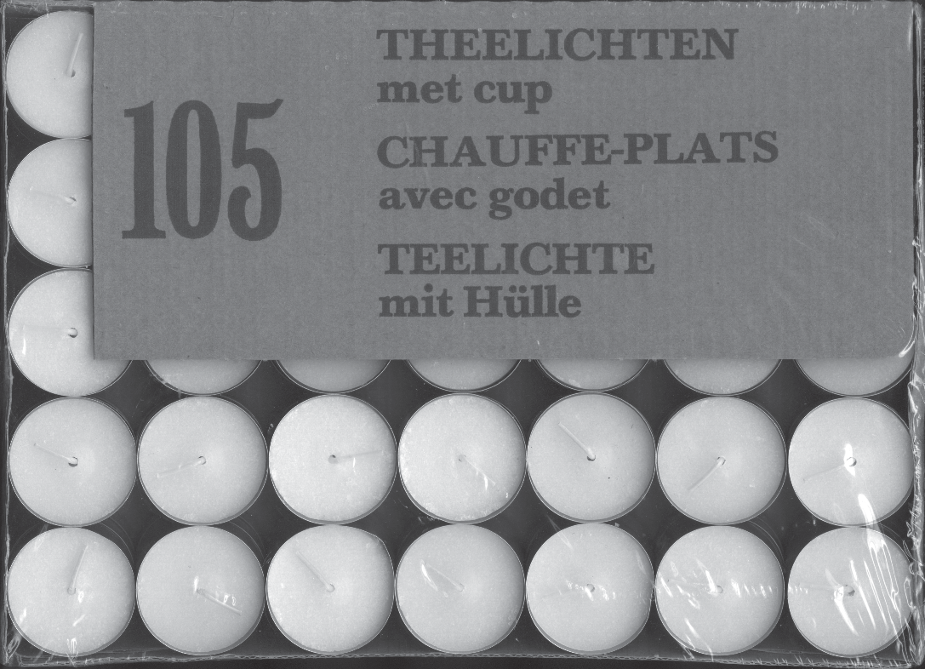

weight:
1.5 pounds

Questions 6 - 7. Refer to the picture of the box of tea candles on the opposite
page to answer questions 6 and 7.

6. In this box there are 105 candles.

In how many layers are these tea candles packed in the box?

7. What is the total weight of 500 boxes in pounds?



F

E

Question 8. Refer to the gas gauge on the opposite page to answer question 8.

8. The gas tank in this truck holds 48 gallons.
About how many gallons of gas remain in the tank? (Assume the gas gauge is accurate.)

0 277326 803671

BRIE
0 284045 401644
GOUDA CHEESE

PRICE/lb
$ 9.80

DATE PACKED
21/5/08

PRICE/lb
$ 6.95

DATE PACKED
17/5/08

$
0.419
4.10
$
0.439
3.05

NET WT lb
DELI
TOTAL PRICE

SMITHS SUPERMARKETS
22 SMITH STREET
SMITHSTON
NET WT lb
DELI
TOTAL PRICE

SMITHS SUPERMARKETS
22 SMITH STREET
SMITHSTON

0 278331 201070
GOAT
CHEESE
0 277586 904941
DANISH BLUE

PRICE/lb
$ 8.90

DATE PACKED
30/5/08

PRICE/lb
$ 7.45

DATE PACKED
14/6/08

$
0.264
2.35
$
0.249
1.85

NET WT lb
DELI
TOTAL PRICE

SMITHS SUPERMARKETS
22 SMITH STREET
SMITHSTON
NET WT lb
DELI
TOTAL PRICE

SMITHS SUPERMARKETS
22 SMITH STREET
SMITHSTON

Questions 9 - 11. Refer to the supermarket price tags on the opposite page to answer questions 9 through 11.

9. If you bought all these items, and paid with a $20 bill, how much change would you get?

10. If you buy a quarter of a pound of Brie how much would you pay?

11. Which of these items was packed first?

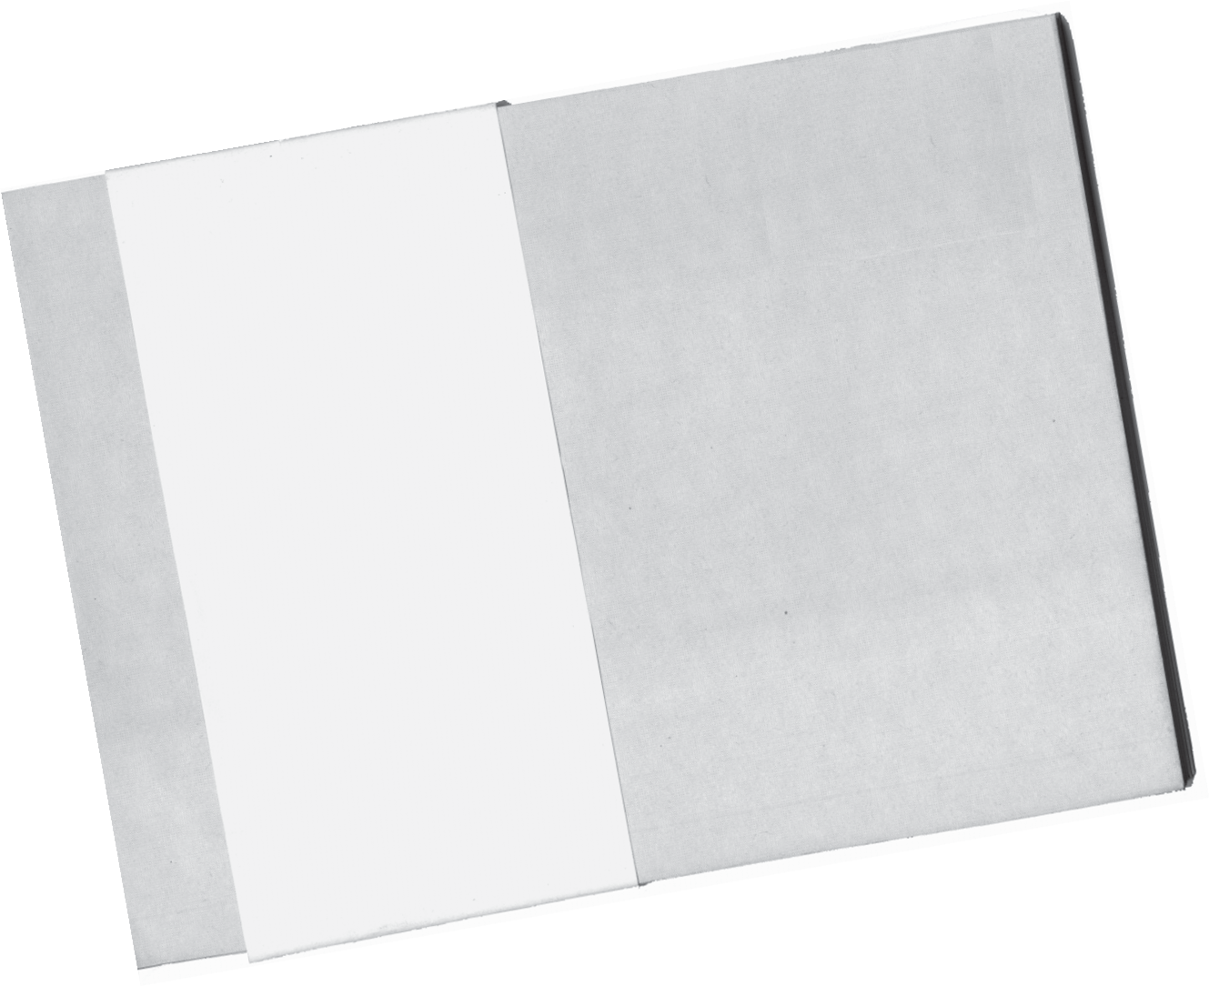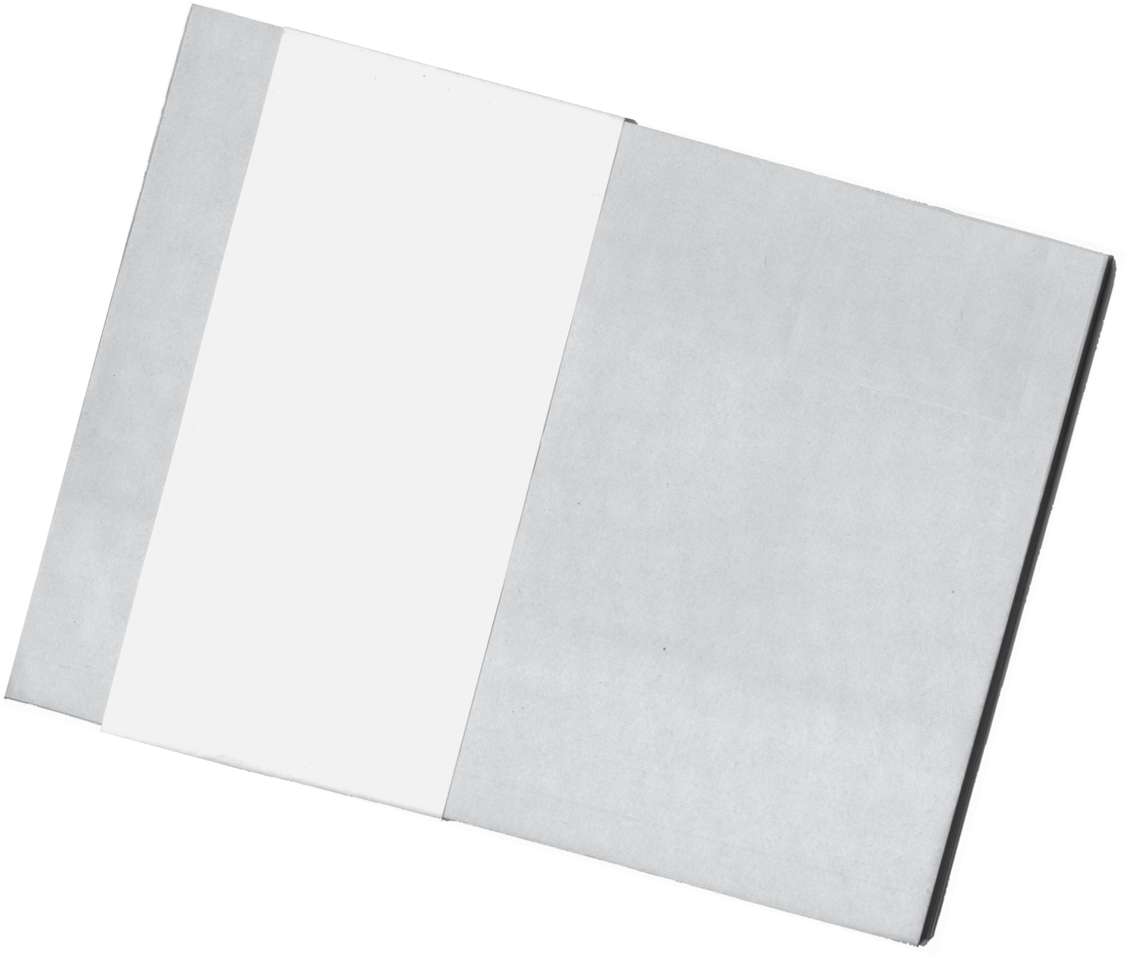

Questions 12 - 14. Use the ruler and the photo that you have been given to
answer question 28 and refer to the image of envelopes
on the opposite page to answer questions 12 through 14.

12. Measure the photo. What are its dimensions in inches

Copies of the photo are to be mailed to every person in the photo.
Mailing envelopes are available in the following sizes: C6 (6” x 9”), C5 (9” x 12”), C4 (10” x 13”).

13. Which size envelope is the smallest that could be used without folding the photo?

14. The envelopes are available only in packs of 10.
How many packs need to be bought to mail a photo to each person in the picture?

OZONE: USEFUL ABOVE...

Twenty to thirty kilometers above the surface
of the earth, high up in the stratosphere, a thin but vital ozone layer protects humans, animals and
plants from the strong ultraviolet radiation present. This ozone veil, which can be compared to gigantic
sun glasses, is especially jeopardized by the effects of the chlorofluorocarbons (CFC). The decomposi-
tion of this protective layer is also commonly referred to as the “ozone hole.” The industrial
states have resolved to forbid the production and use of CFC’s in the future. Until recently, CFC’s
have been widely used as propelling gas for aerosol cans, as cooling agents for refrigerators and
air-conditioning plants, as components in cleaning agents or in insulation foams, to give only a few
examples.

30 km

25 km

20 km

15 km

Stratosphere

Ozone layer

Ozone (O ) is the three-atom form of oxygen and in certain concentrations a natural component of the atmosphere.
3

10 km

5 km

Troposphere

...HARMFUL BELOW
In the lowest layer of the atmosphere, the tropo- sphere, ozone neutralizes certain elements alien to the air. Yet when constantly highly concentrated, ozone has a harmful effect on animals and plants. Sensitive persons may develop breathing trouble and coughs as well as sore eyes. Naturally,
asthmatics, babies and elderly people :are especially vulnerable. But high concentrations of ozone can also affect the well-being and performance of healthy persons. Certain plants like spring-sown wheat and clover react by slowing down their growth process, which results in lower yields for agriculture.

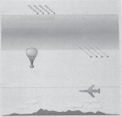Vital processes take place in the two lower layers of the earth’s atmosphere, the troposphere and the strato- sphere.

Source: Amt Für Abfall, Wasser, Energie und Luft. Zürich, 1995.

Questions 15 - 18. Use the article about ozone on the opposite page to
answer questions 15 through 18.

15. According to the article, what is the major cause of the decomposition of the ozone layer?

16. Underline the word that says what “CFC” stands for.

17. Which plants mentioned in the text slow down their growth process in high concentrations of ozone?

18. What is the benefit of the ozone layer?

For cleaning floors

1
Mix 1 container of water with 3
container of the concentrated

cleaning solution.

1

1
2

Questions 19. On the diagram of the container on the opposite
page draw a line for 1 .
3

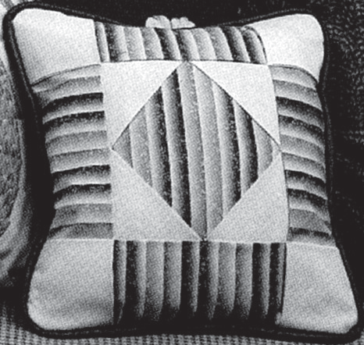

PILLOW COVER

MATERIALS: 45" wide fabric
1/2 yd muslin
1/4 yd print fabric
1/4 yd grey fabric
1/4 yd green fabric

CUTTING:
11" X 11" square: 2 muslin
4" x 4" square: 2 print
31/2" x 4" strips: 2 grey, 2 green
21/2" x 4" strips: 2 grey, 2 green
11/2" x 4" strips: 2 grey, 2 green

Afflare Craft & Fabric Supplies

CASH SALES SLIP

DATE: 12 Dec SALESPERSON: Jan Heaton
QUANTITY | ITEM | PRICE | COST
1/2 yard | muslin | $4.95/yd | $2.48
1/4 yard | print | $3.60/yd | $0.90
1/4 yard | grey | $4.45/yd | $1.12
1/4 yard | green | $5.25/yd

Questions 20 - 21. Refer to the information for making a pillow cover as a craft project and the Cash Sales Slip on the opposite page to answer question 20 and use the ruler you have been given to answer questions 20 and 21.

20. Fill in the correct amount for the green fabric on the sales slip on the opposite page.

21. In the space below, draw a 2¹/₂” by 4” rectangle as a pattern for cutting some of the strips.

THE TIME
Times FINANCE

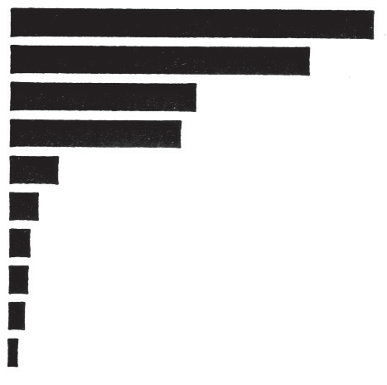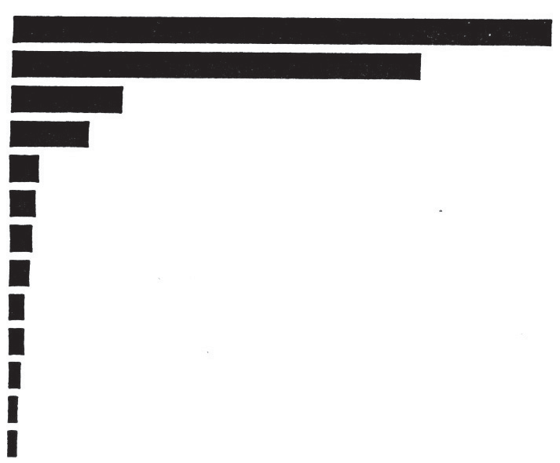Expect consolidation of Baltic stock markets

Opinions concerning the need to consolidate the Estonian, Latvian and Lithuanian stock markets have been heard with increasing frequency during the past half year.
According to data published in the June edition of the Central European Economic Review (CEER), a joint Baltic stock market would split the fifth and sixth places with the Slovenian stock market in terms of market capitalization.
A joint Baltic stock market would lag behind markets such as Russia, Poland, the Czech Republic and Hungary. It
should be noted that the stock market capitalization of any of the above countries would still be five to nine times higher than that of the joint Baltic stock market.
According to CEER data, a joint Baltic stock market would rank fifth to seventh in Central and Eastern Europe in terms of the average market turnover.
Consolidation of the Baltic stock markets may serve to improve market liquidity and promote attracting larger investors.
It is certainly possible, however, that
even after consolidation of the three stock exchanges the Baltic market still could be too small to operate successfully. In such a case, a joint Baltic market might find a place in a possible future joint Scandinavian market structure.

Boriss Epsteins, BNS

I. Market capitalization (Eastern and Central Europe)
in $billion, as of April 30, 1999

1. Russia
2. Poland
3. Czech. Rep.
4. Hungary
5. Slovenia
6. Croatia
7. Estonia
8. Romania
9. Lithuania
10. Latvia

0 10 20 30 40

II. Average daily turnover (Eastern and Central Europe)
in $million, as of April 30, 1999

1. Hungary
2. Poland
3. Czech. Rep.
4. Russia
5. Slovenia
6. Slovakia
7. Romania
8. Estonia
9. Ukraine
10. Lithuania
11. Bulgaria
12. Latvia
13. Croatia

0 15 30 45 60

Questions 22 - 26. Use the article and graphs about the Baltic Stock Markets on the opposite page to answer questions 22 through 26.

22. According to the graph, which country has the largest market capitalization?

23. Identify two countries whose market capitalization is estimated to be between 10 and 15 billion dollars.

24. According to the graph, what is the average daily turnover for Poland?

25. Identify the three countries that are listed in the graph for average daily turnover but not for market capitalization.

26. According to the article, what are two possible benefits of consolidating the Baltic Markets?

Generic Medicines

Not for the Swiss

In theory, Switzerland should be an ideal market for generic medicines. Generic medicines are drugs that have the same formula as brand-name drugs but can be produced by any drug manufacturer because the formula’s patent protection has lapsed. They are just as effec- tive, but because they carry no brand name, they are less ex- pensive (at least 25% less). With health-care costs skyrock- eting and the government urg- ing people to use generic medi- cines, you’d think sales would be going through the roof. Es- pecially since a huge company like Novartis is producing ge- neric drugs by the ton and last year racked up 1.5 billion Swiss francs in generic-drug sales.
The Drug Market, 1996

Generic medicines

Market share within country

%
Denmark | 22.0
Germany | 16.1
Netherlands | 14.6
Ireland | 12.2
USA | 10.8
Austria | 8.7
Finland | 7.8
Belgium | 5.9
Sweden | 4.2
Greece | 4.0
Switzerland (1998) | 3.1
Portugal | 2.9
France | 2.9
Spain | 1.3
Italy | 0.8

Source: HandelsZeitung
Well, despite all this, generic drugs account for a mere
3.1% of total
drug sales in
Switzerland (approximately
4.5 billion francs). Why? First, because many doctors prefer to prescribe the original medi- cines, and pharmacists prefer to sell them, for both psycho- logical and financial reasons. And, oddly enough,
hospitals seldom
use generic drugs, even though they could stand to do
some cost-cutting. Finally,
patients are skeptical of drugs that differ in colour from the ones they are used to.

Questions 27 - 30. Use the article on the opposite page to answer questions 27 through 30.

27. According to the article, in which two countries is the national market share of generic medicines the same?

28. In how many countries does the generic drug market account for 10% or more of total drug sales?

29. According to the article, what are the reasons generic drugs should be used rather than brand-name drugs?

30. List two reasons given in the article for the limited use of generic drugs.

MAXIMUMWHITENESS MAXIMUM PROTECTION
For exce l l e n t r e s u l t s , f o l l o w t h e s e i n s t r u c t i o n s : T O OBT AIN MAXIMUM WHITENESS
ALWAYS WASH FIRST WITH LAVAN SAN BLEACH, WITHOUT DETERGENT OR SOAP

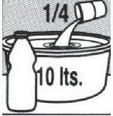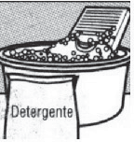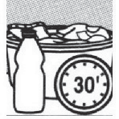WASHING BY HAND

1. Dilute ¼ cup (60 ml) Lavan San Bleach in every 10 litres |  | 2. Put in the clothes to be whitened and leave them | 3. Rinse and then wash with detergent.
of water, without  detergents or soap. |  | to soak for  30 minutes.
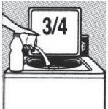USINGWASHING MACHINE

1 litre

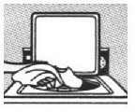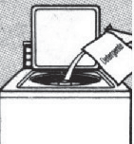1. Select a short 2. Put the 3. When the wash cycle. Wait clothes in cycle finishes,
till the machine the washer. wash the clothes fills with water. with detergent. Add ¾ cup
(180 ml) of
Lavan San Bleach. Add no detergents or soap.

CLEANING AND DISINFECTING AROUNDTHE HOUSE

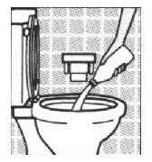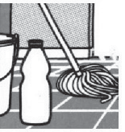Toilet: Flush the bowl. Pour in a cup of Lavan San Bleach and stir. Wait 10 minutes for it to work. Flush the bowl once more.
Floors, walls, furniture and kitchen: Dilute 1 cup (240 ml) of Lavan
San Bleach in 4 litres of water. Clean with this solution and then rinse. For difficult stains: Leave Lavan San Bleach to act for 5
minutes before rinsing.

DISINFECTINGWATER FOR HUMAN CONSUMPTION

1. Add one 2. Allow to drop of rest for 45
Lavan San minutes
Bleach to before every litre consuming of water. or using.

Number of drops of Lavan San Bleach per amount of water.

1 litre

1 drop

10 litres

20 litres
10 drops 20 drops

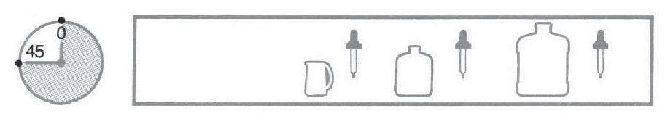3. To wash fruits and vegetables, use one spoonful of Lavan San Bleach for every five litres of water.

Registered in the Ministry of Health No. D 02119
Manufactured by Proctor and Gamble of Venezuela in Barquisimeto, Lara State.
MADE IN VENEZUELA
Give us your opinion on Lavan San Bleach by calling 800 76253 (Toll free)
or write to Mrs. Robles, P.O.Box No. 66349 Caracas 1061

Questions 31 – 34 Use the directions for Lavan San Bleach on the
opposite page to answer questions 31 through 34.

31. How much Lavan San Bleach should you use when washing clothes
in the washing machine?

32. How long should you wait to drink water after you have added bleach to disinfect it?

33. If you are washing clothes by hand, when should you use detergent?

34. If you have a complaint about Lavan San Bleach, what should you do?

Blood alcohol level

The National Board of Health recommends that women should not drink more than 14 units of alcohol a week - men not more than 21. Always remember to offer non-alcoholic beverages such as water when you offer someone a drink. It is also important that you drink 2 liters of non-alcoholic liquid a day - preferably water.

A unit of alcohol corresponds to 12 grams of pure alco- hol. As a rule of thumb, you can estimate that there is 1 unit of alcohol in each of the following drinks and amounts:

1 bottle of beer
1 glass of wine (about 12 cl)
1 glass of port wine (about 8 cl)
1 glass of spirits (about 4 cl)

Blood alcohol level in percent of weight to volume after one unit of alcohol according to the National Board of Health Book of Facts:

Weight | Woman | Man
60 kg | .036 | .029
70 kg | .031 | .025
80 kg | .027 | .022
90 kg | .024 | .020

Blood alcohol levels depend on:
- how quickly and how many units you drink
- your weight
- whether you are a man or a woman

Alcohol is broken down at a constant speed in the liver. The rate of break down is not increased by drinking cof- fee, taking a shower or going for a walk. It is solely body weight that determines how many grams of alcohol are broken down per hour.

Questions 35 – 39 Use the article on the opposite page about alcohol
content in the blood to answer questions 35 through 39.

35. According to the National Board of Health, a man should not drink more
than how many units of alcohol per week?

36. According to the article, what are the three things that determine blood alcohol levels?

37. What determines the number of grams of alcohol that are broken down per hour?

38. How many grams of alcohol are there in a glass of port wine?

39. Use the information in the table to compare blood alcohol levels for men and women of similar weight.

Gas station
Crest Highway

Oak St
Pine Ave

Beech St
Cypress Ave

Valley Rd
Juniper Ave

Palm St
N
Techmedia
Computers

Scale:

0 1 mile

Instructions for question 41:
Start here at Techmedia Computers.
Go on Valley until you come to Juniper Ave .
Turn left. Go on Juniper Ave to Palm St.
Turn left on Palm St. and continue until it ends. Then go south, following the signs to Pleasanton.

Questions 40 - 41. Use the map on the opposite page to answer
questions 40 and 41.

As the receptionist at Techmedia Computers, you are often required to give information and directions to clients over the phone or at the desk. The map taken from the sales brochure shows the location of your office.

40. Following the shortest path, using the roads shown on the map, approximately how far is it in miles from Techmedia Computers to the gas station?

41. A customer, who is at the desk, asks you how to get to Pleasanton, a neighboring town.You explain the turns and trace the path on the map.

Follow the instructions written under the map on the opposite page, and
mark this path directly on the map with your pen.

The TMN Anti-Theft Service
How it works

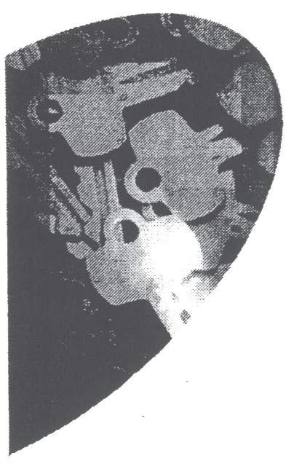

Because unforeseen events can occur at any time, TMN offers the TMN Anti-Theft Service so that your digital mobile phone cannot be improperly used by third parties if it is stolenor lost.

What is the Anti-Theft Service?

The TMN Anti-Theft Service enables you to dissuade people from stealing your mobile phone and also makes it possible for you to get it back if it is recovered.

Your mobile phone possesses a numeric code IMEI1), which identifies it. It is possible for TMN to block the use of your mobile phone on any Portuguese mobile network, but only if we know what its IMEI code is.

Given that the rest of the GSM2 operators are expected to adopt the same service in the near future, it will be possible to prevent any un- desired use of your mobile phone on the international GSM networks

1 IMEI- International Mobile Equipment Identity: the equipment’s international identity number, which is made up of 15 digits. It is generally printed on the label inside the mobile phone and may also be obtained on the phone’s screen by punching in the command *#06#.

2 GSM - Global System for Mobile Communications (Groupe Specialé Mobile).

3 Only applicable to mobile phones that were stolen or lost after the date on which the Anti-Theft Service was launched.

How do you ask for your mobile phone to be blocked?

In order to ask for your mobile phone to be blocked in the event that it is stolen or lost, you must either send the following documents to TMN or hand them in at a TMN shop:
• Proof of your purchase of the mobile phone.
- Proof that you have reported the theft or loss to the authorities.
• A properly completed liability form (avail- able from any TMN shop), on which you should include the make, model and IMEI number of the mobile phone.

How do you ask for your mobile phone to be unblocked?

In the event that you recover your mobile phone and want to unblock it, you must either send the following documents to TMN or hand them in at a TMN shop:
• Proof that you have reported the recovery to the authorities.
• A properly completed liability form (available from any TMN shop), on which you should include the make, model and IMEI number of the mobile phone.

Notifying the Customer

Requests for a mobile phone to be blocked or unblocked will be properly analyzed by TMN. The customer will be notified as to whether his/her request has been approved.

How much does it cost?

The TMN Anti-Theft Service is free and is available to all the customers of TMN’s digital network.

Questions 42 - 45. Use the TMN Anti-theft brochure from Portugal on the
opposite page to answer questions 42 through 45.

42. List all the documents you need in order to be able to ask for your mobile telephone to be blocked.

43. According to the brochure, what function does the numeric IMEI code play in the company’s anti-theft service?

44. What does the brochure say are the current benefits of the anti-theft service?

45. Which document must you submit both to block and unblock your mobile phone?

EXERCISE
EQUIPMENT

If you’re not a fitness fan or if you can’t manage to go to gyms or sports clubs regularly, but even so want to stay in good physical shape, you can install a “private gymnasium” in your own home. There is a wide range of sports equipment that has been specially developed to ensure your safety, comfort and pleasure while you do various types of exercise.

How to choose?–
For example:
OBJECTIVE  Burn off calories | STRATEGY Cardiovascular exercises | EQUIPMENT  Rowing machine, Bicycle,  Ski machine, Treadmill, Stairs....
Strengthen your muscles | Endurance exercises | Bench for Press-ups, Weights and Dumbbells, Elastic Tubes...

1 Decide what effects you want the exercise to have on your body.
2 Assess the space you have available at home.
3 Choose the equipment that suits your objectives. If necessary, ask a specialist for advice.

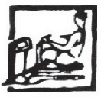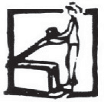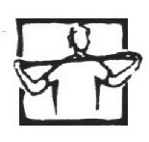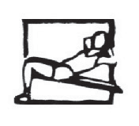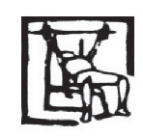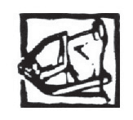Physical Exercise Equipment
Muscle building
Dumb- bells, weights | Elastic | Gym bench | Muscle-  building bench | Multi- trainer | AB  trimmer | AB  shaper | AB  roller

Effects on... | Cardio-training
Effects on... | Exercise bicycle | Rowing machine | Stepper | Tread- mill | Air trainer
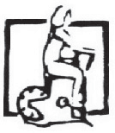

Arm  Strength | Ineff- ective | Good | Average | Ineff- ective | Good
Leg strength | Good | Very good | Average | Very good | Good
Abdo- minal muscles | Average | Very good | Good | Good | Avera
Overall muscle  building | Ineffe- ective | Very good | Ineff- ective | Average | Ineff- ective
Heart/  arteries | Very good | Good | Very good | Very good | Good
Flexi- bility | Ineff- ective | Good | Ineff- ective | Ineff- ective | Avera
Joints | Good | Very  Good | Good | Good | Good
Slim- ming | Good | Average | Very good | Good | Good
Dangers1 | None | Back 2 | None | Legs
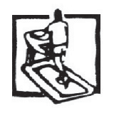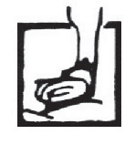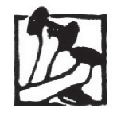1 People who suffer from cardiac, respiratory or rheumatic diseases should take special care and always start with a small number of exercises before progressively increasing their intensity.

ge

ge
Very good | Very good | Good | Good | Good | Very good | Good | Good
Ineff- ective | Good | Average | Good | Good | Ineff- extive | Good | Good
Ineff- ective | Good | Very good | Good | Average | Very good | Very good | Very good
Average | Good | Good | Good | Average | Good | Good | Good
Ineff- ective | Average | Average | Average | Good | Average | Average | Aver- age
Average | Average | Good | Ineff- ective | Ineff- ective | Average | Good | Good
Good | Average | Average | Good | Good | Average | Average | Aver- age
Ineff- ective | Average | Good | Average | Average | Good | Good | Good
It is best to learn to use these types of apparatus properly before you make a major effort

2 You should learn how to row correctly first.

Questions 46 - 49. Use the exercise equipment chart on the opposite page to answer questions 46 through 49.

46. Which muscles will benefit most if you use the gym bench?

47. List all the effects indicated on the chart for which using the rowing machine is rated “Very good”.

48. Which piece of equipment listed received the largest number of
“Ineffective” ratings?

49. State any precautions mentioned that specifically apply to using a rowing machine.

SCORING GUIDELINES

Preschool Rules Questions 1-3

Question 1. What is the latest time children should arrive at preschool?

Scoring Guide:
1: 9:00 (a.m.)
7: Any other response
0: Question refused / not done

Question 2. What are the two rules about taking medicine to the preschool?

Scoring Guide:
1: Mentions or underlines BOTH of the following:
• (Medications) have to be in original, (labeled) container
• (Medications) must be signed into the medication sheet (located in each classroom)
7: Any other response
0: Question refused/not done

[An underlined or circled response is also valid for this question.]

Question 3. Underline the statements that explain the rules about clothing.

Scoring Guide:
1: Underlines at least TWO of the following three sentences:
• Dress your child comfortably and bring a change of clothing.
• Please bring your child fully dressed, no pajamas.
• Please no jewelry or candy.
7: Any other response
0: Question refused / not done

TV Sale Ad Question 4

Question 4. How much would you have to pay for this TV during the sale?

Scoring Guide:
1: ($) 255.00 or ($) 255
7: Any other response
0: Question refused/not done

Raincoat Ad Question 5

Question 5. The regular price of the coat advertised is $80.
What is the price during the sale?

Scoring Guide:
1: ($) 72.00 or ($) 72
7: Any other response
0: Question refused/not done

Tea candles Questions 6 - 7

Question 6. In this box there are 105 tea candles.
In how many layers are these tea candles packed in the box?

Scoring Guide:
1: 3 (layers), (optionally add: with 7 x 5 or 35 in each layer)
7: Any other response
0: Question refused/not done

[Respondent may use equivalent terms, such as "stack," instead of layers.]

Question 7. What is the total weight of 500 boxes in pounds?

Scoring Guide:
1: 750 (pounds/lbs.) (about)
7: Any other response
0: Question refused/not done

Gas Gauge Question 8

Question 8. The gas tank in this car holds 48 gallons.
About how many gallons of gas remain in the tank? (Assume the gas gauge is accurate.)

Scoring Guide:
1: Any answer that falls in the range of 33 to 39 (gallons) (about or approximately)
7: Any other response
0: Question refused/not done

Price Tags Questions 9 - 11

Question 9. If you bought all these items, and paid with a $20 bill, how much change would you get?

Scoring Guide:
1: ($) 8.65
7: Any other response
0: Question refused/not done

Question 10. If you buy a quarter of a pound of Brie how much would you pay?

Scoring Guide:
1: ($) 2.45
7: Any other response
0: Question refused/not done

Question 11. Which of these items was packed first?

Scoring Guide:
1: Mentions at least ONE of the following:
• The Gouda cheese
• the one packed on 17/5/08
• the one that costs $3.05
7: Any other response
0: Question refused/not done

3

Photo & Envelopes Questions 12 - 14

Question 12. Measure the photo. What are its dimensions in inches?

Scoring Guide:
1: 7.5 by 10, or 7-1/2 by 10 (in. or ") (approximately) [in any order] Allow any measure from 7-3/8 to 7-5/8 by 9-7/8 to 10-1/8 (in. or ")
7: Any other response
0: Question refused/not done

Copies of the photo are to be mailed to every person in the photo.
Mailing envelopes are available in the following sizes: C6 (6" x 9"), C5 (9" x 12"), C4 (10" x 13").

Question 13. Which size envelope is the smallest that could be used without folding the photo?

Scoring Guide:
1: 9(in. or ") x 12(in. or ") (envelope) [in any order], or C5
7: Any other response
0: Question refused/not done

Question 14. The envelopes are available only in packages of 10.
How many packages need to be bought to mail a photo to each person in the picture?

Scoring Guide:
1: 3 or "three" (packages)
7: Any other response
0: Question refused/not done

Ozone Questions 15 - 18

Question 15. According to the article, what is the major cause of the decomposition of the ozone layer?

Scoring Guide:
1: chlorofluorocarbons OR CFCs
7: Any other response
0: Question refused/not done

Question 16. Underline the word that says what “CFC” stands for.

Scoring Guide:
1: Underlines the word “chlorofluorocarbons”
7: Any other response
0: Question refused/not done

Question 17. Which plants mentioned in the text slow down their growth process in high concentrations of ozone?

Scoring Guide:
1: Mentions BOTH of the following:
• (Spring-sown) wheat
• Clover
7: Any other response
0: Question refused/not done

Question 18. What is the benefit of the ozone layer?

Scoring Guide:
1: Protection from (ultraviolet) radiation
7: Any other response
0: Question refused/not done

Solution Question 19

Question 19. On the diagram of the container draw a line for 1/3.

Scoring Guide:
Note: Scoring requires the use of a template

Note:
1: A line is drawn on the container located somewhere between the two dotted lines on the transparent template provided.
7: Any other response
0: Question refused/not done

Use the template provided for Question 39. You must check that the size of the drawing of the container in the template matches the actual size of the drawing in the printed test booklet. Otherwise you will need to reduce or enlarge it to match. In the template, the shaded area measures 8 mm above the exact line for 1/3 and
4 mm below it. It does not include the line indicating 1/4.

Craft Questions 20 - 21

Question 20. Fill in the correct amount for the green fabric in the sales slip (on the opposite page.)

Note:
Scoring Guide:
1: ($) 1.30 or ($) 1.31 or ($) 1.32 is written in the space to the right of
$5.25 on the sales slip or anywhere on the page.
7: Any other response
0: Question refused/not done

‘1’ captures permissible rounding to the nearest $.05 as well as rounding to the nearest cent or merely omitting the extra digit. Correct answers must be written in the conventional currency format (2 decimal places in most countries).

Question 21. In the space below, draw a 2 1/2" by 4" rectangle as a pattern for cutting some of the strips.

Note:
Scoring Guide:
1: A rectangle that fits within the US inches template.
7: Any other response
0: Question refused/not done

Use the template provided for Question 60. Use a transparent template with the rectangle and allowed imprecision (+ or - 1/8 ") shaded in. Double check the inner and outer measurements of the shorter and longer lines of the template in inches, just in case photocopying creates a distortion.

Baltic Stock market Questions 22-26

Question 22. According to the graph, which country has the largest market capitalization?

Scoring Guide:
1: Russia
7: Any other response
0: Question refused, not done

Question 23. Identify two countries whose market capitalization is estimated to be between 10 and 15 billion dollars.

Scoring Guide:
1: Mentions both of the following:
• Czech Republic
• Hungary
7: Any other response
0: Question refused, not done

Question 24. According to the graph, what is the average daily turnover for Poland?

Scoring Guide:
1: (About) ($) 45 million [accept any number between 43-47]
[Note: “million” is a required part of the correct response]
7: Any other response
0: Question refused, not done

Question 25. Identify the three countries that are listed in the graph for average daily turnover but not for market capitalization.

Scoring Guide:
1: Mentions all THREE of the following:
• Bulgaria
• Ukraine
• Slovakia
7: Any other response
0: Question refused, not done

Question 26. According to the article, what are two possible benefits of consolidating the Baltic markets?

Scoring Guide:
1: Mentions BOTH of the following:
• improve liquidity
• attract larger investors
7: Any other response
0: Question refused, not done

7

Generic Medicine Questions 27 - 30

Question 27. According to the article, in which two countries is the national market share of generic medicines the same?

Scoring Guide:
1: Mentions both of the following:
• Portugal
• France
7: Any other response
0: Question refused/not done

Question 28. In how many countries does the generic drug market account for 10% or more of total drug sales?

Scoring Guide:
1: Five (Denmark, Germany, Netherlands, Ireland, and USA)
7: Any other response
0: Question refused/not done

Question 29. According to the article, what are the reasons generic drugs should be used rather than brand-name drugs?

Scoring Guide:
1: Must mention or paraphrase BOTH of the following:
• They are as effective (as brand-name drugs)
• They are less expensive (than brand name drugs)
7: Any other response
0: Question refused/not done

Question 30. List two reasons given in the article for the limited use of generic drugs.

Scoring Guide:
1: Mentions at least TWO of the following:
• Doctors AND/OR pharmacists prefer to prescribe brand name (original)
medicines
• (Pharmacists have) financial reasons (for selling brand name medicines)
• (Doctors AND/OR pharmacists have) psychological reasons (for selling brand name medicines)
• Patients are skeptical of generic drugs/drugs that differ in color from the ones they are used to
• Hospitals seldom use generic drugs
7: Any other response
0: Question refused/not done

Lavan San Bleach Questions 31 - 34

Question 31. How much Lavan San Bleach should you use when washing clothes in the washing machine?

Scoring Guide:
1: ¾ cup OR 180 ml
7: Any other response
0: Question refused/not done

Question 32. How long should you wait to drink water after you have added bleach to disinfect it?

Scoring Guide:
1: 45 minutes
7: Any other response
0: Question refused/not done

Question 33. If you are washing clothes by hand, when should you use detergent?

Scoring Guide:
1: Mentions at least ONE of the following:
• After you have washed with bleach
• After the clothes have soaked in bleach for 30 minutes
• After the clothes have been rinsed
7: Any other response
0: Question refused/not done

Question 34. If you have a complaint about Lavan San Bleach, what should you do?

Scoring Guide:
1: Mentions at least ONE of the following:
• Call (800 76253)
• Write (to Mrs. Robles, P.O. Box No 66349 Caracas 1061)
7: Any other response
0: Question refused/not done

Blood Alcohol Questions 35 - 39

Question 35. According to the National Board of Health, a man should not drink more than how many units of alcohol per week?

Scoring Guide:
1: 21 (units of alcohol a week)
7: Any other response
0: Question refused/not done

Question 36. According to the article, what are the three things that determine blood alcohol levels?

Scoring Guide:
1: Must mention or paraphrase at least THREE of the following:
• How quickly you drink
• The number of units of alcohol you drink
• Your weight
• Whether you are a man or a woman.
7: Any other response
0: Question refused/not done

Question 37. What determines the number of grams of alcohol that are broken down per hour?

Scoring Guide:
1: (Your body) weight
7: Any other response
0: Question refused/not done

Question 38. How many of grams of alcohol are there in a glass of port wine?

Scoring Guide:
1: 12 (grams of alcohol)
7: Any other response
0: Question refused/not done

Question 39. Use the information in the table to compare blood alcohol levels for men and women of similar weight.

Scoring Guide:
1: Any response that includes a comparison stating that ‘women have a higher concentration’ OR that ‘men have a lower concentration’ [Do not accept copying numbers from the table without a comparison statement]
7: Any other response
0: Question refused/not done

Map Questions 40 - 41

Question 40. Following the shortest path apparent on this map, approximately how far is it in miles from Techmedia Computers to the gas station?

Note:
Scoring Guide:
1: Any value between and including 1.5 and 3 (miles)
7: Any other response
0: Question refused/not done

Convert all numbers to decimal form. That is, 2 1/4 (miles) would be considered (for scoring purposes) as 2.25

Question 41. A customer, who is at the desk, asks you how to get to Pleasanton, a neighboring town. You explain the turns and trace the path on the map.

Follow the instructions written under the map on the opposite page and mark the path directly on the map with your pen.

Scoring Guide:
1: Path that ends at the south end of Cypress
(see correct route marked by 1 on the map below)
7: Any other response
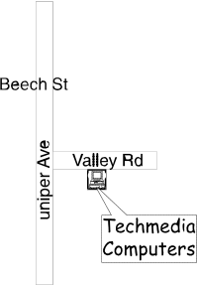0: Question refused/not done

TMN Anti-theft Questions 42-45

Question 42. List all the documents you need in order to be able to ask for your mobile telephone to be blocked.

Scoring Guide:
1: Mentions all THREE of the following:
• Proof of purchase (of the mobile phone)
• Proof that you have reported the theft OR loss (to the authorities)
• (A properly completed) liability form (available from any TMN shop, on which you should include the make, model and IMEI number of the mobile phone)
7: Any other response
0: Question refused/not done

Question 43. According to the brochure, what function does the numeric IMEI code play in the company’s anti-theft service?

Scoring Guide:
1: Mentions or paraphrases at least ONE of the following:
• Provides (a unique) identifier (code) for your phone (in case it is lost or stolen)
• The company needs to know the code in order to block your service
OR unblock your service
7: Any other response
0: Question refused/not done

Question 44. What does the brochure say are the current benefits of the anti-theft service?

Scoring Guide:
1: Mentions or paraphrases at least TWO of the following:
• To dissuade people from stealing mobile phones
• So that mobile phones cannot be improperly used by third parties if they are stolen or lost
• To make it possible to get the mobile phone back if it is recovered
• Blocks or prevents undesired use of your mobile phone (on any
Portuguese mobile network)

[If response includes GSM networks, this should be considered an incorrect response and receive a code 7]

7: Any other response
0: Question refused/not done

Question 45. Which document must you submit both to block and unblock your mobile phone?

Scoring Guide:
1: (A properly completed) liability form
7: Any other response
0: Question refused/not done

Exercise Equipment Questions 46 - 49

Question 46. Which muscles will benefit most if you use the gym bench?

Scoring Guide:
1: Abdominal (muscles)
7: Any other response
0: Question refused/not done

Question 47. List all the effects indicated on the chart for which using the rowing machine is rated “Very good”.

Scoring Guide:
1: Mentions ALL of the following:
• Leg strength
• Abdominal muscles
• Overall muscle building
• Joints
7: Any other response
0: Question refused/not done

Question 48. Which piece of equipment listed received the largest number of
“Ineffective” ratings?

Scoring Guide:
1: Dumb-bells AND/OR weights
7: Any other response
0: Question refused/not done

Question 49. State any precautions mentioned in the chart that specifically apply to using a rowing machine.

Scoring Guide:
1: Learn how to row correctly first so you won’t hurt your back [or equivalent – must mention both learning to row correctly and that this is associated with back injury]
7: Any other response
0: Question refused/not done

