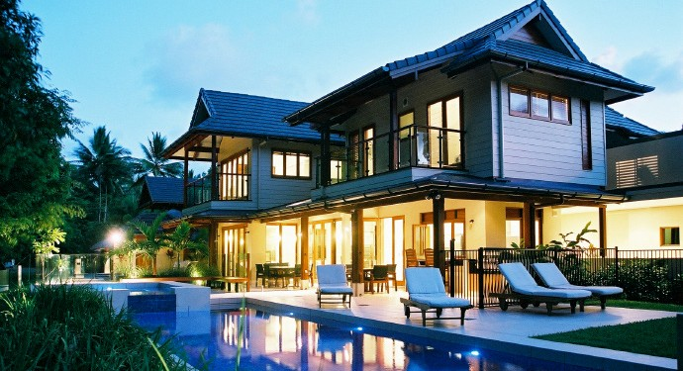
Welcome to our home!
Contact:
Your name here
+1.333.333.3333
member@example.com
HOUSE MANUAL BOOKLET



PROPERTY NAME HERE
City, State, Country

Welcome to our home!
This is a wonderful section to give a brief introduc- tion and overview of the property/destination for your guests. In broad strokes, describe the ameni- ties and highlights of the property.
About Us
Include a small segment about you and your fam- ily! It’s those small personal touches that really make a guest feel at home. You could even include a picture of yourself in the section above.
Make yourself at home!

8
ARRIVAL/DEPARTURE
WIFI/INTERNET
ID:
Password:
Check-in time
Let your guest know what time he/she should plan on arriving at your property.
Directions
Some properties are off the grid. If your home is difficult to find via GPS, be sure to describe, in great detail, the directions to your property. You can also provide direct GPS coordinates here.
Parking
Parking can be confusing if you’re part of a larg- er affiliate/resort property or complex. Let your guests know where their car (if they have one) will be safe.
Airport/local transportation
If your guest isn’t bringing a car, be sure to com- municate alternative ways to reach your house. Include local car rental, bus, taxi or shuttle services.
Check-out time
Let your guests know what time they should de- part. Include any other departure procedures here.
ABOUT OUR HOME
DESCRIPTION
Give a detailed description of your home. Could be the same description listed in your property page.
STAFF/TIPPING PROCEDURES:
Let your guests know if your staff requires certain fees or tips. It might also be prudent to include tipping customs for the destination as a whole.
AMENITIES
Give detailed instructions for featured amenities including any of the following:
Pool
Usage instructions.
Hot Tub
Usage instructions.
Sauna
Usage instructions.
Game Room
Usage instructions.
In-home theater
Usage instructions.
Resort amenities
Usage instructions.
Access to local Golf clubs/Country clubs
Usage instructions.

APPLIANCES/FEATURES
Here are some common appliances that often need explaining:
AC/Central Heating
Quick explanation of usage...
Sink/Garbage Disposal
Quick explanation of usage...
Oven/Range
Quick explanation of usage...
Dishwasher
Quick explanation of usage...
Coffee Machine/Espresso Machine
Quick explanation of usage...
Fireplace
Quick explanation of usage...
Laundry
Quick explanation of usage...
Security system
Quick explanation of usage...
Television/Streaming system/DVD player
Quick explanation of usage...
WIFI Router/Modem
Quick explanation of usage...

APPLIANCES/FEATURES
Here are some common appliances that often need explaining:
Shower/Bathtub
Quick explanation of usage...
Garage Door
Quick explanation of usage...
Grill
Quick explanation of usage...
Cleaning Supplies
Quick explanation of usage...
Smoke Detectors
Quick explanation of usage...
Bidet
Quick explanation of usage...
Pool
Quick explanation of usage...
Sound/Music System
Quick explanation of usage...
Refrigerator
Quick explanation of usage...
Water purifier
Quick explanation of usage...

GUEST CONTACTS
Housekeeping
Enter contact information here...
Maintenance Staff
Enter contact information here...
Security
Enter contact information here...
THIRDHOME Member Experience Team email: memberexperience@thirdhome.com phone: 615-454-2329
LOCAL INFORMATION
Weather
Give a brief overview of the weather in your area...
Restaurants
Give a brief overview of your favorite local restuar- ants...
Local Activities
List your favorite local hobbies and activities...
Local Transportation
Taxis, busses, ridesharing, ski-lifts, gondolas, etc.

COMMUNITY CONTACTS
Airport
Enter address and contact information here...
Bank
Enter address and contact information here...
Church
Enter address and contact information here...
Gas Station
Enter address and contact information here...
Grocery
Enter address and contact information here...
Hospital
Enter address and contact information here...
Pharmacies
Enter address and contact information here...
Police Station
Enter address and contact information here...
PLEASE LEAVE A REVIEW
We’d love to hear your feedback! Please leave us a review on the MyTHIRDHOME Dashboard.

