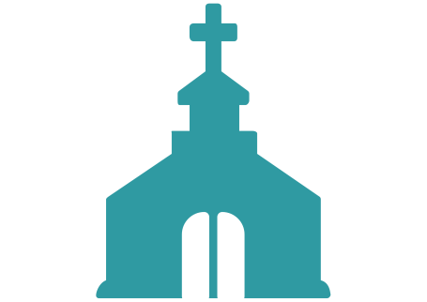
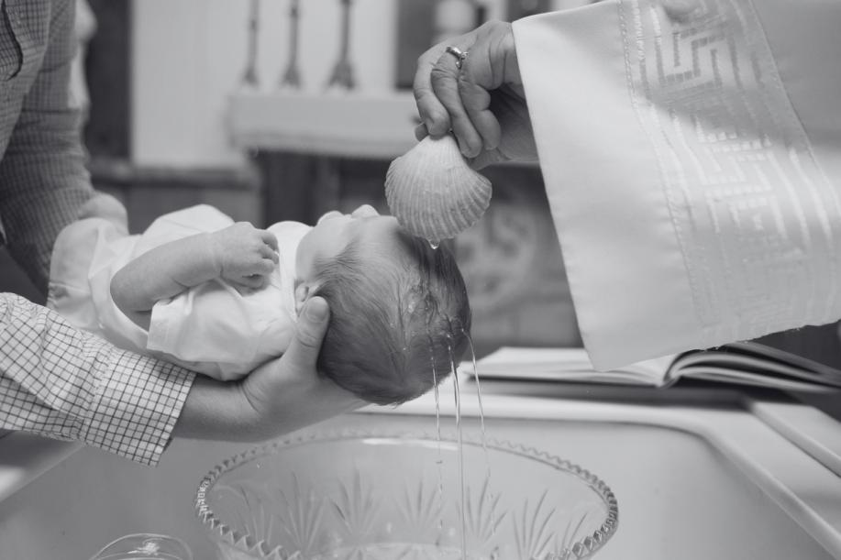

"WELCOMING ALL TO THE HOUSE OF OUR LORD"
August 13, 2023
First Baptist Church
of Hometown
Address: 456 Baptist St, Hometown, USA
Phone: (123) 789-0123
Email: info@firstbaptisthometown.org
Website: www.firstbaptisthometown.org
Stay Connected
To disciple believers, evangelize the lost, and show
Christ's love through acts of service and compassion.
Our Mission
To be a beacon of hope in our community, drawing people closer to God through our words, actions,
and service.
Our Vision
Established in 1923, First Baptist Church of Hometown has faithfully served our community, spreading the Gospel's good news and extending a hand of fellowship and service to all.
About First Baptist Church of Hometown
Church Picnic
Don't forget our annual Church Picnic on August 27th
at Hometown Park. All are welcome!
Our next Baptism Class is on August 20th, 6 PM.
Contact Deacon Paul to sign up.
Baptism Class
Registration is open for Sunday School! Ages 4-12,
starts next month.
Sunday School
Join us every Wednesday at 6 PM for our community
prayer meeting.
Prayer Meeting
Upcoming Events
- Proverbs 3:5-6
"Trust in the Lord with all your heart and lean not on your own understanding; in all your ways submit to him, and he will make your paths straight."
Pastor John Doe
Benediction
"Come Thou Fount" - Hymnal #98
Hymn of Response
"Embracing God's Love" by Pastor John Doe
Sermon
"Blessed Assurance" - Hymnal #45
Hymn of Praise
John 3:16-21, read by Brother James Black
Scripture Reading
Deacon Mary White
Prayer of Invocation
Pastor John Doe
Welcome & Greeting
"O Worship the King" - Hymnal #21
Opening Hymn
Order of Service

