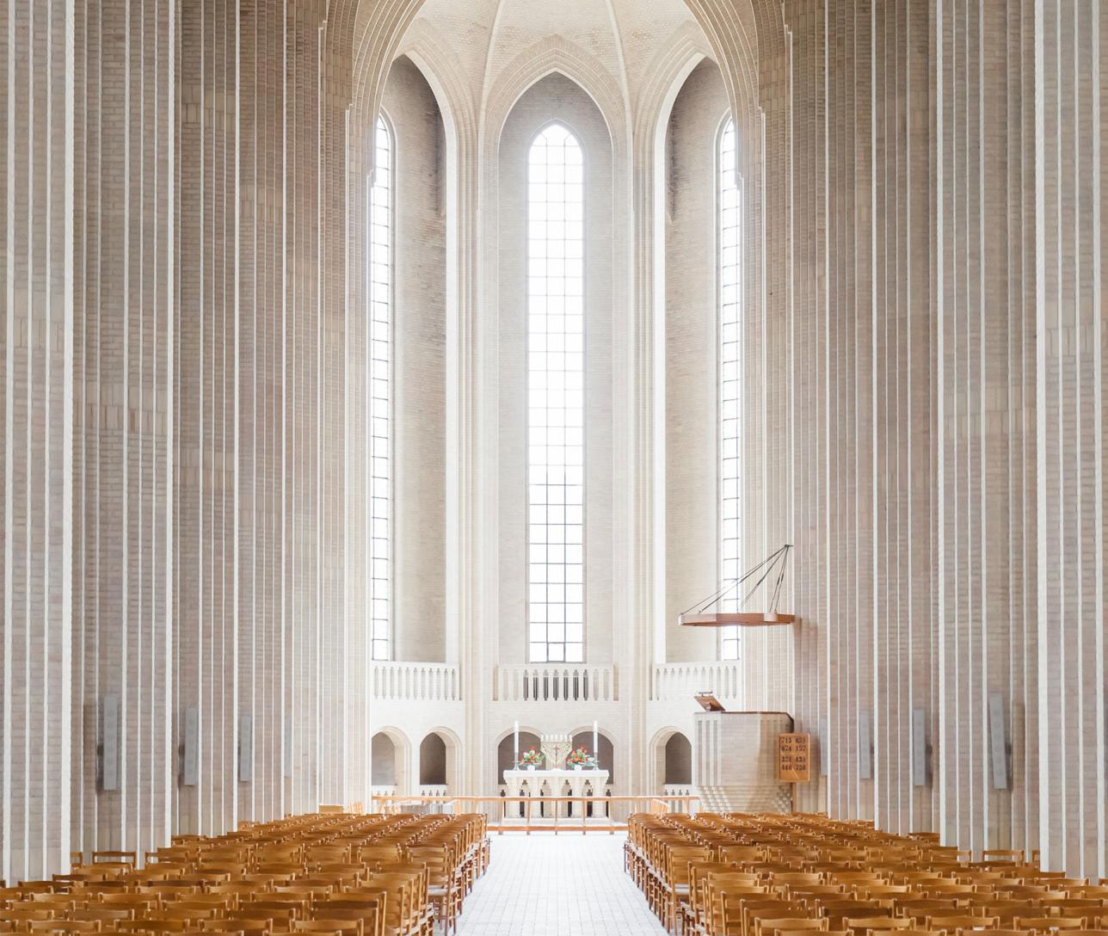
10th Church
Anniversary
THANK YOU
Sed ut perspiciatis, unde omnis iste natus error sit voluptatem accusantium doloremque laudantium, totam rem aperiam eaque ipsa, quae ab illo inventore veritatis et quasi architecto beatae vitae dicta sunt, explicabo. Nemo enim ipsam voluptatem, quia voluptas sit,
aspernatur aut odit aut fugit, sed quia consequuntur magni dolores eos, qui ratione voluptatem sequi nesciunt, neque porro quisquam est, qui dolorem ipsum, quia dolor sit amet consectetur adipisci[ng] velit, sed quia
aut fugit, sed quia consequuntur magni dolores eos, qui ratione voluptatem sequi nesciunt, neque porro quisquam est, qui dolorem ipsum, quia dolor sit amet consectetur adipisci[ng] velit, sed quia
ST. PETER’S CHURCH
FOR GOD SO LOVED THE WORLD, THAT HE GAVE HIS ONLY BEGOTTEN SON, THAT WHOSOEVER BELIEVETH IN HIM SHOULD NOT PERISH, BUT HAVE EVERLASTING LIFE.
- JOHN 3:16
Sunday, September 5 at 11:00 am
Pastor John Smith
Phone
562-435-129
Mail:
church@email.com
Address
132 IpsumStreet
Lorem City
Oscar Fredrik Church
Pastor John Smith

Sed ut perspiciatis, unde omnis iste natus error sit voluptatem accusantium doloremque laudantium, totam rem aperiam eaque ipsa, quae ab illo inventore veritatis et quasi architecto beatae vitae dicta sunt, explicabo. Nemo enim ipsam voluptatem, quia voluptas sit,
aspernatur aut odit aut fugit, sed quia consequuntur magni dolores eos, qui ratione voluptatem sequi nesciunt, neque porro quisquam est, qui dolorem ipsum, quia dolor sit amet consectetur adipisci[ng] velit, sed quia
Perspiciatis, unde omnis iste natus error sit voluptatem accusantium doloremque laudantium, totam rem aperiam eaque ipsa, quae ab illo inventore veritatis et quasi architecto beatae vitae dicta sunt, explicabo. Nemo enim ipsam voluptatem, quia voluptas sit,
aspernatur aut odit aut fugit, sed quia consequuntur magni dolores eos, qui ratione voluptatem sequi nesciunt, neque porro quisquam est, qui dolorem ipsum, quia dolor sit amet consectetur adipisci[ng] velit, sed quia , qui ratione
ANNIVERSARY
PROGRAM
Master/Mistress of Ceremony - Person’s name and title
Led by Anne Scott
Led by Brian Doe
Led by Pastor Smith
Led by Pastor John
Led by Mary Lee
Worship service
Prelude
Scripture Reading
Welcome Address
Song Selection
Offertory Service: Deacons & Ushers
Worship service
Prelude
Scripture Reading
Welcome Address
Led by Anne Scott
Led by Brian Doe
Led by Pastor Smith
Led by Pastor John
CHURCH HISTORY

