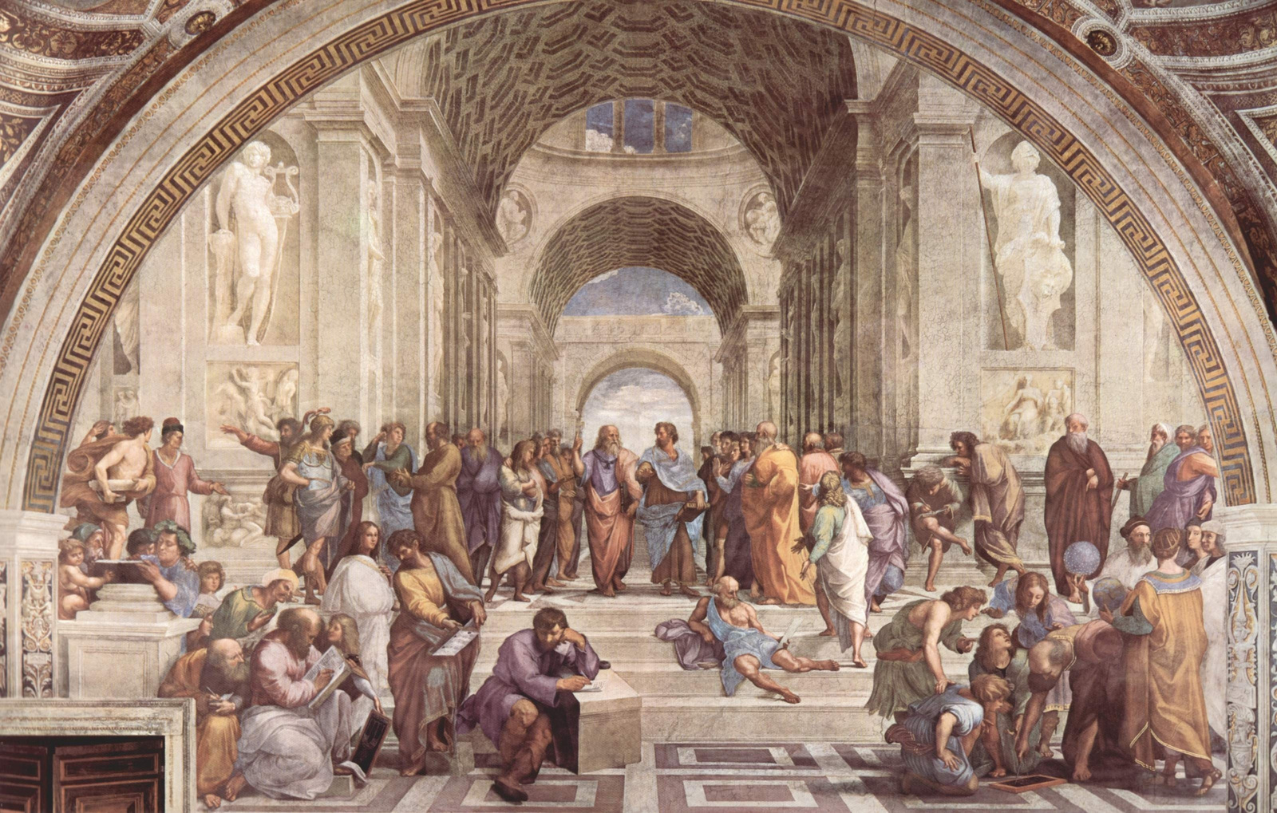


ROOTED IN TRADITION, GROWING IN FAITH
The Eleventh Sunday
after Pentecost
ST. AUGUSTINE’S EPISCOPAL CHURCH
Join our outreach programs!
Details on our website.
VOLUNTEER OPPORTUNITIES
Website: www.staugustines-episcopal.org
Phone: (123) 456-7891
Social Channels:
Facebook: @StAugustinesEpi
Twitter: @StAugustinesEC
CONNECT & SERVE
Last Tuesday 7 PM
MONTHLY HEALING SERVICE
Thursdays at 7 PM
CHOIR
REHEARSAL
Fridays at 6:30 PM
YOUTH
GROUP
Mon-Fri, 8 AM
MORNING PRAYER
WEEKLY GATHERINGS
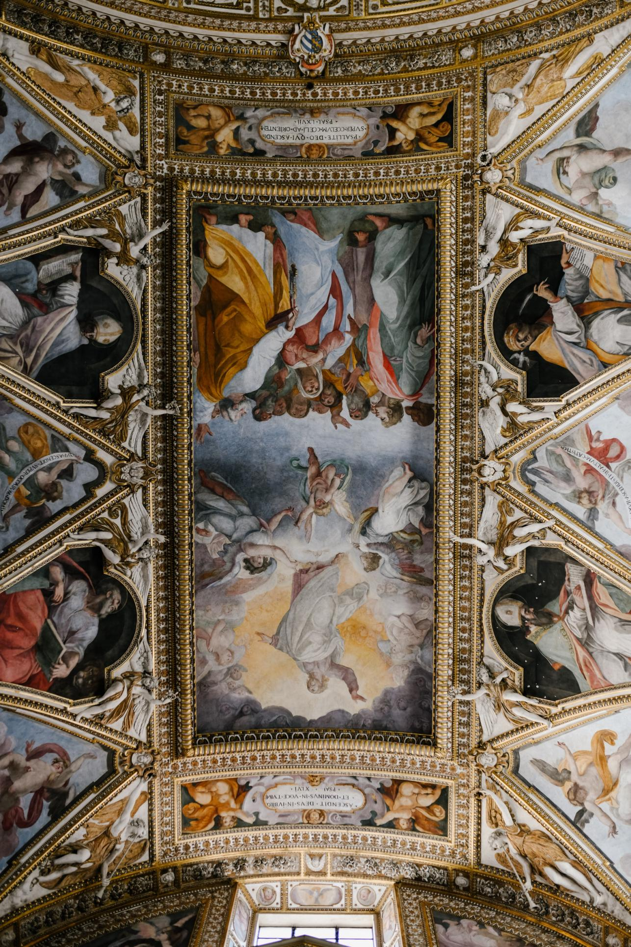
"Now Thank We All Our God"
Post-Communion Hymn
Communion
All baptized Christians are invited
Fraction Anthem sung
The Breaking of the Bread
Sung by the choir
Sanctus & Benedictus
Hymn "Bread of the World"
Presentation & Preparation of Gifts
THE CELEBRATION OF
THE EUCHARIST
"Living the Baptized Life" by Father Lawrence White
Reflection
Luke 12:32-40, proclaimed by Deacon Peter Collins
Gospel Reading
Sung by the congregation
Alleluia & Verse
Ephesians 4:17-32, read by Mr. Harold Davis
Second Scripture
Psalm 98, sung responsively
Response
Jeremiah 7:1-11, read by Miss Olivia Turner
First Scripture
WORD OF GOD
Read by Father Lawrence White
The Collect of the Day
Recited together
Collect for Purity
Sung by the choir and congregation
Gloria
Led by Deacon Peter Collins
Confession of Sin
Celebrant: "Blessed be the one, holy, and living God."
Opening Acclamation
"Fugue in G Minor" by J.S. Bach
Prelude
BEGINNING THE WORSHIP

