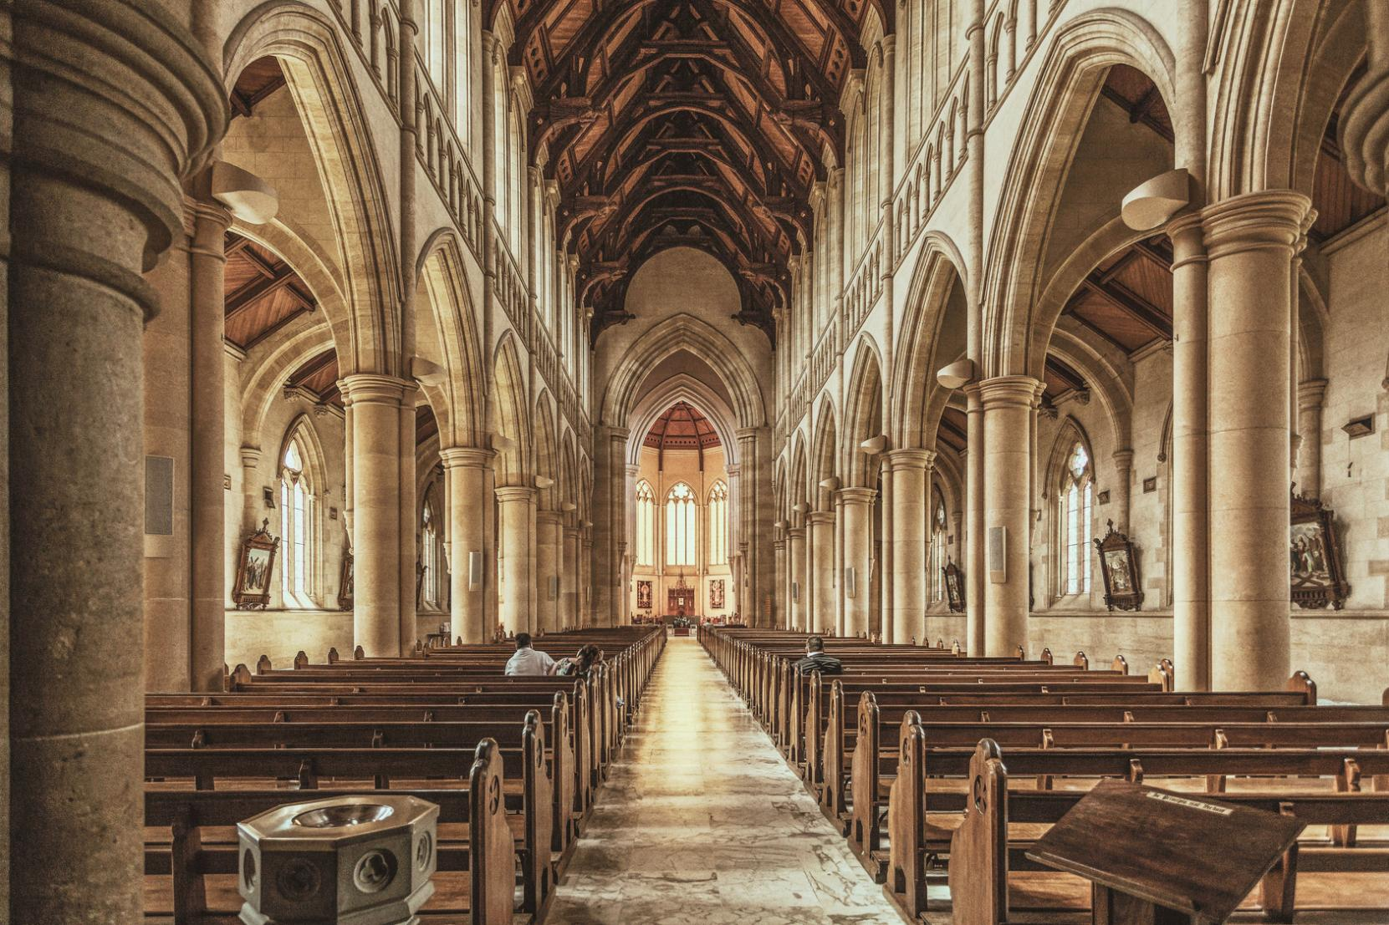
Sunday workshop program
Revolution
City Church
123 Anywhere St., Any City, ST 12345
hello@templatelab.com
templatelab.com
123-456-7890
123-456-7890
Contact Us
Revolution City Church
- Martin Luther King Jr.
Darkness cannot drive out darkness; only light can do that. Hate cannot drive out hate; only love can do that.

"Build Your Kingdom Here"
Closing Song
"Radiate Love Living Out Divine Love
in Everyday Life", by Pastor Jane Doe
Message
1 John 4:7-12, by Elder Tom Smith
Scripture Reading
Led by Pastor Jane Doe
Community Prayer
"This is Amazing Grace"
Opening Song
ORDER OF SERVICE
Can't make it in person? No worries. Join our live-streamed services every Sunday on our website or catch up later on our YouTube channel. Wherever you are, we're there for you.
ONLINE
SERVICES
New to Revolution City Church?
We're glad you're here! Join us for our newcomers' meetup every Sunday after the service. You'll get a chance to meet our pastor and learn more about our community. Let's connect and make
you feel at home.
NEWCOMERS
Welcome to Revolution City Church.
We are a vibrant, inclusive community committed to living out Jesus' revolutionary message of love. Our vision is to create
a space where love is the default, where acceptance is unconditional, and where everyone feels at home.
WELCOME & VISION STATEMENT

