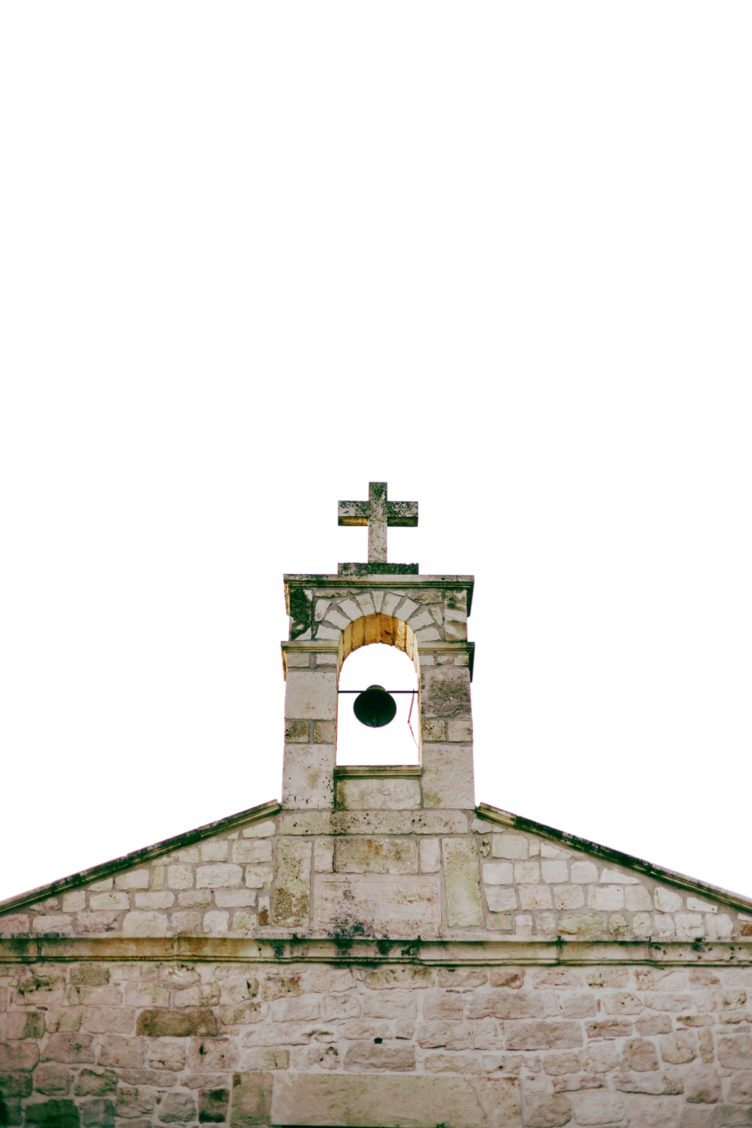
Finding Peace in the Storm
FIRST PRESBYTERIAN CHURCH
1234 Grace Lane, Presbyterian Town
+123-456-7890
www.templatelab.com
Connect with Us
- Psalm 27:1
The LORD is my light and my salvation; whom shall I fear? The LORD is
the stronghold of my life;
of whom shall I be afraid?

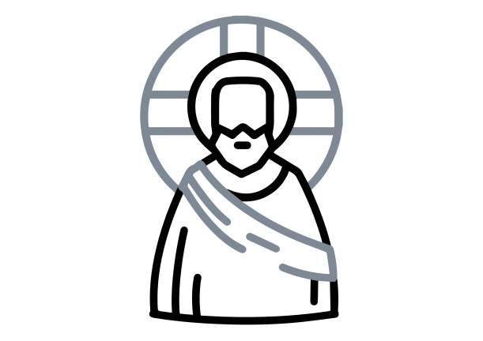
First Presbyterian Church is a community of believers united by our faith in Jesus Christ. We welcome all who seek to grow in grace, love one another as Christ loved us, and serve in our world as bearers of the Good News.
About First
Presbyterian Church
Thursdays, 7 PM in the Fellowship Hall.
BIBLE STUDY
Wednesdays, 6:30 PM in the Youth Room.
YOUTH GROUP
This Week at
First Presbyterian
Share a sign of Christ's peace
with those near you
Passing of the Peace
Pastor John Doe
Assurance of Pardon
Led by the congregation
Prayer of Confession
Led by Elder Jane Smith
Call to Worship
Pastor John Doe
Welcome and Announcements
Selection by our Organist
Prelude
ORDER OF WORSHIP

