
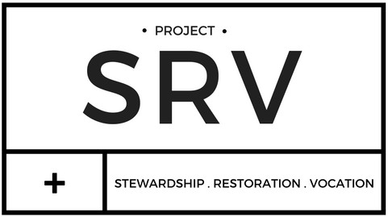
JUPITER CHRISTIAN SCHOOL COMMUNITY SERVICE FORM
Student Information
Print Name
Grade
I understand that all community service hours are unpaid activities-time given freely of my own free will and not
because it was required to do so. Community service is designed to improve the quality of life for others individually or through an organization. The service may not be done for a family member and must be done after school hours.
Student Signature
Site Supervisor Name & Title
Site Supervisor Signature
1.

2.

3.

4.

Date

Organization Name

Project Description

# of hours
1.

2.

3.

4.

