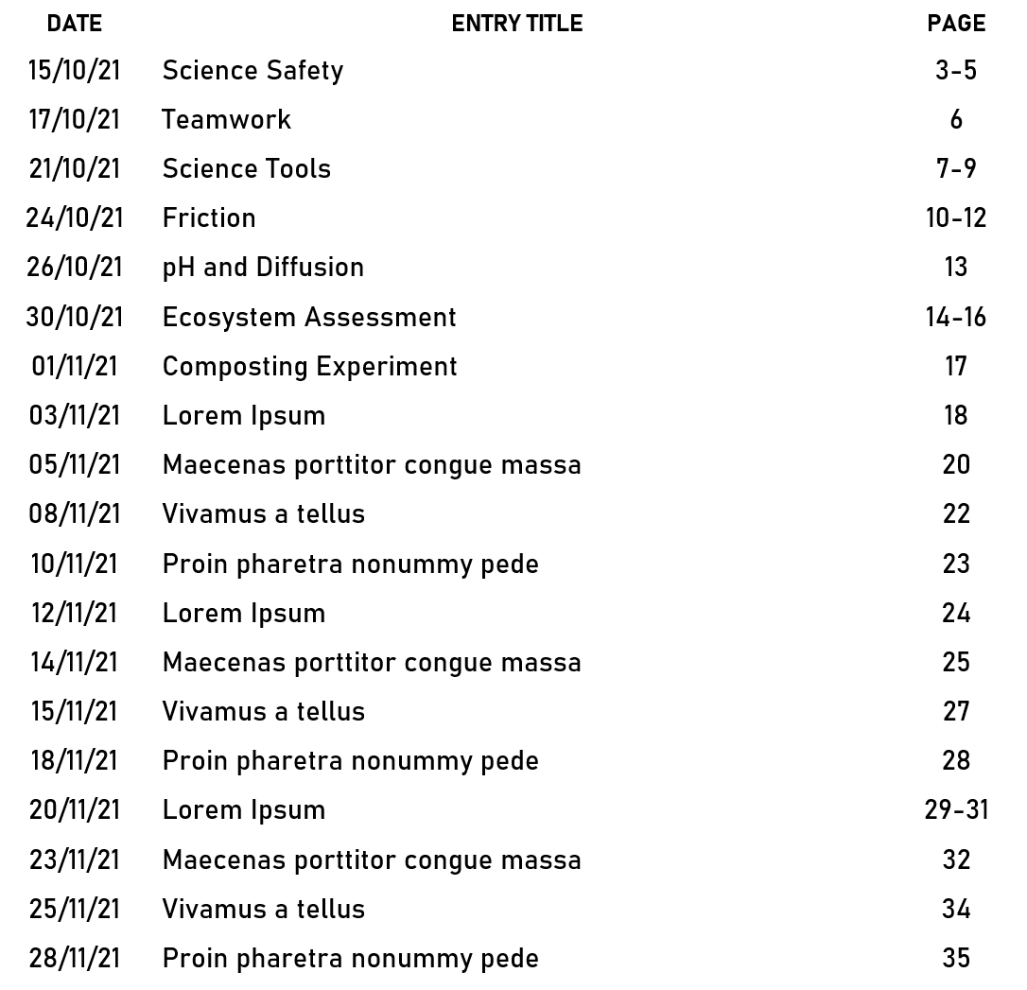
LAB NOTEBOOK
TABLE OF
CONTENTS

