
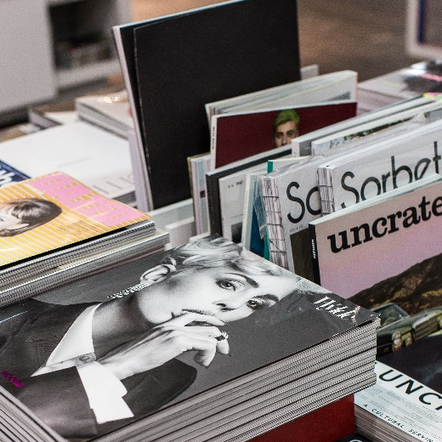

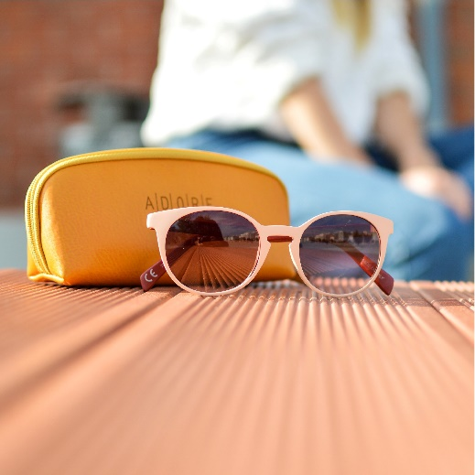
TABLE OF CONTENTS
PROFESSIONAL
02
The Basics
17
Grade Photos
25
Autographs
47
Art Connection
59
Modern Thesis
72
Outbursts

