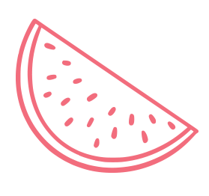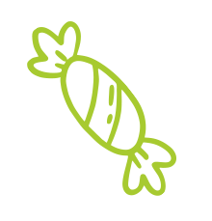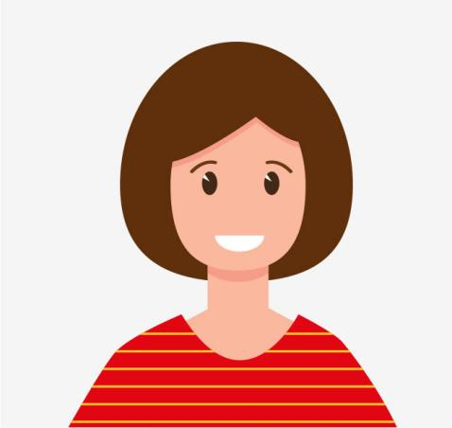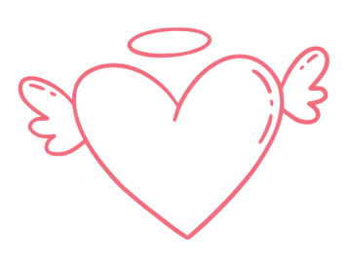
Book:
Color:
Drinks:
Snack:
Animal:
Toy:
Movie:
Food:
Favorites:
3 things I love about myself:
When I grow up I want to be:
My favorite
School subject is:
Years old
I am
My Name is
ALL ABOUT ME

